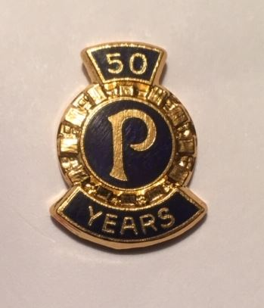

A HISTORY OF
SUNBURY PROBUS CLUB
2001-2019

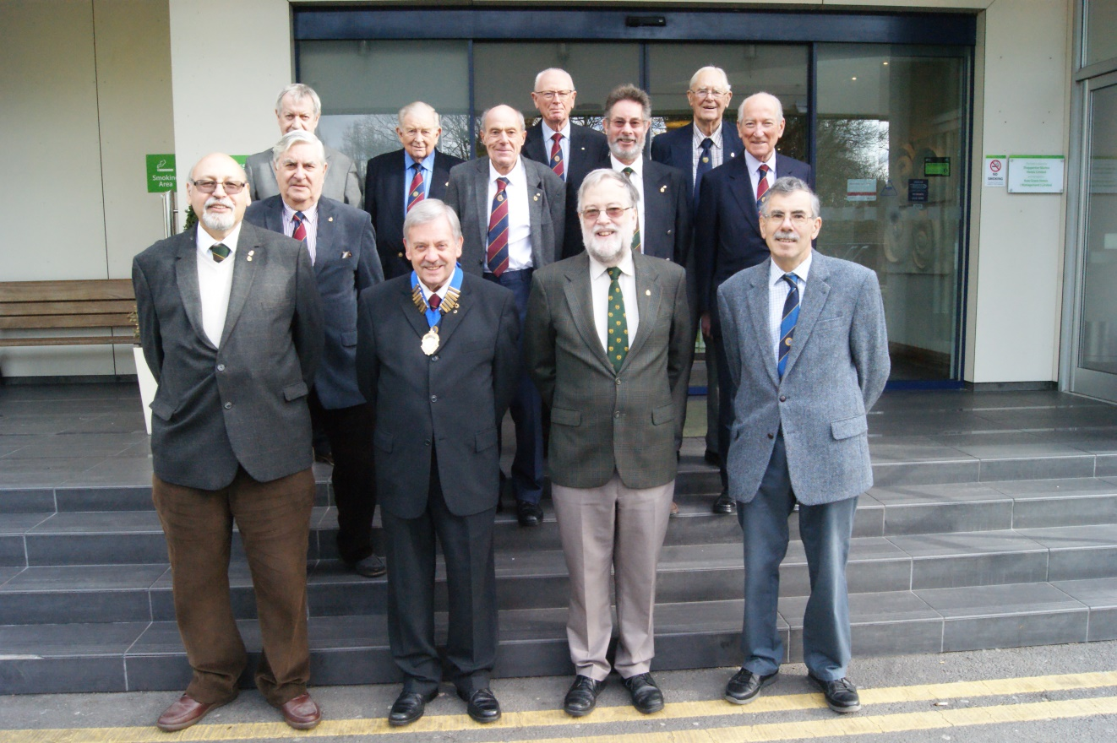
A HISTORY OF SUNBURY PROBUS CLUB 2001-2019

First issued by Sunbury-on-Thames Probus Club
February 2019

.

Photograph on cover: Sunbury Probus Club Committee 2018-19
(Back row, from left) Alan Worrell Don Shimmield Terry Lawrence Leo Pemberton
(Middle row, from left) Gavin Stanley Chris Mayell Tony L’Angellier John Lodge
(Front row, from left) Mike Attias David Leitch David Priddy Martin Moore
[Denis Scott was unavoidably absent when the photograph was taken]
.

Copyright © 2019 Sunbury Probus Club
No part of this document may be reproduced in any form or by electronic or mechanical means including information storage and retrieval systems without the express permission in writing of the Chairman of Sunbury Probus Club.

CONTENTS Page

Table of contents 1

Acknowledgements 3
Preface 4

1.0 Introduction 5
1.1 Outline of the document 5
2.0 The Spirit and Purpose of Sunbury Probus Club 6
2.1 The early years (1969-2001) in retrospect 6
2.2 Committee membership and business affairs (2001-19) 11
2.3 Club Constitution and Rules (status and review) 22
2.4 Membership trends 24
2.5 Finance and related matters 26
2.6 Honorary Life Membership (HLM) 31
2.7 The Probus Ladies’ Group 33
2.8 Sunbury Probus Club in print 34
3.0 Programmes of Social Events (2001-19) 36
3.1 Day trips 36
3.2 5-day holidays 42
3.3 Theatre visits 49
3.4 Pub lunches 54
3.5 The speakers’ programme 62
3.6 Ladies’ night 72
3.7 Ray Gaunt’s centenary birthday 74
4.0 The 50th Anniversary (Jubilee) Year 78
4.1 Calendar of events 2018-19 78
4.2 The Golden Jubilee Dinner 81
4.3 Profile of Club members 2019 87
4.4 Personal reflections on Sunbury Probus Club 93
Listing of Appendices Page
Appendix A Sunbury Probus Club: order of precedence in the
National League Table 101

Appendix B Minutes from a Luncheon Meeting (11 May 2015) 102

Appendix C Minutes from AGMs (11 March, 2002; 8 March 2010;
13 March 2017) 104

Appendix D Constitution and Rules: Club Rules (1999);
Club Constitution (2015) 115

Appendix E Talk presented to Probus by Frank Barnes HLM
(14 November 2011) 121

Acknowledgements
Without the support and encouragement of our members, this updated history to mark the 50th Anniversary of Sunbury Probus Club would not have been written. Gentlemen, I thank you for your genuine interest and good-humoured assistance. We have been privileged to share your memories and photographs in defining key events in the rhythm and life of our Club and its changing fortunes.
In this context I pay tribute to our Club Secretary, Martin Moore, and his predecessor, Terry Duffy, for delving into the dusty boxes of Club records and searching computer files in response to the authors’ unrelenting demands for yet more information!
Finally, it gives me great pleasure to acknowledge the stamina of the production team who updated the history of our Club. I am confident that the journey down memory lane will enable our senior members to recall happy times; for recent members, I’m sure that it will foster a sense of our common heritage.
Gentlemen of Sunbury Probus Club, enjoy your reading.
With sincere best wishes

David Leitch
(Chairman, Sunbury Probus Club, 2018-2019)

Preface
There are many ways to approach a history of Sunbury Probus Club on the journey towards its 50th Anniversary in January 2019. We are fortunate, however, to retain A History of Sunbury Probus 1969-2001 as a model. The writing team have adopted and developed the framework of that document as it reviews key features in the earlier life of our Club.
Our present objective is to give future members an insight into the vitality of the Club in the period between the AGM in 2001 and AGM 2019, and the roles performed by key members in securing its future and in providing a range of activities to meet the ever-widening interests of membership. In places we catalogue the profile of social activities to show variety, frequency and location. Elsewhere, we demonstrate how the affairs of our Club are organised and delivered. This includes financial considerations and amendments to the Club Constitution to reflect changing circumstances and opportunities. The personal reflections of our three HLMs and Senior Member enrich this account.
We are privileged to report on the calendar of events connected with the 50th Anniversary celebration. This includes a description of keynote activities including the 50th Anniversary Dinner, a photographic record of events and profile of members at that time.
In delivering A History of Sunbury Probus 2001-2019 we have taken sensible decisions to minimise production costs and target a wider readership. We publish the illustrated text on our Club’s (password protected) website and have reproduced an edited gallery of photographs provided by members from their personal collections.

Norman Dixon (Author and HLM)
Robert Gant (Editor and Author)
Richard Greaves (Webmaster)
Mike Hesford (Author and HLM)
Gordon Hopkins (Photography and Design)
David Leitch (Author and Chairman 2018-19)
Don Shimmield (Author and HLM)

