APPENDIX E
Frank Barnes HLM gave the following talk at the Club luncheon on 14th November 2011.
65 Years of Avionics
Frank Barnes BSc CEng FRAeS
History of Avionics: landmark events
Firstly, a bit of history :- Throughout time man has always wanted to fly -
ICARUS, in Greek mythology, was the first recorded air accident when his wings fell off.
LEONARDO DE VINCI, his design did not get into production, maybe the banks would not lend him the money!
MONTGOLFIER, was the first manned flight in a balloon in 1783
SIR GEORGE CALEY, his lift/ drag glider earned him “coachman” status in 1853.
THE WRIGHT BROTHERS, flew over the Channel over 100 years ago in 1903.
CODY, built his first British manufactured aircraft at Farnborough in 1908.
I was born 22 years after the Wright Bros and have been lucky to have seen and participated in a number of the fantastic advances since then.
Enough of history – now for my experiences
(1) The Royal Aeronautical Society was formed 37 years BEFORE the Wright Bros to bring together interested experimenters. It is now world-wide and multi-disciplinary containing Engineers, Pilots Lawyers, Scientists and Medical groups.
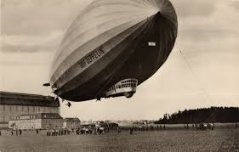
(2) The Graf Zeppelin, Built in Germany in 1927, flew 590 flights between 1928 and 1937 including 136 across the Atlantic at speeds of between 65 and 80mph. It had a dining room, washrooms with hot and cold water, cabins but no heating. It was more Orient Express than Ryanair. It landed at Hanworth Airport prior to a tour of the UK. I saw it on 18th August 1931 by leaning out of my bedroom window supported by my father. After the Hindenburg disaster In1937 airships lost their popularity and were finally scrapped in 1940.
The Graf Zeppelin at Hanworth 1931

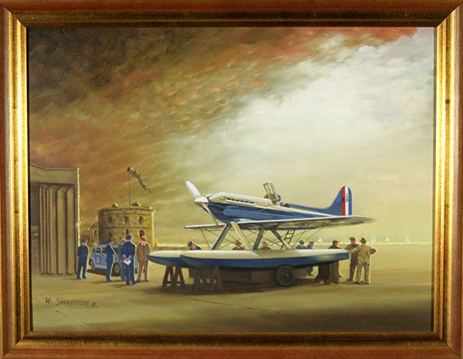
(3) My interest grew in flying by following the Schneider Trophy air races during the 30s. I show a picture of the winner on 13th Sept 1931. It had a Rolls Royce 2350hp engine by R J Mitchell which was a precursor to the Merlin and Spitfire engines. My school visited Croydon Airport, then the airport for London, in 1935, now derelict, and I saw Skywriting and the huge airliners. I had my first flight in 1936 Railway Aviation Services from Bembridge, IOW, to Shoreham - cost 7/6 or 37.5p, in a De Haviland 89a Rapide on loan to R.A.S. for their half hour service to the mainland. A similar plane was chartered to carry General Franco from Morocco to Spain on 2nd July 1936 to start the Spanish Civil War. This is now in Museo del Aire, Madrid.
The Schneider Trophy winner 1933
(4) As soon as I could I joined the Air Training Corps at its formation as RAF No 1 Squadron at Tangmere, attending camps at Halton for Air/ Sea rescue training held during the first 1000 bomber raids on Germany in 1942. During the Battle of Britain we schoolboys would cycle to the sites of air crashes to find German cartridges and bullet holes. Saw the first signs of Doodlebugs by the contrails at 16000 ft. While at Tangmere, I saw a Beaufighter fitted with multiple painted strips on the nose as airborne Radar for aircraft recognition. I heard that Group Capt. Guy Gibson had shot down a Junkers JU88. While waiting to start my Engineering Degree I tried to get into courses run by the RAF, FAA, RN at Southampton University and I was posted to the BOAC works at Croydon then the aerodrome for London. The terminal is still on Purley Way. After university I returned to BOAC. While in Southampton I saw a Flying Boat undergoing maintenance and overhaul on Southampton Water including test flights round the Isle of Wight. In mid.1946 London Airport was all tented including Smith’s bookstall. I had a spell at a temporary office in Brentford where the 7th Heathrow runway was planned – Northolt. In August 1946 I was sent to Cairo which took 2 days via Malta. At Almaza I was involved in major overhaul of Loadstars – fuel and electrical rigs, Radar workshops ex Evitrau with test flights around the Pyramids. I had my first ride on a camel.
(5) We had regular stops by the Heathrow to Australia flying boat service. The Hythe Flying boat stopped at Crete for an overnight service. It took 8 days to get from London to Sydney via Poole, Marseilles, Karanga, Malta, Cairo, Bahrain then on to Sydney where they finished with a house party. On the way they had the use of an observation lounge to view the Pyramids and Victoria Falls. We checked the engines, replaced the oil, refuelled from the Shell refuelling launch and checked the magneto contact gaps all while the flying boat was floating in the dock with crocodiles in the water a few feet below us. Later we had a Lancastrian stop for service, it had 9 bunks and 1 seat with a 16 year old steward serving cold meals for the 6 day flight to Australia.
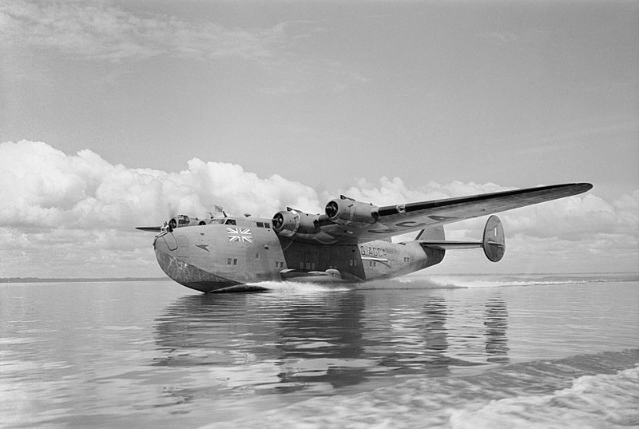 Hythe Flying Boat
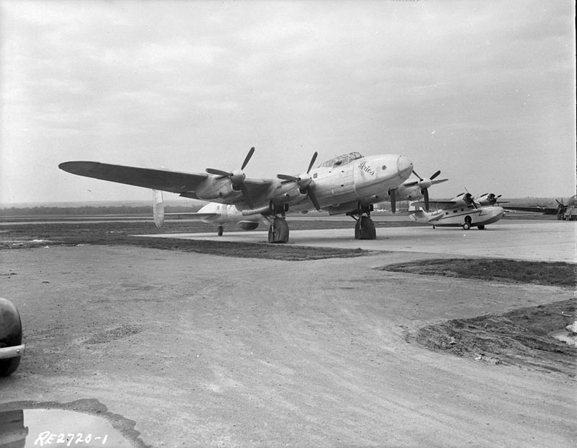 Lancastrian
There were several ex WW2 Bombers adapted for long haul flights by BOAC. The Lancaster was lengthened and fitted with the necessary seating and bunks to become the Lancastrian. The Avro York, fitted with a Lancaster wing was introduced for passenger and cargo use. It was extremely noisy. My ears rang for 2 days on my return from the UK. On this occasion the cargo was Monkeys and Polo ponies. Later the Handley Page Hermes was developed from their Hastings with innovated air conditioning and 120 volt electrics. It had separate ladies and gents toilets with electric razors provided. But after all that it was underpowered. At this time also we had the Berlin Airlifts which provided us all with problems of dealing with the cold war. During this period Boeing were developing their long haul fleet having a head start from the WW2 bombers, hundreds of which were stationed in Fen District of the UK during the war.
(6) I was posted for a time to Bristol where I was engaged on the development of the altimeter for the use at higher altitudes. While there I saw the Bristol Brabazon being built and the Britannia, when they had problems with the Proteus engines. I had periods in Nigeria, Kano, Nairobi, Salisbury (Zimbabwe) and Johannesburg for high altitude tests. I had round table meetings with Ian Smith the Prime minister of Rhodesia. BOAC bought the Stratocruiser for the New York to London service (some bunks, engines with spark plug change). It was used until 1954 when it had damage on landing at Prestwick after which it was discontinued. The Brabazon first flew in 1949, at Farnborough Air Show in 1950 and scrapped in 1953.
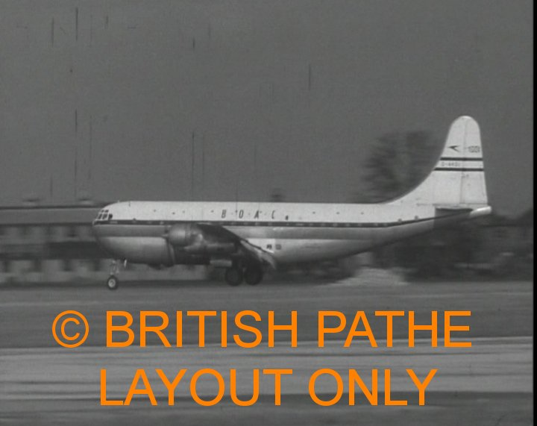 BOAC Stratocruiser
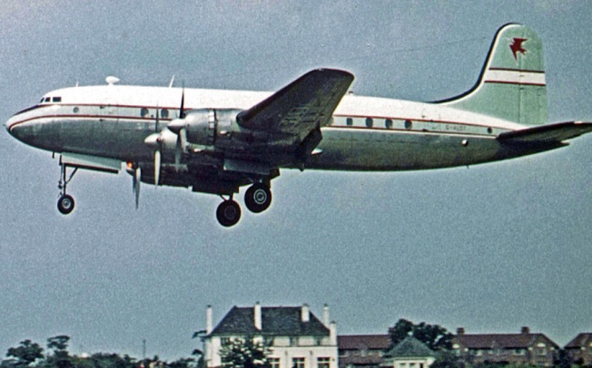 Handley Page Hermes
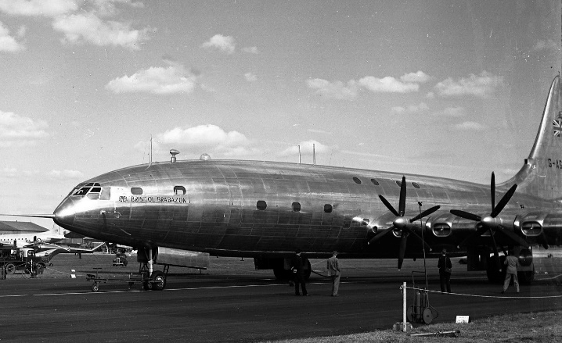 Bristol Brabazon
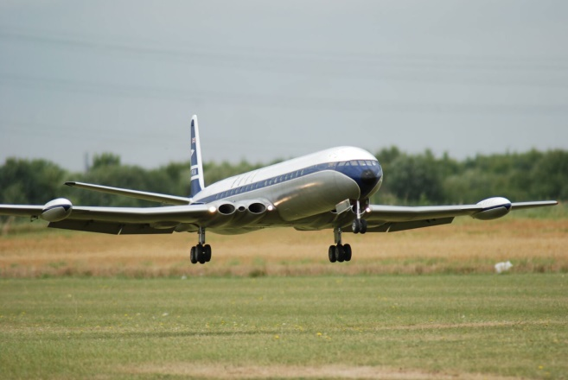 Comet
The De Haviland Comet was the first airlines jet to catch the public’s imagination involving major increase in speed and height. It flew from London to Johannesburg in a day in 1952 piloted by a friend Phil Tivey. By this time the Americans were opening up competition for the long haul routes Boeing were working on their 707 to open up flights for the masses We thought the VC 10 was better for anti corrosion due to the development of WD 40 (water displacing oil). I introduced a 9-hole punch tape for automatic testing of autopilots. Airtours were introduced for inclusive holidays. The first exponent was Sir Freddie Laker with his flight of DC10s and his engineering cooperation in spite of commercial conflicts. 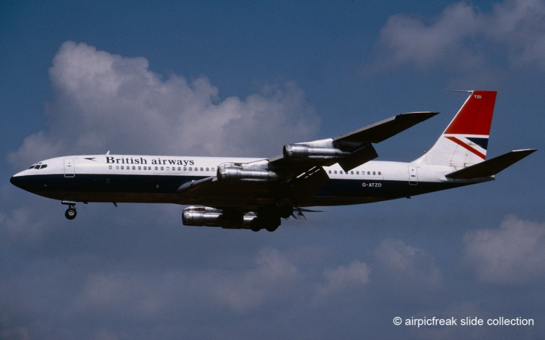 BA 707
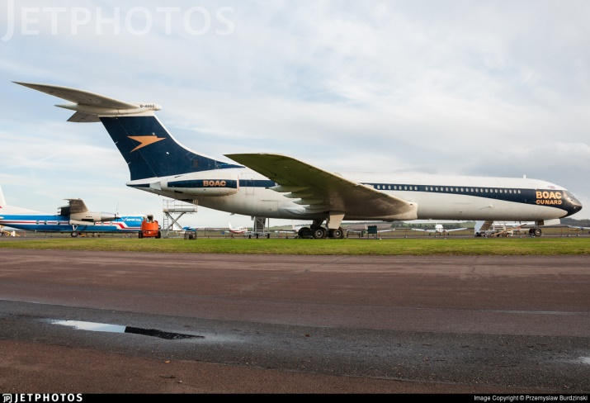 BOAC VC10
(7) About this time work was beginning on Concorde. It was a joint project between the UK and France being constructed partly at Filton in Bristol and partly in Toulouse in southern France. In the UK, Imperial measurements were used but in France it was metric, it was a wonder they fitted together. The intake controls were digital. I was involved for 18 months on the flight deck design having discussions with Brian Trubshaw, Andre Toureat and Jimmy Andrew, the main test pilots. Shown below is a photo of the finished job, note the space for the coffee cups. In the middle of all this activity we attended the Memorial service for Sir Frank Whittle at Westminster Abbey. Shown also is a view of Concorde in flight, a wonderful sight. A party of Japanese tourists visiting Windsor Castle clapped their hands. I later visited Boeing and Lockheed Airospace but they cancelled their orders. I flew on Concorde several times reaching speeds of Mach 2, twice the speed of sound, the ideal way to reach New York in two and a half hours.
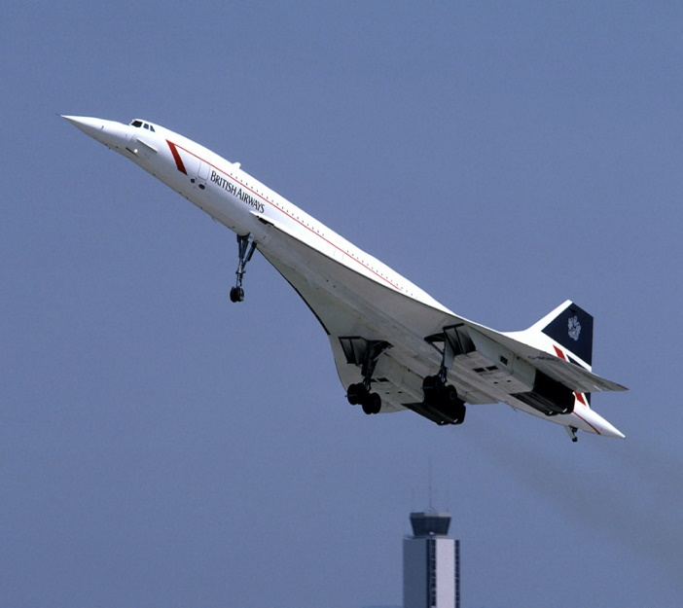 Concorde in full flight.
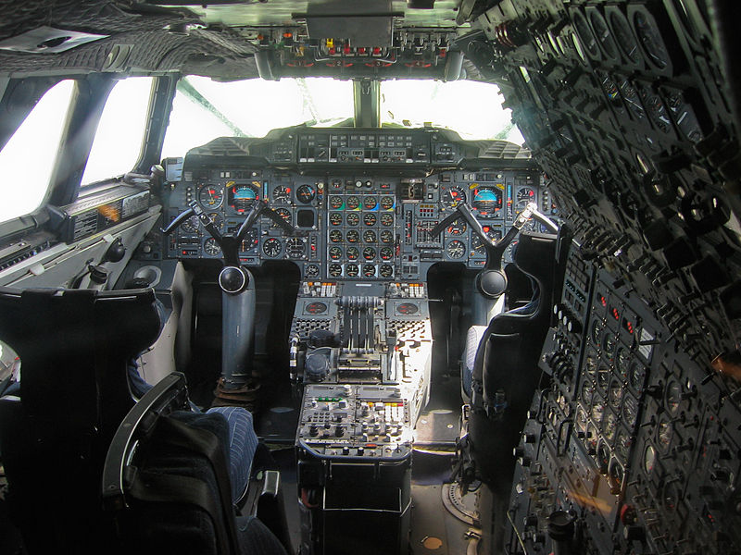 Concorde Pilots’ flight deck.
(8) I was made Project Manager for the acquisition of the Boeing 747 by BOAC, being the point of contact between the companies for all contacts, specifications, changes of orders and visits between companies. My first visit I was surprised at the huge size of the aircraft and the half mile factory at Renton. I was concerned how to test it. After consulting Boeing and the regulating authorities, meetings were set up for the forthcoming year. Later I received the keys and invoice for the first delivery. I took the receipt and invoice to Customs and on to the PM Harold Wilson for the balance of payments at a dinner with him and Joe Sutton at the Oliver Messel Suite at the Dorchester. Later I received two 747’s in one week. It was known as Boeing’s “Queen of the Skies”. The team co-operated with other airlines like Quantas and Europeans DLH. I took DLH Engineering director to Hendon Air Museum where he saw a JU88. He said the last time he flew one he was dropping bombs on London.
(9) In 1974 BOAC and BEA were merged to form British Airways. For a time things proceeded as normal. A 747 service to New York was developed as a sleeper to return over night as a 7-hour service with sleeper seats with pneumatic struts and weight pivots similar to that used to operate boot lids and bonnets on big cars. I lunched with the Chairman and the Duke of Kent at a meeting at the Board of Trade. BA, Eastern and Miami Airlines all wanted a 180 seater aircraft long enough to serve the Canary Islands and Cyprus with full load and I worked up specifications and equipment door positions jointly with Frank Borman late CEO of Appollo 8 Space Mission completing 10 orbits round the moon. After the
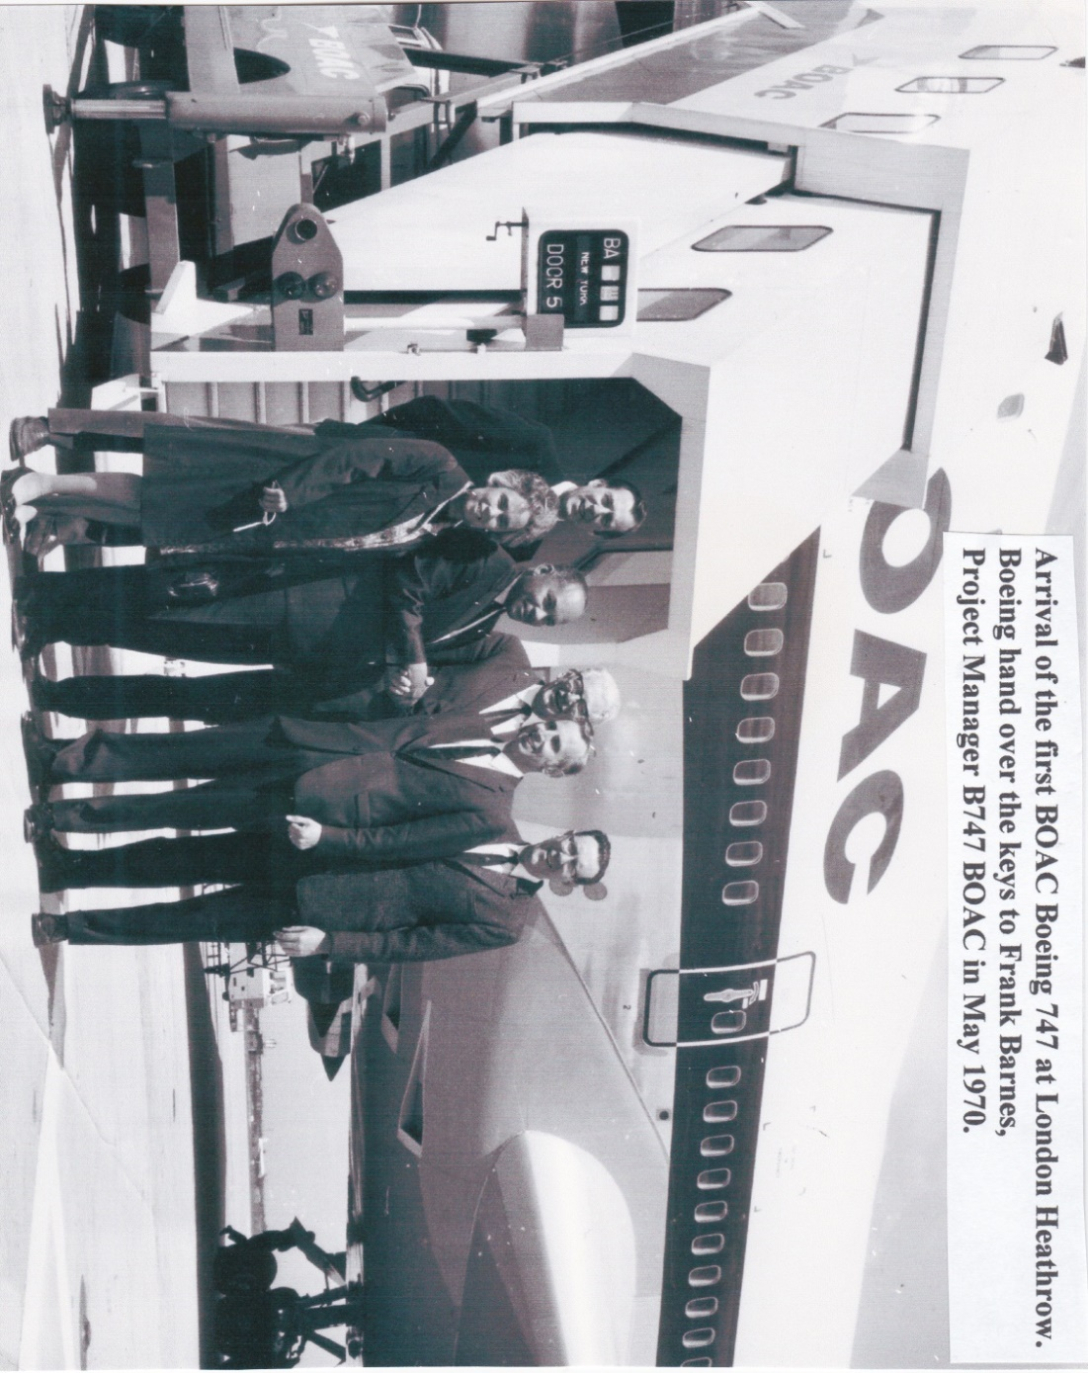
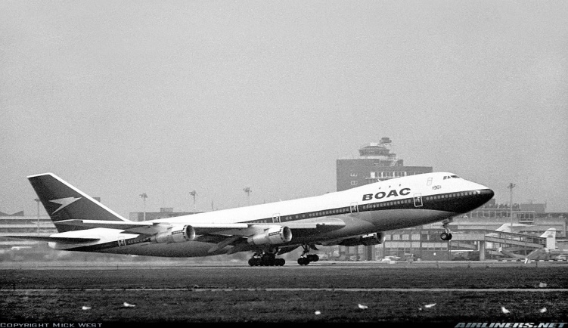 BOAC 747 taking off from Heathrow 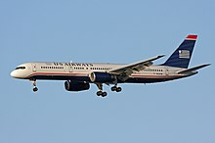 Boeing 757
merger with BEA things speeded up considerably. The 707 was retired and the 757 brought in more and more seats were required and planes were increased in size and Boeings developed the 777 then on to the Airbus, named the A330 on to the A340 and then a major leap forward to the Airbus A380. I visited huge hangars in Toulouse but the wings were made in Broughton Cheshire. I also visited Munchen near Munich to see the multi national Typhoon Eurofighter. In their museum I saw WW2 Meshersmitt BF109 both single and two engined fighters both in airworthy condition, also an ME163 rocket propelled fighter, fortunately never used.
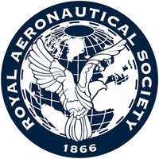
I received an end of year increment of £8 per week which was very disappointing. I left BA, had a short spell with Cyprus Airways and Air India. I was called to the High Court as a specialist witness on a case where access doors on Avro 748s had been opening inadvertantly. A pilot had been killed who had a wife and 2 children. I came to the conclusion the aeroplane was trying to tell you something. I was called on a number of occasions as an expert witness. Finally I decided to retire but to keep my membership of the Royal Aeronautical Society going in order to keep up to date with events.
(10 The R.Ae.S is a multi disciplined professional body which embodies Engineers, Pilots, Scientists and Medical Groups. I attended many society meetings and chatted to several interesting people. I met and talked to: Douglas Bader, Adolf Galland, Valentina Tereskova (who spent 3 days in space in 1963), Helen Sharman (the first british woman in space in March 2001) amongst many others. I attended the 100th anniversary of the Wright Bros flight in the Science Museum London dining with the Duke of Edinburgh in December 2003. Finally I was presented with the RAeS Turnbuckle Award by the society’s President, Air Chief Marshall Sir David Couzins, in December 2010.

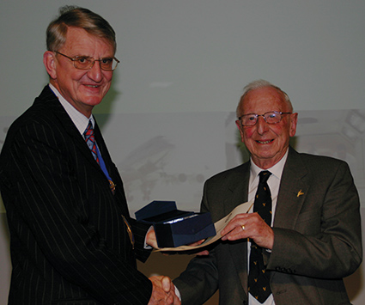
Presentation of The Turnbuckle Award to Frank Barnes in 2010

(11) Finally, what of the future? Could it be Space. Shown below is a picture of the Soyuz International Space Station sent up by Russia. Perhaps a venue for a future Probus 5 Day Holiday?
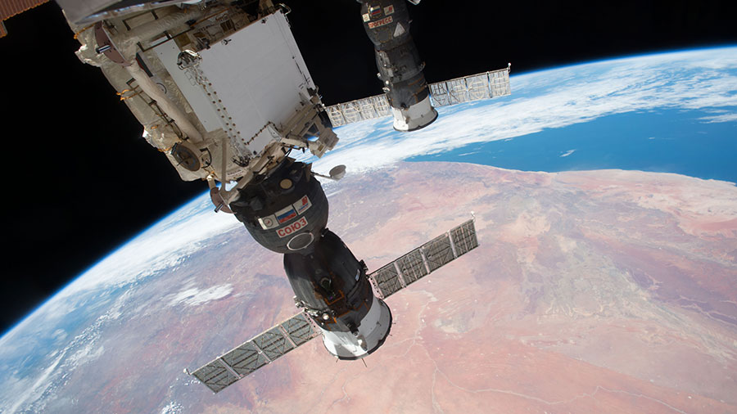
A vote of thanks was given by George March saying that his own dealings with aeronautics at Heathrow had largely been one of kicking the tyres to see if they were inflated properly before despatching the aircraft. He thanked Frank for a most illuminating talk which had held the attention of all the members and called for a show of appreciation.

