2.0 THE SPIRIT AND PURPOSE OF SUNBURY PROBUS CLUB
2.1 The Early Years (1969-2001) in retrospect
Context
The writing team believe that a brief summary of key points from A History of Sunbury Probus Club 1969-2001 is essential to explain how our Probus Club developed in the first three decades of its life. This résumé is not intended as a substitute for reading the original 71-page (typewritten) document: it seeks to establish elements of continuity and change in the organisation and life of our Club.
Roots and branches
PROBUS is derived from two words: PROfessional and BUSiness. In this connection, members (with a classical education) may also draw comfort from the Latin word ‘probus’ meaning honest or virtuous. In essence, Probus is an international organisation for retired men (and, later, women) that meets regularly to promote social contact and good fellowship. Three Probus clubs existed in the United Kingdom before 1967: Welwyn Garden City (June 1965) known as the Campus Club after its meeting venue; Caterham (February 1966), the first club to be formally designated as Probus; and Coulsdon, also founded in February 1966. These early Probus Clubs were sponsored by local Rotary Clubs which duly reported their creation to Rotary International British Isles (Figure 1). Each Probus Club was autonomous and responsible for the organisation of its activities with a minimum of formality.
Bill Reddick, a delegate at the Rotary International Conference in 1968, recommended the formation of a local Probus Club to Sunbury Rotary Club. Together with Mr R.E.White and Mr T.H.Paxton he was instrumental in founding Sunbury Probus Club on 28th January, 1969 (the Charter Meeting). The first Luncheon Meeting, attended by 24 members, followed on 10th February, 1969. In 2005 it was determined that Sunbury Probus Club was the 7th club to be formed in the UK. A revision to this national league table published in the Probus Magazine 2017 (Winter Edition) indicates that our Club’s ranking has now fallen to 13th (See Appendix A).
Membership and administration
Until 1979 the club provided a modest programme of social activities. The monthly luncheon meeting was supported by a pub lunch (for men only), a Christmas dinner (to which ladies were invited) and an occasional day’s outing. The average lunch attendance was 24. By 1983, following an advertising campaign in Sunbury library and the local press, membership had increased to 62, with six applications pending. The Committee, with the consent of members, then ruled that membership should be capped at 100 and restricted to Sunbury, Shepperton and Walton-on-Thames.

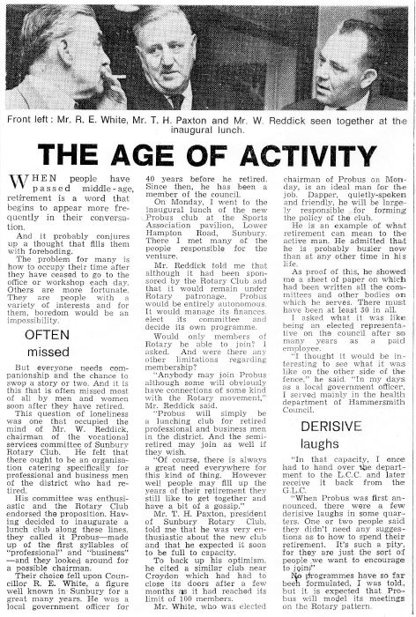
Figure 1: Foundations of Sunbury Probus Club (Local press report)
Increased membership justified a wider and more varied social programme. Committee structure was revised. In 1980, The Committee comprised of six members (4 Officers and 2 elected members). The proportion of elected committee members increased to 7 in 1990, 8 in 1994, 9 in 1995 and 10 in 2000. Committee Meetings were scheduled for the Tuesday evening preceding the luncheon held on the second Monday in each month.
The social programme
With a growing membership, the frequency and variety of social activities increased. These focused on:
Day outings
In 1983, 70 members and guests visited Beaulieu Abbey and Motor Museum. Visits to Arundel, Bletchley Park, Buckingham Palace, Chartwell, Leeds Castle, Lords Cricket Ground, Sandhurst Military Academy, The Thames Barrier and The Houses of Parliament soon followed.
Pub lunches
These became more regular and varied. In 1979 one member dared to bring his wife! This provoked a debate at the following luncheon meeting. The outcome: in 1980 4 pub lunches were arranged, 2 for men alone, and two with the ladies! Not until 1982 were wives and guests included as of right. Thereafter, and under the leadership of Doug Roberts, a member of CAMRA, pub lunches flourished. In February 1993, for instance, records confirm that 53 members and wives attended the pub lunch at the Bell Inn, East Molesey.
Theatre trips
A past Chairman, John Hawkins, lead the first theatre trip in 1988 to The Mikado at Richmond Theatre. In each of the next seven years John organised 2-3 theatre visits, including one to Chichester in August 1992. Theatre visits were very popular: in February 1995, a Probus party of 114 visited Woking to see The Constant Wife. John’s swansong, in 1995, was The Mikado at Woking. For these, and other services, John was made an Honorary Life Member (HLM) in 1996. The popularity of stage performances continues.
5-day holidays
Frank Barnes introduced 5-day holidays in 1993. The first, to Torquay, was enjoyed by 65 members and guests. The following year, Eifion Thomas arranged two holidays: the Isle of Wight and Rhine Valley. This formula was successful: thereafter, for several years, the Club offered one UK-based holiday and one to a destination in mainland Europe. Trips to Europe first by ferry and later the Channel Tunnel soon embraced air travel, first used in 2000 for the visit to Lake Garda.
Speakers
Since the early days of the Club, members have appreciated the talks by after-lunch speakers. Initially, club members were expected to speak for two minutes on a topic drawn from a hat! The first recorded member-speaker, in 1980, was Len Hargreaves who spoke on his visit as Mayor of Richmond (Surrey) to Richmond (Virginia). Since then presentations have been delivered on a variety of topics. No speakers were invited in the summer months to permit the twenty members of the Probus Bowls Club to practise their art. For the first time, in 1984, (paid) speakers were invited from outside the Club membership.
Sporting activities
Until 1989, Sunbury Probus Club regularly fielded quality bowls teams for competitions against the Probus Clubs from Staines and Walton-on-Thames. A success rate of 50% is recorded. In 1983, a young 79 year-old Ray Gaunt took charge of the bowls team and for the next five years the success rate improved to 100%! Ray remained an active Club member until his death aged 102 in 2016.
Throughout the 1980s and 1990s regular home and away golf matches were held against seven neighbouring Probus clubs. Records for 44 matches reveal a success rate of 50%. Several Probus members had already belonged to Ashford Manor Golf Club which hosted our home matches.
Ladies’ Night
Apart from a ‘Ladies Dinner’ held in 1971, the first ‘Annual Dinner’ was recorded in 1978. The following year, 60 members and guests attended the ‘Annual Dinner’. The number increased to 100 in 1983; subsequently, this total was exceeded on several occasions.
In 1991 the ‘Dinner’ was re-titled ‘Ladies Night’. Until 1999 it was held at the Sunbury Cricket Club. On account of its increasing popularity, and the restricted catering facilities at the Cricket Club, it was then relocated to Ashford Manor Golf Club through the agency of John Church, our Probus Chairman, and a playing member at Ashford. Records confirm that the 110 revellers enjoyed a most successful event. The formula for a successful Ladies’ Night developed at the Ashford Manor Golf Club and involving toasts, fine-dining, a raffle in support of the Chairman’s Charity Fund and dancing to live music has been carried forward to recent times.
In the 1980s the Mayor and Mayoress of Spelthorne were the distinguished guests. From 1991 Sunbury Rotary Club President and his lady presided; they reciprocated with an invitation to the Probus Chairman and his lady to attend the Rotary Presidential Evening.
Financial arrangements pre 2001
Subscriptions and balances
Sunbury Rotary Club donated the sum of £10 to start Sunbury Probus Club. Early members paid an annual subscription of £1.00; non-members of the Sports Association paid a further £1.00. In 1980 both subscriptions were raised to £2.00. The Sports Association then reduced its fee to £1.00 in 1985. Probus Club subscriptions increased steadily to £5.00 in 1989 and, after a two year period in which fees were waived, £7.00 in 1999.
Each year annual accounts were prepared, audited and approved. The Honorary Auditor 1972-1995 was Geoff Kaye. As levels of Club activity increased, so did the finances. On 31st January 1989 the Accumulated Fund stood at £198. This balance increased steadily to £811 in 1995, £2695 in 1997 (following the introduction of 5-day holidays) and £3019 in 2000 when it was agreed to donate £300 to the Sports Association for new chairs. That year, following the precedent set in 1990, it was agreed to allocate £242 to the Chairman’s Charity Fund. Members also agreed that the sum of £2000 was a reasonable balance to hold for contingencies.
In March 2001, £316 was transferred to the Chairman’s Charity Fund, raising the annual total to a record £1300.
Minor disbursements and ephemera
Since 1969 the Probus Club has laid a wreath at the Sunbury War Memorial. The cost of the first wreath is recorded as £1-9s-0d.
Moreover, since 1969 it has been expected that all members would purchase and wear a club tie. These are displayed for sale at monthly luncheon meetings. Doug Rimmer, Chairman in 1985, introduced the Probus lapel badge. Arthur Tyers, Chairman 1997, introduced the award of a tie and lapel badge to each ‘past Chairman’ at the end of his year in office. At present a badge is given to each new member at induction. Arthur also introduced the final ‘Toast to Probus’ at luncheons.
To celebrate the 25th Anniversary in 1994 and 30th Anniversary in 1999 each club member was given a bookmark.
Club rules
There were few Club Rules before 1979. The main requirement was that members should be aged over 60 and retired. In 1982 the Committee faced a high level of demand for membership. The prospect of forming a second club was mooted, but discounted. Applications for membership continued to grow. In 1991 it was agreed that the first 8 men on the waiting list should be categorised as ‘potential members’ and permitted, in rotation, to attend luncheons, but without voting powers. The number of potential members was increased to 10 in 1992. Participation was allowed in social outings, subject to preferential consideration for full members and the ladies of former members.
In 1993, a Green Rule Book was produced. Rules restricted membership to 60 men from electoral wards in Sunbury (Sunbury East, Sunbury West and Halliford and Sunbury Common); they also authorised a waiting list for membership. By 1998, in addition to ‘potential members’, there existed a waiting list of 16 names.
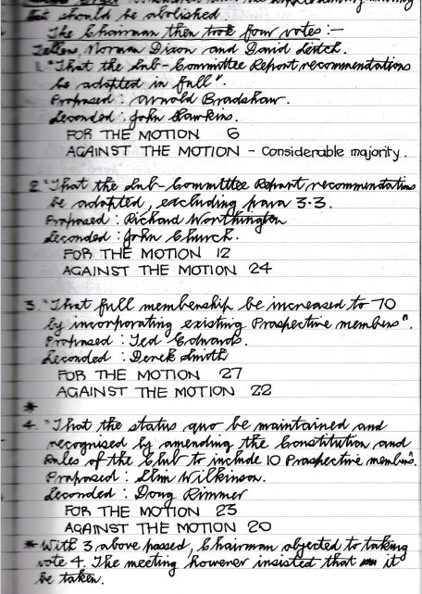
Figure 2: In the days before word-processing: an extract from the
Club Luncheon Minute Book, 17th August, 1998. (Note:
David Leitch, the teller with Norman Dixon, is the father
of David Leitch, our Chairman 2018-19)

2.2 Committee membership and business affairs (2001-19)
Committee membership: overview
The Club was well established by 2001. On 9th February 2009 a popular celebratory luncheon was held to mark the 40th Anniversary of Sunbury Probus Club.
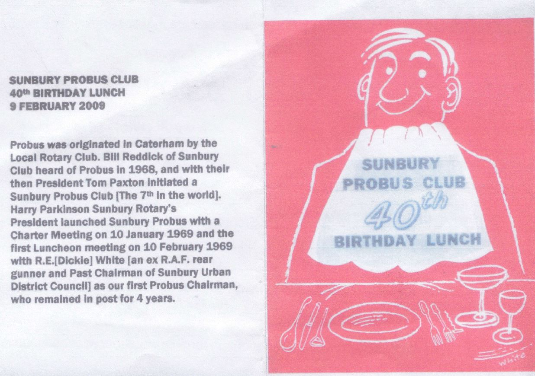
Figure 3: The 40th Anniversary Lunch
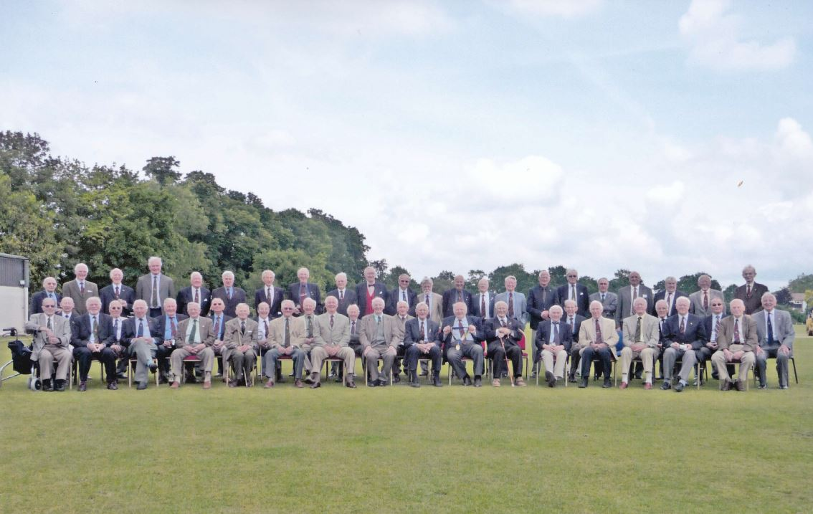
Figure 4: Probus members at the time of the 40thAnniversary Lunch 2009
A regular pattern of business meetings was scheduled in each month. Meetings had a clearly defined purpose and near-standardised agenda.
Table 1 lists the principal office holders 2001-2019. In accordance with the Club Constitution, the Chairman serves for one year; the Vice-chairman normally succeeds the Chairman. Terms of office for the Secretary and Treasurer are invariably of longer duration. Additional members of the committee (with co-options) and designated assistants fulfilled a variety of roles.
Table 1 Principal Officers appointed at the Annual General Meetings 2001-18
AGM Chairman Vice-Chairman Secretary Treasurer
2001 Norman Dixon Derek Smith Frank Brown Tony Stride
2002 Derek Smith George Powell Frank Brown Tony Stride
2003 George Powell Ray Knott Frank Brown Tony Stride
2004 Ray Knott Frank Brown Colin Kitt John Cavalla
2005 Frank Brown Don Shimmield Colin Kitt John Cavalla
2006 Don Shimmield Richard Gould Ken Pockett David Potkin
2007 Richard Gould Arthur Cryer Ken Pockett David Potkin
2008 Arthur Cryer Dick Nimmo Ken Pockett Gavin Stanley
2009 Dick Nimmo Mike Hesford Ken Pockett Gavin Stanley
2009* Mike Hesford Gavin Stanley Ken Pockett Gavin Stanley
2010 Gavin Stanley George March Mike Hesford Des Duffy
2011 George March Charles Watkins Mike Hesford Gavin Stanley
2012 Edwin Genet Harold Nicholson Mike Hesford Gavin Stanley
2013 Harold Nicholson Leo Pemberton Terry Duffy Gavin Stanley
2014 Leo Pemberton Les Messum Terry Duffy Gavin Stanley
2015 Les Messum Robert Gant Terry Duffy Gavin Stanley
2016 Robert Gant John Cavalla Martin Moore Gavin Stanley
2017 Mike Attias David Leitch Martin Moore Gavin Stanley
2018 David Leitch David Priddy Martin Moore Gavin Stanley
* During the year 2009, Mike Hesford became Acting Chairman (March) and then Chairman (July) due to the serious illness and subsequent death of Dick Nimmo.

Committee membership in 2002
There have been only minor changes since 2001 in designated Committee posts and the balance of representation. The Committee appointed at the AGM in 2002 comprised ten members with responsibilities as listed in Table 2.
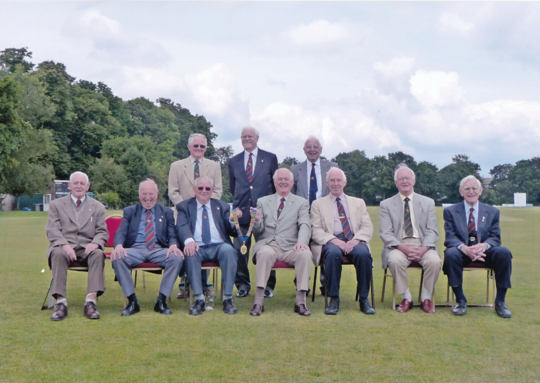
Figure 5: Sunbury Probus Club: Past Chairmen at a luncheon in the Spring 2009
(Standing, from left) Eifion Thomas Derek Smith Frank Barnes
(Seated, from left) Ray Knott Richard Worthington Don Shimmield Arnold Bradshaw Richard Gould Norman Dixon Arthur Cryer

Table 2 Sunbury Probus Club Committee 2002/03
Office holder Name Date inducted
Chairman Derek Smith July 1995
Vice-Chairman George Powell June 1997
Hon. Secretary Frank Brown October 1998
Immediate Past Chairman Norman Dixon April 1996
Hon. Treasurer Tony Stride October 2000
Theatre trips Stanley Wyles June 1999
Day Outings Don Shimmield July 1999
5-day holidays 2001/02 Arthur Cryer July 1996
5-day holidays 2003/04 Mike Morgans March 2001
Speakers Ron Forrester March 1993
In addition, Roy Brampton was appointed Honorary Auditor, James Johnston arranged Pub Lunches and Arnold Bradshaw, a past Chairman, represented the Club on the Sunbury Sports Association Committee.

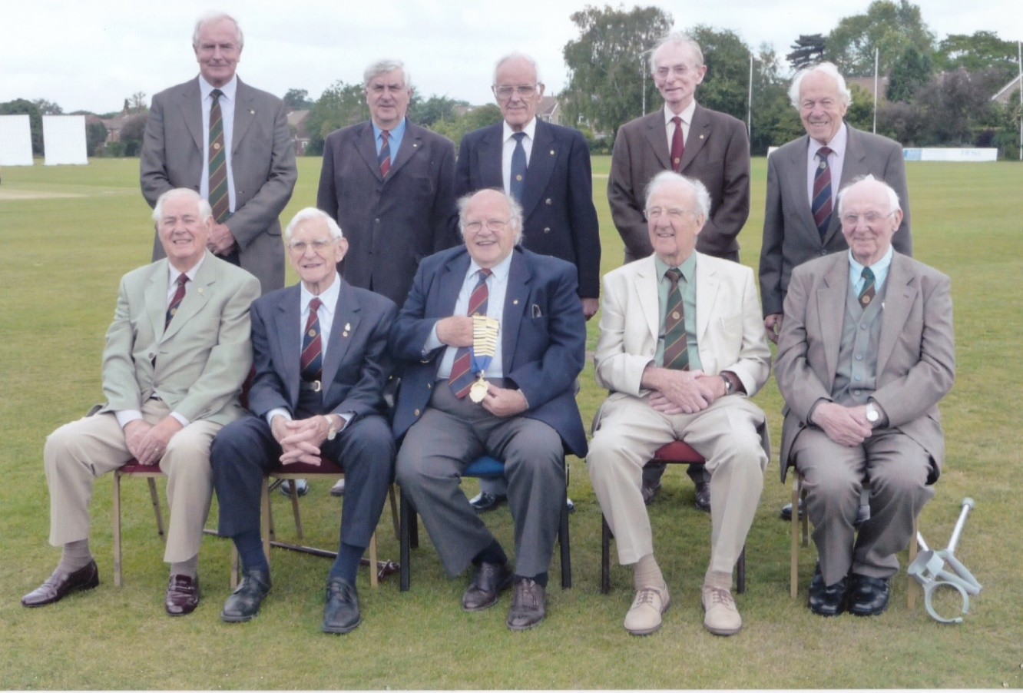
Figure 6: Sunbury Probus Club: Committee 2009-10
(Standing, from left) Robert Gant Gavin Stanley Mark Wilson Ken Pockett André D’Arbre
(Seated, from left) Arnold Bradshaw Arthur Cryer Mike Hesford Stan Ingall Brian Barlow
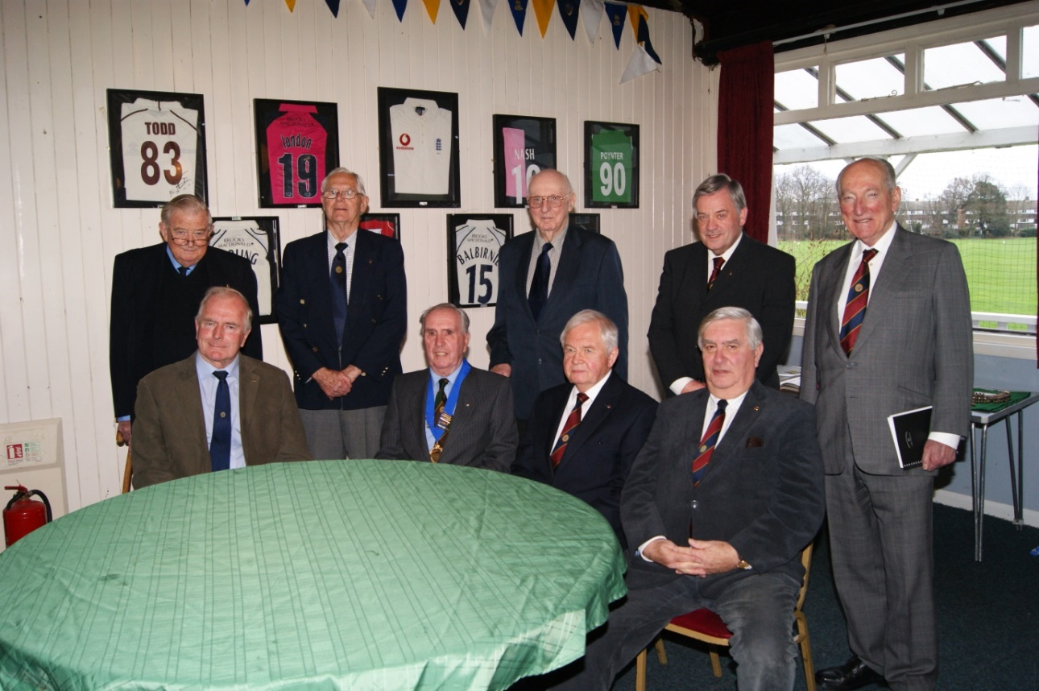
Figure 7: Sunbury Probus Club: Committee 2015-16
(Standing, from left) Don Shimmield Leo Pemberton Brian Barlow David Leitch John Lodge
(Seated, from left) Robert Gant Les Messum Terry Duffy Gavin Stanley
Committee membership and related posts 2018-2019
Table 3 shows Committee representation as approved at the AGM in 2018. The Committee post of Almoner (2015) and supporting role of Webmaster (2016) have been added.
Table 3 Officers and Committee Members 2018-19
A: The Committee: Officers and Representatives 2018-19
Post | Name | Date Inducted
Chairman | David Leitch | February 2012
Vice-chairman | David Priddy | August 2016
Past Chairman | Michael Attias | December 2009
Almoner | Leo Pemberton | January 2001
Secretary | Martin Moore | December 2013
Treasurer/meal bookings | Gavin Stanley | May 2005
Speakers | John Lodge | October 2010
Theatres (1) | Denis Scott | January 2011
Theatres (2) | Alan Worrell | June 2015
Day Trips | Terry Lawrence | October 2013
Pub Lunches | Tony L’Angellier | September 2015
Holidays/Ladies’ Night | Don Shimmield | July 1999

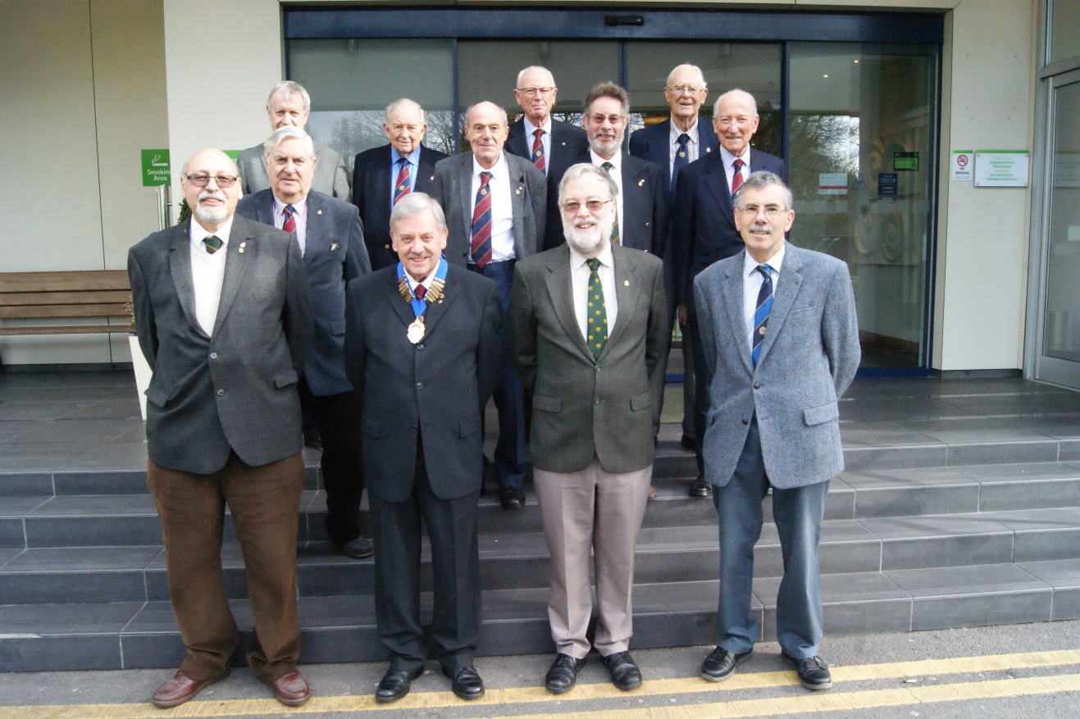
Figure 8: Sunbury Probus Club: Committee 2018-19 – The Golden Jubilee Year
(Back row, from left) Alan Worrell Don Shimmield Terry Lawrence Leo Pemberton
(Middle row, from left) Gavin Stanley Chris Mayell Tony L’Angellier John Lodge
(Front row, from left) Mike Attias David Leitch David Priddy Martin Moore
[Denis Scott was unavoidably absent when the photograph was taken]

A dedicated team of Supporting Office Holders and Assistants now supports the Club Committee. This team blends the skills of the experienced and newer members in delivering Club activities for the 50th Anniversary Year. It has to be acknowledged, however, that recruitment to ancillary roles has sometimes proved difficult.
B: Supporting Office Holders 2018-19
Photocopies | Frank Brown | October 1998
Photography/Publicity Officer | Gordon Hopkins | November 2012
Accounts Examiner | John Dowell | December 2015
Local traders’ list | Michael Attias | December 2009
Photo ID Board | Stan Ingall | January 2005
Regalia/ Ties | George March | September 2005
Webmaster | Richard Greaves | June 2013

C: Assistants to Office Holders 2018-19
Almoner | Tom Dowthwaite | September 2017
Day trips | Christopher Mayell | November 2016
Holiday/Ladies’ Night | John Mold | November 1998
Pub Lunches | John Dowell | December 2015
Secretary | Terry Duffy | October 2010
Speakers | Robert Gant | June 2007
Treasurer | Michael Wood | June 2011

Routine business meetings (since 2001)
The Monthly Committee Meeting
This evening meeting is held on the first Tuesday in each month. It is chaired by the Chairman (or, in absentia, the Vice-Chairman) and provides a forum for the Committee to plan activities and deal with routine administrative matters. Although the format of the Agenda has changed slightly since 2001, it normally includes:
- Apologies for absence
- Minutes of the previous meeting
- Matters Arising from the Minutes
- Almoner’s Report (since 2016)
- Secretary’s Report
- Treasurer’s Report
- Pub lunches – report and planning
- Theatre visits – report and planning
- 5-day holidays – report and planning
- Ladies’ Night – report and planning
- Day trips – report and planning
- Lunch speakers – report and planning
- Catering: monitoring of standards and monthly attendance
- A.O.B.
The Monthly Luncheon Meeting
The luncheon meeting is scheduled at 1.0 p.m. on the second Monday in each month. Until October 2017, lunches were held at the Sunbury Sports Association. Since then, and including a trial period, they have been re-located to the Holiday Inn, Shepperton.
Members usually arrive from mid-day. The Treasurer collects lunch fees (and annual subscriptions). Members then socialise with colleagues in the vicinity of the bar and, as appropriate, meet Event Organisers to discuss (and pay for) organised trips and other activities. Members collect two name cards: one to be placed on the lunch table; the other, for purposes of identification, is slotted into the top pocket of the member’s jacket.
At 1.0 p.m. the Chairman, wearing his chain of office, calls the meeting to order. The pre-circulated business agenda is then transacted, in stages, throughout the lunch. This typically includes:
- Chairman’s welcome to members, the speaker and guests
- Grace, normally by a Minister of Religion
- If apposite, delivery of a eulogy for a departed member, and a period of silence
- Acceptance (or otherwise) and Chairman’s signing of past Minutes, leading to Matters Arising
- As appropriate, the induction of new member(s)
- Chairman’s announcements on current administrative or organisational issues
- Almoner’s report – indisposition of any member, and welcome back to members who have recovered from illness
- Secretary’s report
- Treasurer’s report on financial position, including the Chairman’s Charity Fund collection at the previous month’s luncheon
- Short presentations by the organisers of theatre visits, day trips, Ladies’ Night, 5-day holidays, and speakers – relating to future plans and joining instructions for forthcoming events
- Any other business – sometimes including short statements by members on topical issues of concern to membership
- Toasts: The Loyal Toast to the Monarch and Toast to Probus
When appropriate, the seating is re-arranged to accommodate the wishes of the guest speaker. A member delivers a vote of thanks and a short account of the talk is added to the Luncheon Minutes.
For illustration, the Minutes for the Luncheon Meeting held on 11th May 2015 are included as Appendix B.
In the early days, as two extracts show, touches of humour often lightened the presentation of Minutes from the Luncheon Meetings.
Extracts from the Luncheon Minutes, 13th December, 2004
A.O.B.
“Edwin Brownett (delivering a thinly veiled sales pitch) reminded members that he had a stock of Probus ties. He recalled the days of yore when members not wearing a club tie were subjected to a small fine. The Chairman remarked that a committee member who should remain nameless (John Cavalla) was sporting a particularly fetching bow-tie. However, the question of a fine was not pursued – presumably because the procedure for the Treasurer to fine himself could raise insuperable constitutional problems. There being no further hilarity, the Chairman closed the meeting at 2.15 p.m.”
Report on the after-lunch speaker
“There followed a highly entertaining talk on ’80 Years of Scouting’ by the indefatigable Eddy Lea, resplendent in his uniform. He raised the biggest laugh telling the tale of how he had acquired a human skeleton whilst serving with the Royal Army Medical Corps, which for reasons best known to himself he kept under the bed. He got rid of it when his wife remarked one morning that: ‘That thing under the bed has got more life in it than you have!’” [A photograph of Eddy Lea is presented as Figure 28]
The Annual General Meeting
Since the foundation of Sunbury Probus Club in January 1969, the AGM has been held in March. Members present at the AGM sign an attendance sheet; and apologies for absence are recorded.
The format of the Agenda has remained largely unchanged. The first section comprises: Minutes of the preceding AGM; Matters Arising from the Minutes; Report by the Hon Treasurer (with matters arising therefrom) and a vote for adoption; Chairman’s Review of his year in office; and a separate report from the Honorary Secretary on keynote activities. Elections for the new Chairman (and his induction), officers and the new committee follow. Members are invited to raise issues under A.O.B. The Accounts Reviewer (auditor) is appointed.
As appropriate, resolutions submitted in advance by members and changes proposed to the Club Constitution and Rules are addressed.
Until 2001, the Minutes were entered in ledgers in an impressive copperplate script. Subsequently, these records were type-written. Soon the word-processor came to the aid of the Honorary Secretary: the distribution of essential papers to members gradually became less onerous thanks to email and the duty to read the Minutes aloud from the ledger had thankfully passed. [Note: An extract from the Lunch Minutes in August 1998 is included as Figure 2].
Minutes kept in the AGM archives, like those from luncheon and committee meetings, provide a rich seam of information on Club activities and summarise debates connected with the successful operation of the Club. An appreciation of past activities and administration can be drawn from the three sets of AGM Minutes, spaced at intervals across the period 2001-17, and included as Appendix C.
Reports by the Secretary, Treasurer and Chairman provide insights into aspects of continuity and change in the administration of Club affairs and issues addressed by the committee in managing the aspirations of membership. Full detail on the Club Constitution, membership and finances is given in Sections 2.3, 2.4 and 2.5.
The brief overview that follows for the Probus years 2001-19 identifies key themes addressed by Club officers.
Chairman’s Report
Recurring themes in the Chairman’s Report include:
- an expression of gratitude to all office holders and the ‘backroom boys’ who have ensured the smooth running of the Club. In 2017, for instance, the true ’Spirit of Probus’ was (tentatively) measured by the Chairman who reported that 40% of members had helped in some way with the delivery of club activities, from assisting at monthly lunch meetings to planning day trips, theatre visits; 5-day holidays, Ladies’ Night and pub lunches, and in recommending quality after-lunch speakers
- gentle warnings that long-term vacancies for designated organisers of core elements in the social programme would have implications for the vitality of Club life. Nominations to fill such positions (even on a shared basis) were invited. Such appeals extended equally to appointments as assistant organiser
- appeals to sustain and increase membership; as reported in Section 2.4, membership totals had declined since the early 2000s when a ‘waiting list’ and membership cap of 70 were imposed. Given the skewed age structure of membership, successive Chairmen have urged members to actively recruit friends, former colleagues and neighbours who met the criteria for membership. More recently, Chairmen have acknowledged the significant contribution made by the Probus Ladies to Club activities (see Section 2.7)
- Chairmen, on occasions, referred to changes to the Club Constitution and Rules (Section 2.3). Likewise, at intervals, changes to catering arrangements were reported and explained
Secretary’s Report
Successive Honorary Secretaries have recounted the annual pattern of events and landmark features in Club life. Typical presentations for the sample years 2002, 2010 and 2017 are included in Appendix C. In continuation of good practice noted before 2001, annual reports record:
- a schedule of formally-organised club activities (with dates) for the past year
- changes in annual membership totals, normally itemising the recruitment, death, relocation and resignation of named members
- sincere thanks to members responsible for different club activities, emphasising that without their unstinting commitment the vitality of the Club would be compromised
- increased levels of internet access that have enabled more effective contact with members for routine administration and messaging news items
Treasurer’s report
The format of the Treasurer’s Report has remained largely unchanged throughout the period 2001-19. It mirrors that set in earlier years in the Club’s history. The (audited) Annual Balance Sheet circulated to membership in advance of the AGM provides the basis for an open discussion. It includes a statement on donations from the Chairman’s Charity Fund. Where appropriate, the Treasurer introduces discussion around Committee-recommended changes in membership subscriptions and luncheon costs (Section 2.5).
Special General Meeting (SGM)
The Club Constitution makes provision for Special Meetings. These are rarely called and take place only when a major change is proposed in the running of the Club. The procedure at such a meeting is determined by the Chairman with guidance from the Committee. In the period March-May 2010 a new set of Club Rules was devised, although there is no trace in club records of ratification by a Special Meeting. At that time, however, both the Committee Minutes and Luncheon Minutes note the agreement of members to a reduction in the admissible age of joining from 60 to 55 years.
On 13th July 2015, a Special General Meeting was convened to discuss whether ladies should be admitted, formally, to Club membership. This proposal was resoundingly defeated by 33 votes to 8! At that meeting, a further two resolutions were passed: firstly, guests should not be present at an AGM or SGM; secondly, that the immediate past Chairman should act as Club Almoner for one year.
2.3 Club Constitution and Rules (status and review)
This summary of Club constitution and Rules is presented in two sections. Firstly, the Probus Club Rules in force from March 1999 to July 2015 (with amendments) are described; secondly, the revisions made to the Club Constitution and Rules in March 2015 (with later amendments) are introduced.
The definitive set of Rules (1999) and revised Constitution and supporting Rules (2015) are itemised, with amendments, in Appendix D.
Probus Club Rules in force from March 1999 to July 2015
In May 1999 a new (blue) Rule Book was issued to all members. Rule 12 was added in June 1999. The Rule Book provided guidance to the Committee in the conduct of Club affairs at a time of increased demand for membership. It declared the object of the Sunbury-on-Thames Probus Club to be: “The promotion of good fellowship among members”. It then set rules for classes of membership and prescribed the composition of the Committee and its pattern of meetings. Rules for subscription, accounting and auditing were set out. Alterations to Rules could only be made at an AGM or SGM called for that purpose. Regulations for maintaining a waiting list for membership were declared (see Appendix D).
At subsequent AGMs members approved the following changes to these Rules:
- At the AGM on 12th March 2007, three resolutions related to membership were approved:
- the Committee would consider on merit and accept at its discretion applications for membership from qualified men living outside the prescribed area of Spelthorne
- a member who fails to attend eight meetings in a membership year shall cease to be a member
- members will be required to join and continue in membership of the Sunbury Sports Association.
- At the AGM on 9th March 2009, the Treasurer, Gavin Stanley, proposed a change in the year-end from 31st January to 31st December to allow more time for the preparation and examination of the accounts. This was agreed.
- Given the decline in number of applicants and need to stimulate recruitment, at the AGM in March 2010 members agreed to make changes to Rule 4 and Rule 5.
- The qualifying age for admission in Rule 4 was reduced from 60 to 55.
- The qualifying residential area was totally removed from Rule 4.
- The restriction to two years of Committee service for non-members in Rule 6 was removed.
These changes were agreed unanimously at the luncheon meeting on 10th May 2010.
Revised Club Constitution and Rules introduced on 13th March 2015
In 2015 a further and full review was conducted of the Club’s Constitution. This addressed
the standard issues of committee composition, classes of membership, types of meeting,
subscriptions, accounting and auditing. Significantly, a separate set of detailed Rules was
introduced to manage the Constitution (see Appendix D).

In addition: the following changes were introduced:
- Inclusion of the date of the Club’s Charter Meeting in the Title.
- The club year was noted as 1st January to 31st December.
- A ruling that the retiring Chairman will act as Club Almoner during the year of his ex-officio Committee membership.
- A statement of the process for awarding an Honorary Life Membership was included in the Rules; hitherto, it had featured only as a Committee guideline
The Revised Constitution and Rules were approved at the AGM on 13th March 2015.
Amendments to the Club Constitution and Club Rules since March 2015
Towards the end of 2017, a succession of events indicated that the Probus Club was no longer welcome at the Sunbury Sports Association (SSA). This unfortunate situation ended an amicable relationship that had existed for 48 years. At the luncheon meeting held on 13th November, and following two trial meals at the Holiday Inn (Shepperton), 87% of members supported the Committee’s recommendation to re-locate the Club to the Holiday Inn with effect from 12th February, 2018 (the 49th anniversary of the first Club luncheon).
At the AGM on 13th March, 2018 members, therefore, agreed to:
- Remove all references to a past association with the SSA from the Club Constitution (Section 6) and Club Rules (Section 1d, Section 4a and Section 5).
- Revise the Constitution, Section 4, to read as: “The retiring Chairman will become an ex-officio member for one year and normally act as Almoner during that year”.
2.4 Membership trends
Until 2010, there were no vacancies for membership. A long waiting-list existed for applicants. Recruitment then faltered. Figure 9 shows a gradual decline from 76 (including 5 HLMs) in 2001 to just under 60 in 2019, including the complement of three HLMs. Unfortunately, the AGM Minutes in the period 2009-2011 do not disaggregate classes of membership; nor do they provide sufficient detail on resignations, deaths and members’ inductions to support a critical analysis of changes in membership. It is clear, however, that since 2010 HLMs have been included in the annual census at the March AGM.

Figure 9: Membership recorded at AGM
Since 2012 successive Club Committees, holding the approved target of 70 in mind, have urged members to encourage friends, former work colleagues and neighbours to join us for lunch, in congenial company. The objective is to introduce guests to the activities run by the Club, with a view to enrolment. In recent years, sustained recruitment has become an even more pressing issue given the growing proportion of senior members vulnerable to periods of illness and enforced absence from Club events.
In April 2016 the Chairman, Robert Gant, tabled at Committee a discussion paper entitled Steps towards a recruitment strategy for Sunbury Probus Club. This paper advocated direct measures to meet the challenge of building membership given the Club’s majority decision against women being admitted to Club membership. The text, and response, is quoted in full below to demonstrate the Committee’s resolve to address recruitment issues.
“Steps towards a recruitment strategy for Sunbury Probus Club”
Now that we have resolved the gender-related issue of eligibility for membership for our Club, it is timely to consider ways in which we can boost the number of active members. It is my guess(!) that through long-term illness, removal from the locality and death we shall lose more than ten members in the next year or so from our luncheon meetings. There are consequences, too, for the viability of related activities, including 5-day holidays, day trips, theatre visits and Ladies’ Night. It is clear that we need not only to replace these men, but to increase our total membership to secure the future vitality of our Club.
For discussion, in Committee, I propose three lines of action:
- Persuading existing members to seek out and invite neighbours, relatives, friends, former work colleagues and acquaintances as luncheon guests. Extending invitations to known individuals who would be likely to fit in with the ethos of the club would raise the probability of an acceptable application for membership. As an incentive (and where the probability of a subsequent application for membership is judged to be good) the lunch fee would be met by the club, and not the host, as at present. By seating lunch guests at the ‘round tables’, existing members could ‘work on’ them and demonstrate the congenial nature of our club.

- A short and targeted advertisement in the Community Matters section of ‘Sunbury Matters’. Something along the lines of:

‘The Probus Club of Sunbury on Thames for retired professional and businessmen meets for lunch, followed by a speaker, at the Sunbury Sports Association on the second Monday of each month. The club supports an attractive set of social activities for members and guests, including short holidays, day trips, theatre visits. We welcome new members. Please telephone 01932 788028’.
This approach, run across three issues of ‘Sunbury Matters’, is designed to raise awareness of the Club throughout Sunbury. Shepperton Probus Club already advertises in this way on a regular basis. Meanwhile, the current issue of The ‘Informer’ carries a more lengthy and illustrated appeal for members by the Staines-upon-Thames Probus Club!
- Advertisements in the wider regional press. I consider this ‘scatter-gun’ approach to be less attractive, initially, than either (i) or (ii).

My recommendation is that we proceed with (i) and (ii) above, subject to modification and approval by the Committee”.
The Committee accepted the Chairman’s recommendation. Subsequently, appeals were made at luncheon meetings for members to invite eligible guests to monthly luncheons, with a positive view to recruitment. Meanwhile, The Editor of Sunbury Matters agreed to carry the Club advertisement for three months (subsequently extended to 24 months!), with intermittent publication, thereafter).

Figure 10: Membership changes reported at AGMs 2001-19
Despite these initiatives, the problem of recruitment persists. Although the total membership hovers at around 60, for reasons of illness, frailty and caring responsibility for a partner, several members are unable to attend luncheon meetings on a regular basis. This proportion is likely to increase. Figure 10 focuses on changes in annual membership totals since 2010 reported at AGMs. In addition to short-term variations in annual recruitment and mortality, it highlights the number of members forced to resign for reasons of serious ill-health or on leaving Sunbury to live closer to supportive children and family members elsewhere in the UK.

2.5 Finance and related matters
Finance: overview of surpluses, balances and the Chairman’s Charity Fund
Balances and surpluses reported at AGMs
Until November 2018, when the Club removed its luncheon and Committee meetings from the Sunbury Sports Association (SSA) to the Holiday Inn at Shepperton, the main items of annual expenditure were: the caterer’s meal charge; the hire of premises; an affiliation charge to the SSA; fees paid to speakers (other than club members) and a courtesy lunch; sundry expenses such as printing and stationery; insurance; costs of badges for new members; and the ‘Past Chairman’s badges and ties. In addition, since 2016 prospective members invited as guests have not been charged for their introductory luncheon. In some years, too, a small subsidy has been allocated to the Ladies’ Night.
At the SSA, the caterer’s charge and fee for hiring the hall (10% of the caterer’s fee) were included in the cost of the luncheon. Additional costs were covered by an annual membership subscription supported by any net surpluses from Club activities. Throughout the period, pub lunches were self-financing. Until November 2018, Club members without SSA membership paid an additional £1.00 per annum to that organisation.

Figure 11: End-of-year financial surplus/deficit reported at AGMs 2001-2018
Figure 11 shows that with the exception of 2010 the end-of-year financial surpluses/deficits 2001-2018 reported at AGMs have remained relatively small. It should be noted, however, that until 2009 the accounting year ended on 31st January since when it changed to 31st December. At the time of writing, the surplus for 2018 had not been ratified by the AGM in March 2019.
Closing balances have ranged from £1,789 in 2009 to £4,867 in 2010. This variance can be explained by the necessary accumulation of large sums to be paid, well in advance, to theatres and coach companies in support of Club activities.
Trends in meal charges and membership subscriptions
Club membership fees and the cost of lunches are subject to periodic review and report at the AGM. The upward trend in lunch charges from £9.50 in 2001 to £19.00 in 2019 is shown on Figure 12. Relocation to the Holiday Inn, with the elimination of SSA charges, has allowed the cost of lunch to be held at £19.00 in 2018.
Membership subscriptions shown in Figure 13 have increased, stepwise, from £7.00 in 2001 to £25.00 in 2018. The reduction of £5.00 in 2011 followed the success of several social activities that delivered significant surpluses. The increase to £20.00 in 2013 resulted, in part, from non-recoverable losses on catering.

Figure 12: Luncheon cost 2001-18

Figure 13: Membership fee 2001-19

The Chairman’s Charity Fund
Since the year-end in 2002, Probus Chairmen have donated a total of £17,650 to 17 (mainly local) charities. Table 4 details the pattern of donations. Five charities (Princess Alice Hospice;
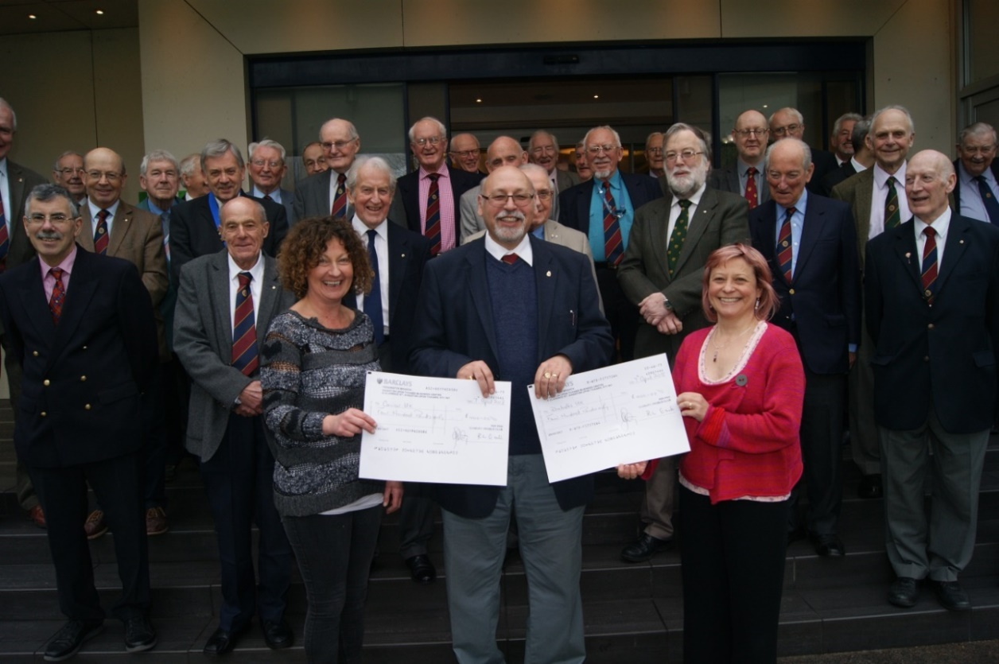
Figure 14: Chairman Mike Attias makes donations from the Chairman’s Charity
Fund to representatives from Diabetes UK and Cancer Research UK (2018)

The Shooting Star Chase; St Mary’s Church Sunbury; Macmillan Cancer Care; and Cancer UK) have benefited from in excess of £1000, in multiple donations.
Table 4 Donations from the Chairman’s Charity Fund
Year Chairman Charity Amount (£)
2002 Norman Dixon Princess Alice Hospice 425
Homestart Spelthorne 225
The Shooting Star Trust 650
2003 Derek Smith Princess Alice Hospice 650
Parkinson’s Disease Society 650
2004 George Powell Princess Alice Hospice 650
The British Heart Foundation 650
2005 Ray Knott Princess Alice Hospice 500
MacMillan Nursing 500
2006 Frank Brown Princess Alice Hospice 500
The Shooting Star Trust 500
2007 Don Shimmield Princess Alice Hospice 500
The Shooting Star Trust 500
2008 Richard Gould Princess Alice Hospice 500
The Shooting Star Trust 500
2009 Arthur Cryer St Mary’s Church Sunbury 333
The Shooting Star Trust 333
The Sunbury Embroidery Centre 334
2010 Dick Nimmo/ Macmillan Nursing 250
Mike Hesford Riverside Arts Centre 250
Crossroads 250
2011 Gavin Stanley St Mary’s Church 375
Princess Alice Hospice 375
2012 George March St Mary’s Church Sunbury 555
Surrey Air Ambulance Service 555
2013 Edwin Genet Sam Beare Hospice for Children 600
St Mary’s Church Sunbury 234
2014 Harold Nicholson St Nicholas Church Shepperton 421
Princess Alice Hospice 420
2015 Leo Pemberton St Mary’s Endowment Fund 274
Multiple Sclerosis Society 274
Crossroads 274
2016 Les Messum Meningitis Society 400
Princess Alice Hospice 400
2017 Robert Gant MacMillan Cancer Support 400
The Shooting Star Chase 400
2018 Mike Attias Diabetes UK 400
Cancer Research UK 400
2019 David Leitch Cancer Research UK 500
Willen Hospice (Milton Keynes) 500

Figure 15: Donations from the Chairman’s Charity Fund 2002-2019
Three significant features underlie the pattern of donations which in most years have been ‘topped-up’ by a modest transfer of funding from the general account. Firstly, as Figure 15 shows, the annual sum donated has gradually declined (reflecting falling membership) from £1300 in January 2002 to £800 in each year, 2016-18. The increased donation of £1,000 in 2019 commemorates the 50th Anniversary of the Club. Secondly, Chairmen have invariably chosen to divide the benefits from charitable giving. In each of three years, for instance, three local charities have been nominated for shares of the charitable fund. Thirdly, local hospices which feature regularly in the list of supported charities received 46% of total donations. In return, ambassadors from these worthy organisations have featured in the speakers’ programme.

2.6 Honorary Life Membership (HLM)
Since 1969 Sunbury Probus Club has awarded Honorary Life Membership to 18 (9 since 2001) distinguished members who have made a significant and sustained contribution to the life of the Club. The processes of selection and award are outlined below.
At present, the Club Constitution (Item 3) states:
“A member who has rendered outstanding service to the Club may be elected an Honorary Life Member on the recommendation of the Committee in accordance with the procedure set out in the Club Rules”.
Club Rule 2 explains the process of award:
“(a) This award is a very great honour and should only be given to a member who has rendered sustained and outstanding service to the club over a good number of years. The maximum number of HLMs is four.
(b) Nominations for HLM, with the agreement of the member nominated, should be made in writing by at least two members and submitted to the Chairman, who will refer it, for decision, to a meeting of three past Chairmen.
(c) If the nomination is not agreed by the sub-committee, the Chairman will notify the nominators accordingly. If the nomination is agreed, the sub-committee should present their nomination to the full committee. If the sub-committee’s recommendation is agreed, the membership should be informed and the honour bestowed at the next most convenient meeting”.
Table 5 Honorary Life Members 2001-2019
11th March 2002 Doug Rimmer
13th February 2006 Fred Clark
11th May 2009 Richard Worthington
14th March 2011 Arnold Bradshaw
14th March 2011 Frank Barnes
11th March 2013 Ray Gaunt
28th March 2014 Don Shimmield
12th September 2016 Mike Hesford
12th September 2016 Norman Dixon

Since 2001 the nine members identified in Table 5 have been awarded the status of HLM for outstanding service to the Club.
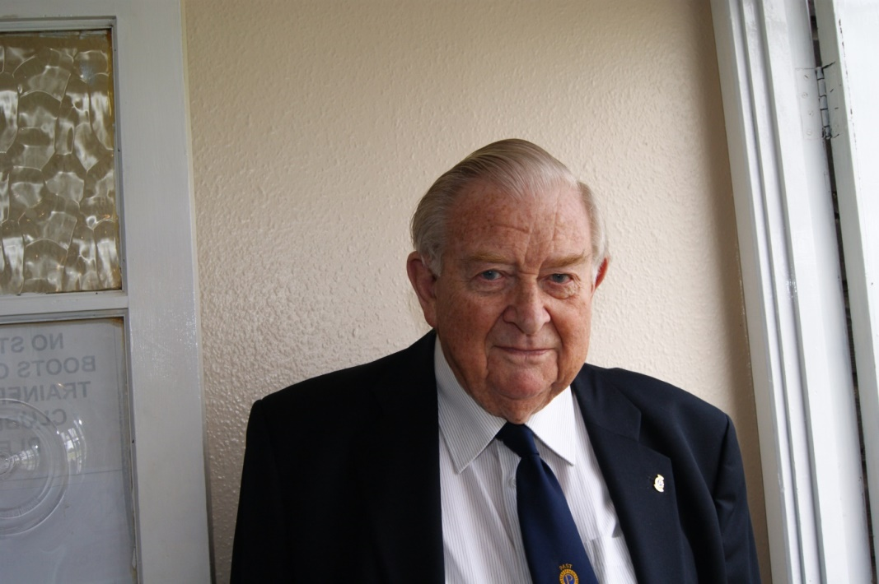
Figure 16: Don Shimmield HLM
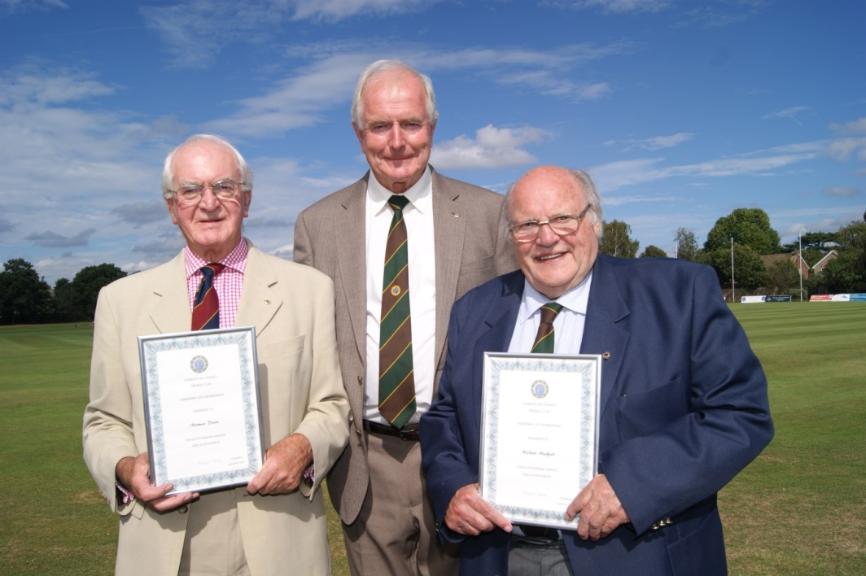
Figure 17: Norman Dixon HLM (left) and Mike Hesford HLM (right)
with Chairman Robert Gant

2.7 The Probus Ladies’ Group
With the exception of the monthly luncheon meetings, the wives, partners and close female friends of members are invited to take part in several Club activities. They are welcomed to join the menfolk for theatre visits, day trips, pub lunches, 5-day holidays and, of course, Ladies’ Night. In recent years, the invitation to attend special-interest after-lunch talks has proved a popular option.
In January 2018, the separate contact list of 25 wives/partners of deceased members was updated. These Probus Ladies are well-networked for the exchange of information. Many are personal friends and belong to a ladies luncheon club (not related to Probus, but sadly disbanded in April 2018). Event organisers use this network to promote activities and secure prompt payment for tickets. In recent years, the economic viability of theatre visits, day trips and 5-day holidays has become more dependent on support from the Probus Ladies. This trend is set to increase as a consequence of the advanced average age (and increasing immobility) of male members. In fact, in the Probus year 2017-18 Probus Ladies accounted for 23% of those attending pub lunches, 28% of participants in theatre visits, and 39% of the party enjoying the 5-day holiday at Chepstow.
In return for their support, the Probus Ladies benefit from the services of experienced events’ organisers, comfortable and safe coach travel, and the company of courteous gentlemen! Without Probus, many ladies would find it difficult to secure night-time access to top-of-the-range theatre and concert performances in the West End (and elsewhere) and engage in Summer-time visits to heritage sites and historic cities in the South East or farther afield as part of a 5-day holiday programme.
2.8 Sunbury Probus Club in print
Significant events in the life of our Club and the achievements of distinguished members have been reported in The Probus Magazine and local community publications. Recent reports (with authors) include:
S. Ingall: ‘Parallel lives revealed as members recount experiences’. Probus Magazine, Autumn 2010.

J. Cairns: ‘My Memory of Lt Alexander Purdon Donald’. St Mary’s Sunbury Parish Paper, December 2013.

M. Chard: ‘100 Years and Counting’. Sunbury Matters, June 2014.

Mike Hesford/Terry Duffy: ‘Ray’s centenary celebrated’. Probus Magazine, Winter 2014.

M. Chard: ‘Légion d’Honneur for Sunbury Man’. Sunbury Matters, November 2015. [see Figure 18]

T. Duffy: ‘A Salute to John Church’. Probus Magazine, Autumn 2015. [see Figure 19]

M. Moore: ‘Charity bowl raises funds’. Probus Magazine, Autumn 2018. [see Figure 14]

M. Chard: ‘Probus Sunbury Celebrates 50 Years’. Sunbury Matters’, March 2019.

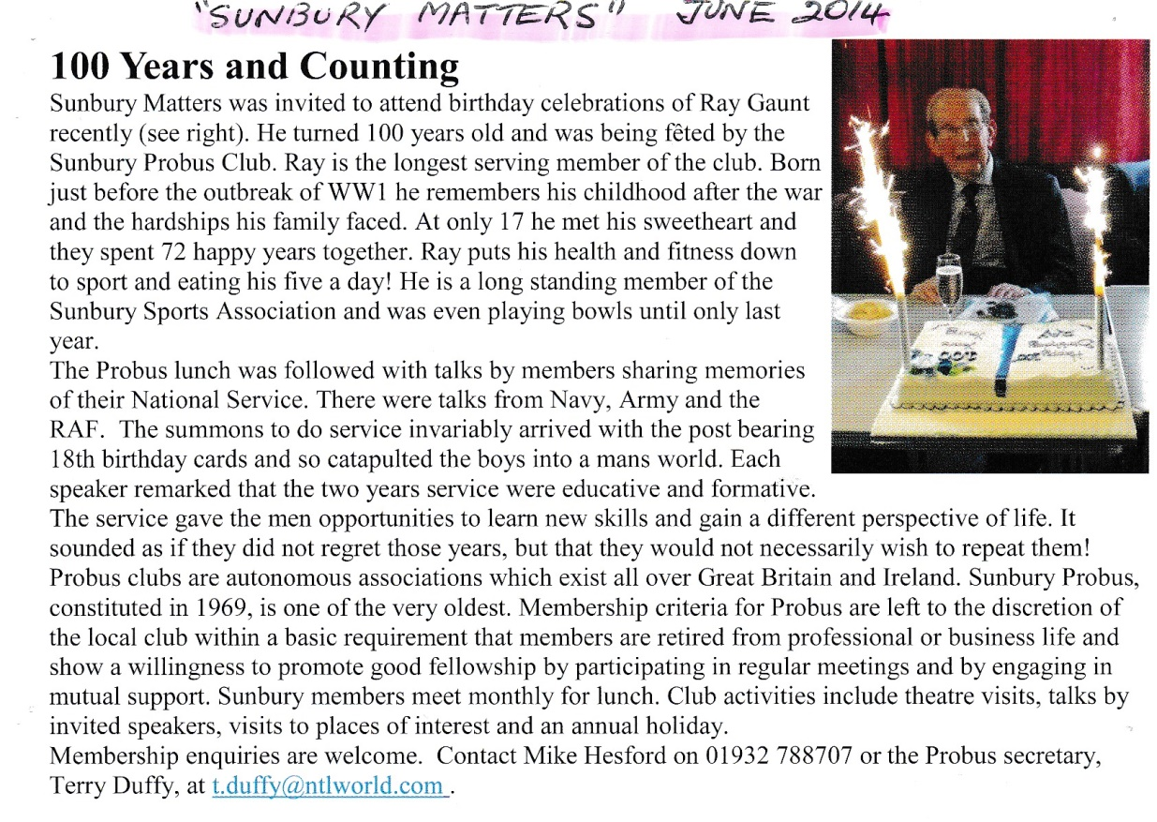
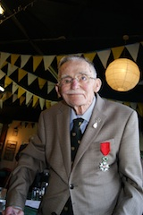
Figure 18: John Cairns, Chevallier de la Légion d’Honneur
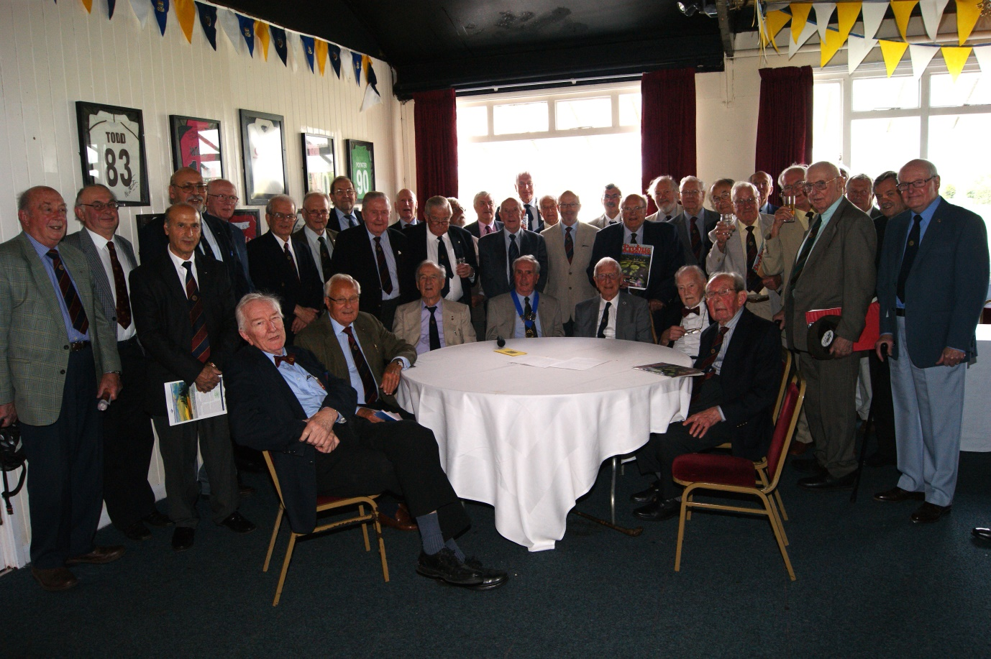

Figure 19: Probus members pay tribute to ex-Chairman John Church who provided funds in his will for members to drink to his farewell!

