3.0 PROGRAMME OF SOCIAL EVENTS
3.1 Day trips (2001-19)
Characteristics
Day trip organisers have combined local excursions with more ambitious visits to venues throughout the South East of England. Trips have taken place at different times in the year and have included visits to prestigious University towns, cathedral cities, stately homes, museums and heritage sites. Day visits typically include more than one venue or site of cultural interest. Guided on-site tours are invariably combined with opportunities for members to “do their own thing(s)”.
The menu of day trips since 2001 has several key features, including:
- A variety of destinations selected by the organiser(s) and recommended by members
- Sites that focus on British cultural heritage and urban history
- Venues of industrial and maritime significance throughout South East England
- Shorter (half-day) visits negotiated with lunch-time speakers (e.g. Eton College; Kempton Park Pumping Station; Brooklands Motor Museum)
- Participation by Probus Ladies and guests to reduce the unit costs of coach hire
Since 2010, responsibility for the design and delivery of day trips has been shared by two organisers. Partnership working has enabled the development of an ambitious programme that is much appreciated by members. This model of sharing the responsibilities for administration has been adopted for theatre visits.
Listing of trips
Probus Year Location Organiser
2001-2002
28 June Wintershall (Bramley, Surrey) Norman Dixon
8 August Sandhurst Don Shimmield
1 November Cambridge Don Shimmield
2002-2003
15 May Longleat Don Shimmield
10 July Garden Party: St David’s School, Ashford Derek Smith
13 November Bath Don Shimmield

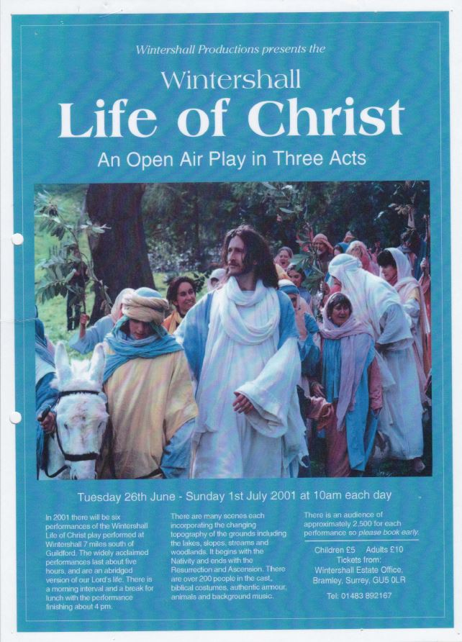
Figure 20: Programme for the performance ‘Life of Christ ‘at Wintershall (June 2001)

2003-2004
26 March Beaulieu Don Shimmield
6 July New Forest and Hampshire County Fair Don Shimmield
29 October Greenwich Don Shimmield

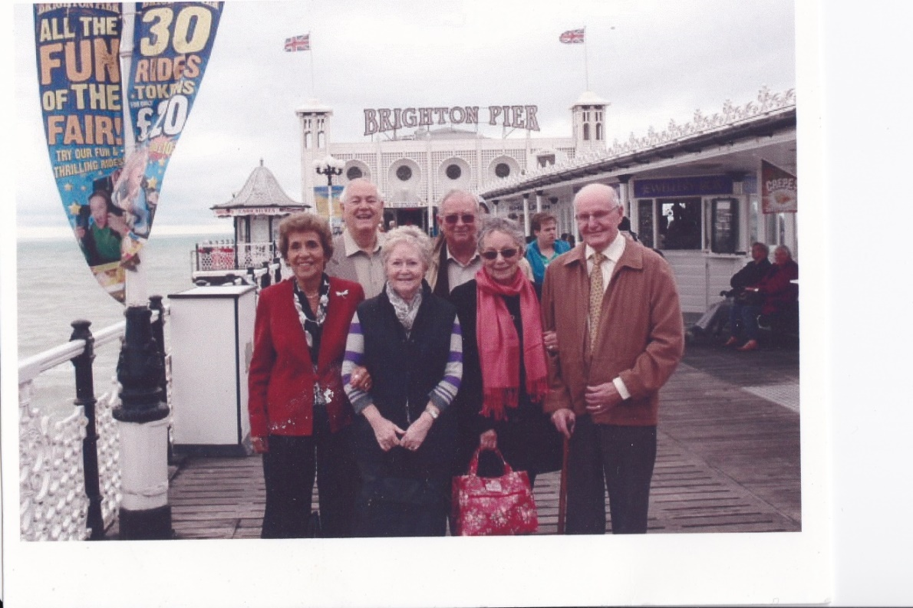
Figure 21: Brighton Day Trip (August 2005)
(Back, from left) Arnold Bradshaw Don Shimmield
(Front, from left) Vera Bradshaw Barbara Ranger Audrey Shimmield Frank Brown

2004-2005
26 May Chichester Don Shimmield
14 October Sussex tour Don Shimmield
2005-2006
26 May Legal London Don Shimmield
11 August Brighton Richard Gould
6 October Arundel Ken Pockett

2006-2007
9 May London Docklands Ken Pockett
18 October Portsmouth Pat Smith
2007-2008
27 March House of Commons/Cabinet War Rooms Mark Wilson
20 May Kempton Park Pumping Station Mark Wilson
30 May Wellington Barracks: Under the Bearskin Pat Smith
2008-2009
15 July Rochester/Chatham Mark Wilson
27 August Tutankhamen Exhibition (02 Arena) Mike Hesford
2009-2010
None
2010-2011
18 May Fishbourne/Chichester Mark Wilson
15 September Canterbury Mike Attias
12 January Olympic Park Stratford Mark Wilson
2011-2012
18 May Salisbury Mike Attias
21 September Brighton Mike Attias
7 December Winchester Xmas Fayre Mike Attias
2012-2013
13 June Oxford Mike Attias
28 November Bournemouth Xmas Market Mike Attias
20 February Brooklands Motor Museum Mike Attias
2013-2014
15 May Cambridge Mike Attias
17 September Bletchley Park Mike Attias
20 November Eton College Mike Attias
2014-2015
16 November Hampton Waterworks and Steam Museum Brian Barlow
2015-2016
3 June Waddesdon Manor Brian Barlow
2016-2017
18 March Beaulieu Motor Museum Brian Barlow
19 September Stratford upon Avon Terry Lawrence

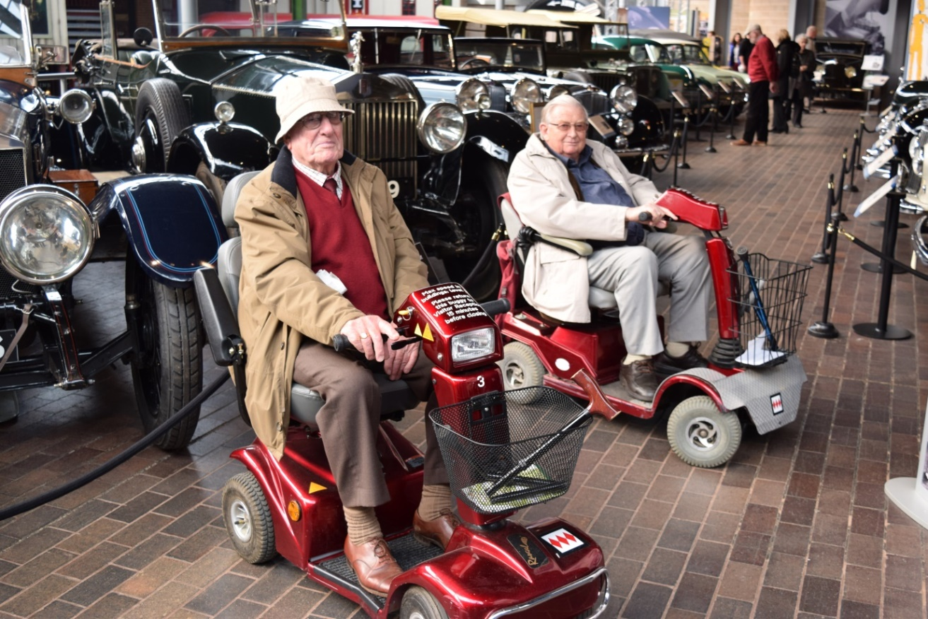
Figure 22: In pole position? Edwin Genet (left) and Don Shimmield (right) at Beaulieu
Motor Museum (March 2016)

2017-2018
15 June Parham House Terry Lawrence

2018-2019
14 June Mottisfont and Sir Harold Hillier Gardens Terry Lawrence
Sample costings
Costings for a representative sample of three one-day excursions are presented below.
13th November 2002 Longleat £20.00 (excl. lunch)
18th May 2011 Salisbury Cathedral £20.00 (excl. lunch)
15th June 2017 Parham House and Bignor £49.00 (incl. lunch)
Representative Visit
Visit to the Tutankhamen Exhibition at the O2 Arena, 27th August 2008
A total of 48 members, relatives and friends boarded the Sureline coach at Sunbury Cricket Club at 8.30 a.m. to visit the Tutankhamen Exhibition at the O2 Arena and afterwards a City Cruises lunch from the O2 Pier to Westminster.
On a surprisingly traffic-free journey, we arrived at our destination at 10 a.m. in plenty of time to check-in and receive our audio equipment for our 10.30 Exhibition slot which was expected to take 90 minutes.
The Exhibition featured over 130 ancient Egyptian treasures coming from the tomb of the young king Tutankhamen, but also from other kings’ burial sites. It used innovative design and technology to demonstrate the life and times of the young king during his short reign and how it changed history. There were more than 70 objects from royal tombs dating from the 18th Dynasty (1555 BC – 1205 BC) which included two Pharaohs who reigned before Tutankhamen. It featured 50 major objects excavated from the Tutankhamen Tomb. They included the Royal Diadem, the gold crown encircling the head of the mummified body. We also saw the gold and precious stone inlaid canopied coffins that contained the King’s organs.
There were computer-generated images and constructions together with film footage of the golden age of the Pharaohs, all contained in 12 Exhibition Rooms featuring:
- An introductory film 7. Tutankhamen – King of Egypt
- Ancient Egypt before Tutankhamen 8. Causing his name to live
- Traditional beliefs 9. The science of Tutankhamen
- Death, burial and the after-life 10. The Tomb
- Religious revolution 11. Howard Carter Gallery
- The Boy King 12. Daily life in Tutankhamen’s world
The burial site was discovered by Howard Carter during his Egyptian tour in 1922. Many of the exhibits were brought to London in the 1970s and some of our members saw them then. One of our members was fortunate to have seen the burial site during his army service in 1946.
This is the last time the relics (so I’m told) will be allowed to leave Egypt and the Exhibition which opened in July 2007 closed 3 days after our visit. I felt that we were privileged to have been among the last few to see this wonderful show before it returned to its rightful home, particularly since it was set in the most controversial venue in London.
I received several very appreciative comments from our members who were, as I was myself, very impressed by the wonderful workmanship, the amazing quality and the way the antiquities had survived over the last three and a half thousand years incarcerated in the tomb.
The second half of the trip was a bit of a disaster. The Pier Master informed me, on enquiry, that no boat had been arranged to take us back to Westminster, nor had a meal been arranged, although printed schedules had been issued. After rapid consultation with senior members, it was decided to have lunch at the Dome and then take the river bus to Waterloo where our coach would meet us for the return to Sunbury.
Everyone had a satisfactory meal of their choice, and our ride on the water was quite exceptional by seeing London from the river. We arrived at Waterloo at just after 4p.m., leaving at 4.30p.m. for home. After a traffic-free journey we reached Sunbury at 5.30 p.m. Mike Hesford thanked Sureline driver, Steve, for his help in re-locating at short notice, presenting him with a token of the Club’s appreciation. The Chairman thanked Mike, on behalf of the party, for dealing with the difficulties. This, the fifth Probus outing in 2008, was a success. A rebate to members will be paid shortly.
[Report prepared by Mike Hesford]

3.2 5-day holidays (2001-19)
Characteristics
Throughout the period, 5-day holidays have given members (and wives/partners/guests) an opportunity to visit different environments in the congenial company of Probus colleagues. Typically, two holidays have been organised each year. Venues have been selected either in different parts of the UK within a reasonable journey time by coach from Sunbury or in mainland Europe with travel by luxury coach, ferry or a flight from nearby airports. In September 2012 a Greek Islands cruise featured in the programme. The holiday listing confirms that since 2001 several Probus members have taken responsibility for background organisation and on-site leadership.

Highlights of the holiday programme since 2001 include:
- A balance between UK and mainland-Europe destinations
- The skills of organisers in liaising with service providers to secure high-quality hotel accommodation and a balanced programme of activities suited to the interests of party members
- The ingenuity and resourcefulness of organisers in dealing with unexpected on-site issues (e.g the local impacts of the Foot and Mouth epidemic in Bowness, 2002; adverse traffic conditions at points in several holiday itineraries; and the health circumstances of a participant)
- The value that Probus Ladies have attached to the holiday programme; in latter years their support has been crucial to the viability of several trips
- Successful outcomes to the challenges connected with the choice and planning of future holidays. However, due to small numbers of prospective participants, some proposed trips have been aborted despite the appreciable effort of organisers in planning and negotiating with providers. Increasingly, too, health issues have constrained participation by some (erstwhile) supportive members
Listing of holidays
Probus year Location Organiser
2001-2002
7-11 May Bowness Ray Knott
3-7 September Loire Valley Ray Knott
2002-2003
29 April-3 May Norwich Arthur Cryer
23-27 September Cork, Ireland Arthur Cryer
2003-2004
25-30 April Loch Long (Scotland) Mike Morgans
15-19 September Champagne (France) Mike Morgans
2004-2005
30 March-3 April Newcastle Pat Smith
20-25 September Liege Pat Smith
2005-2006
18-23 April Jersey Ray Knott
22-26 September Spoleto (Umbria) John Mold
24-28 September Falmouth Ray Knott
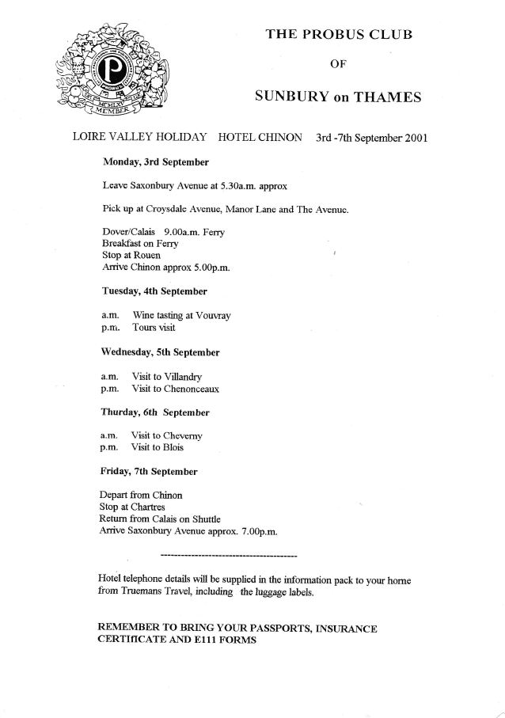
Figure 23: The Loire Valley 2001: tour programme
2006-2007
24-28 April Nottingham George Powell
25-29 September Berlin Derek Smith
2007-2008
23-27 April Isle of White Don Shimmield
2008-2009
21-25 April Harrogate Derek Smith
2009-2010
21-25 September Bath/Bristol Charles Watkins
2010-2011
21-26 April Northumberland Charles Watkins

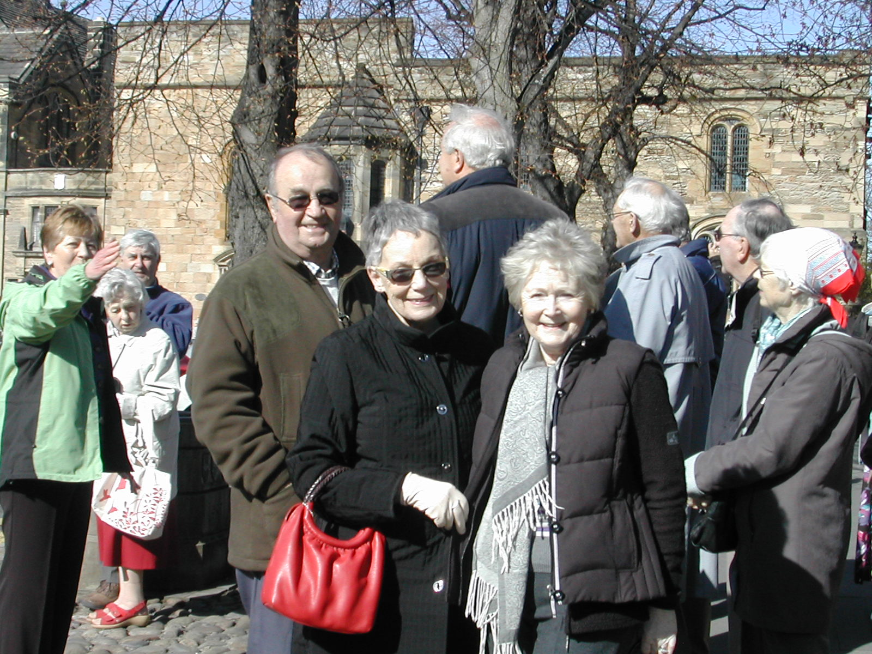
Figure 24: Northumberland 2011: our guide at Durham Cathedral
2011-2012
17-21 April Isle of Man Charles Watkins
2012-2013
22-29 September Greek Islands Cruise Don Shimmield
2013-2014
23--27 September Normandy Don Shimmield
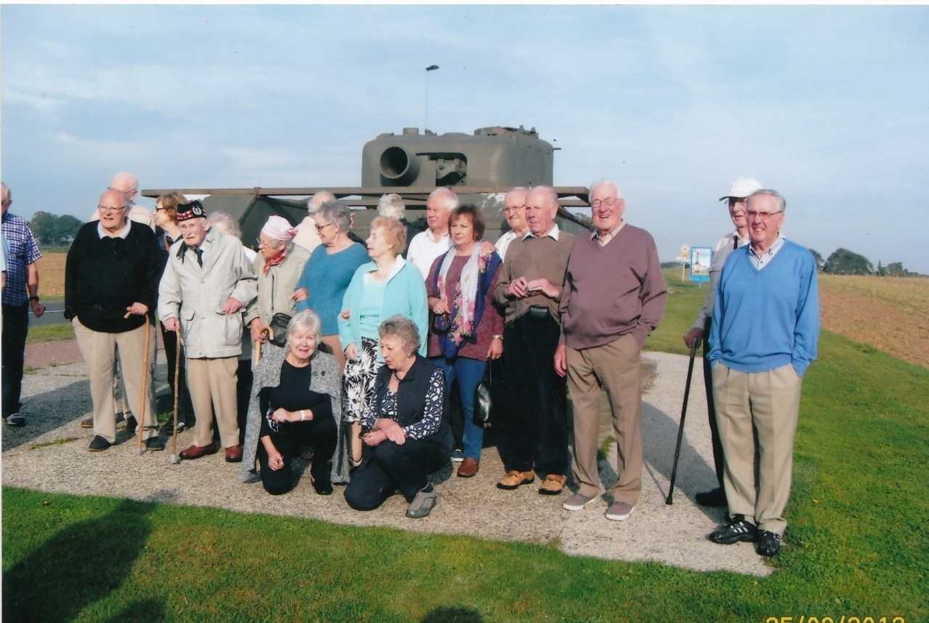
Figure 25: Normandy 2013: ready for action
2014-2015
19-23 May Chester John Mold
2015-2016
27 April-1 May South Devon Don Shimmield
2016-2017
25-29 April Esposende, Portugal Don Shimmield
27-31 October Liverpool John Mold
2017-2018
15-19 October Chepstow Don Shimmield

2018-2019
24-28 September Lytham St Annes Don Shimmield
Representative holiday
The Greek Isles from Venice, 22-29 September, 2012
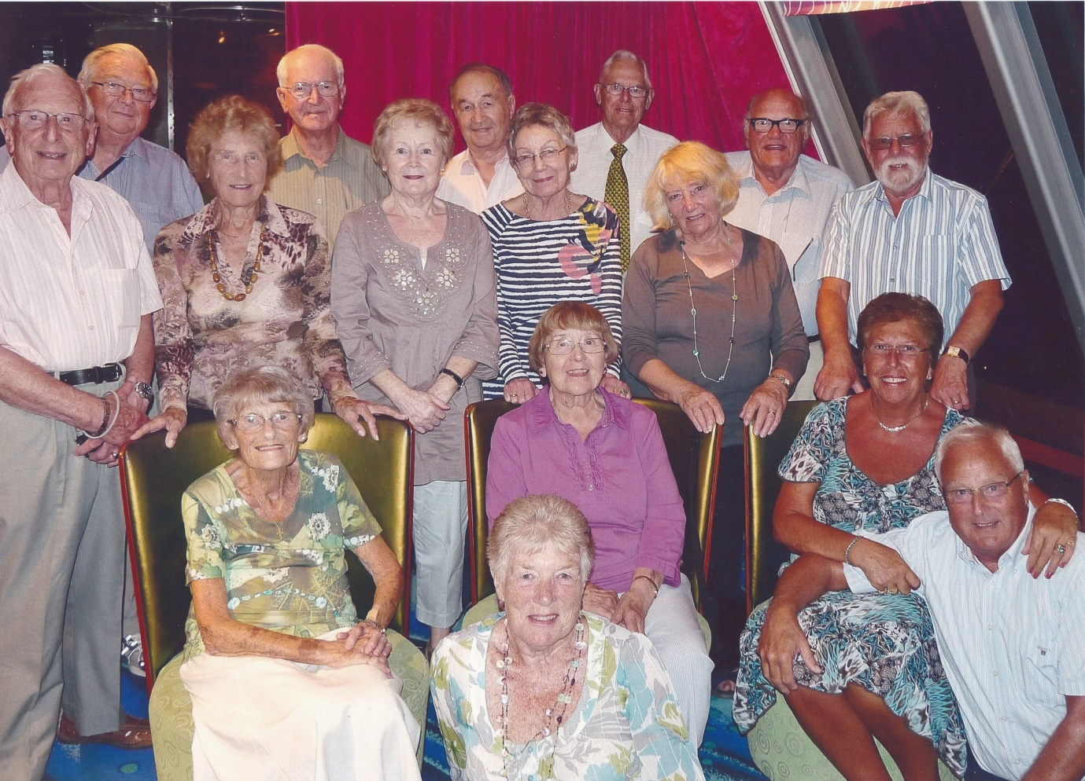
Figure 26: On-board the Norwegian Jade
An email from Don Shimmield, the Probus organiser, to Tailored Travel on return to the UK expresses the concern of the group with travel arrangements and highlights features of life on-board the cruise liner Norwegian Jade.
“Dear Sandy
As promised, I now have a little time to send you a few comments regarding the Sunbury Probus Greek holiday.
Transportation:
The pick-up at Lower Sunbury went like clockwork. We left at 0430 and only required one other pick-up at St Ignatius Church at 0440. We were at Gatwick at 0530. Pity BA spoilt things with the plane being an hour late in taking off.
Katia was waiting for us and coached us to Venice and efficiently dealt with the embarkation procedures.
On the return, Sylvia met us and transferred us by boat to Venice to meet up with our guide Susanna. A most informative and amusing tour followed. Before transferring by boat/coach to Verona. BA spoilt things again with the flight taking off 1.5 hours late.
At Gatwick, the luggage arrival in the baggage hall was delayed another half hour. The instructions for picking up the coach were inapplicable as there were no coach marshalls around, but after several phone chats to the driver he was eventually located and drove us back to Sunbury by midnight.
Overall, the travel organisation and Banstead coaches were excellent.
Norwegian Jade:
Initial reactions on embarking were mixed, but after a few days a routine was generally adopted. There was a feeling that the boat was charging excessively. With probably 2000 passengers on board the free restaurants were pretty full. Where a cover charge was made we felt that the food did not warrant it. Wine was very expensive and even at the free eating places a charge was made for tea or coffee after the meal. A single photograph was costing just under £20 which meant that there were not many takers. The itinerary was good but often clashed with large ships from other cruise lines. The trips were often dear and it was often better to arrange something once off the boat (this is the case with most cruise ships).
One good thing about the Jade was a really good resident band that put on excellent traditional jazz and swing music concerts. On two evenings a group of four male singers called the 4Ever Group brought the house down.
On arrival in my cabin was a letter from Jade’s Group Services Coordinator, Lucille Seno, and an invite to the cocktail party for our group. This went down very well and phone contact with Lucille at a later date proved beneficial. This came about when following your instructions re. disembarkation. The Pursers Office did not wish to know about the early disembarkation arrangements. Lucille saw to it that we were one of the first groups off.
Finally, you can rest assured that our group had a very good time, but in hindsight would probably have favoured a smaller vessel.
I trust that these comments will be of some use. Our thanks to Tailored Travel, especially to yourself, for all the organising etc.
Very best wishes
Don”

3.3 Theatre visits (2001-19)
Characteristics
Theatre and concert visits are popular events in the social calendar. The number of visits has varied from two to four each year. These have included a variety of performances: ever-popular pantomimes; light-hearted musicals; classical concerts; and stage productions. Venues have ranged from theatres in the West End to those located conveniently at Windsor, Woking, Guildford and Richmond. In recent years members have attended several Christmas concerts and orchestral performances at The Royal Albert Hall.
Key features in the programme have included:
- Popular matinee performances which organisers have (often) linked with a first class meal in a nearby restaurant
- Quick responses by organisers who secure early-bookings and group ticketing concessions to minimise total costs; and sufficient Probus funds ready to underwrite advanced booking arrangements
- Ever-present support from the Probus Ladies who subsidise the per capita cost of coach-hire and enable block-booking of tickets at favourable prices
- In recent years, the appointment of joint-organisers has delivered, through partnership working, a high quality series of theatre visits and concert performances
Listing of visits
Probus Year Venue Performance Organiser
2001-2002
20 June Woking Phantom of the Opera Stanley Wyles
23 October Hippodrome Friday Night is Music Night Stanley Wyles
10 January Woking Pantomime - Aladdin Stanley Wyles
13 February Drury Lane My Fair Lady Stanley Wyles
2002-2003
3 July Woking Whistle down the Wind Stanley Wyles
18 October Woking Chicago Stanley Wyles
2 November Magna Carta Pirates of Penzance Stanley Wyles
15 January Woking Pantomime - Cinderella Stanley Wyles

2003-2004
2 April Woking The Chalk Garden Stanley Wyles
11 September Woking My One and Only Stanley Wyles
24 October Festival Hall RAF Memorial Concert Stanley Wyles
15 January Woking Pantomime - Peter Pan Stanley Wyles
2004-2005
24 March Drury Lane Anything Goes Stanley Wyles
8 September Palladium Chitty, Chitty Bang Bang Richard Gould
4 November Strand Rat Pack Richard Gould
11 February Fairfield Halls Concert Richard Gould
2005-2006
24 March Windsor Sweet Revenge Richard Gould
2006-2007
11 October Woking Me and My Girl Richard Gould
8 March Windsor Spirit of the Musicals Richard Gould
2007-2008
16 January Lyceum The Lion King Mike Hesford
13 March Ambassadors Zorro Mike Hesford
2008-2009
20 May Woking Joseph and the Amazing Mike Hesford
Technicolour Dreamcoat
29 June Albert Hall Royal Philharmonic Mike Hesford
22 October Woking Carousel Mike Hesford
2009-2010
13 March Prince of Wales Mamma Mia Mike Hesford
4 June Albert Hall Gala Concert Mike Hesford
16 September Woking Chitty, Chitty Bang Bang Mike Hesford
4 February Shaftesbury Billy Elliot Mike Hesford
2010-2011
28 June Albert Hall Gala Concert Brian Barlow
2011-2012
26 June Albert Hall Carmina Burana Brian Barlow
18 October White Lodge Royal Ballet School Brian Barlow
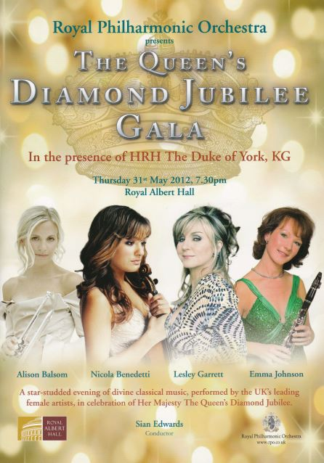
Figure 27: The Queen’s Diamond Jubilee Concert, The Royal Albert Hall
2012-2013
31 May Albert Hall Queen’s Jubilee Concert Mike Hesford
3 December Albert Hall John Rutter Xmas Concert Mike Hesford
2013-2014
16 April Palace Theatre Singing in the Rain David Leitch/Denis Scott
12 December Albert Hall John Rutter Xmas Concert David Leitch/Denis Scott
2014-2015
18 March Vaudeville The Duck House David Leitch/Denis Scott
10 September Woking Dreamboats and Mini-skirts David Leitch/Denis Scott
2015-2016
18 March Albert Hall Best of Broadway Concert David Leitch/Denis Scott
10 September Windsor Before the Party David Leitch/Denis Scott
7 December Albert Hall Xmas Concert David Leitch/Denis Scott
2016-2017
19 May Windsor Lotty’s War Denis Scott/Alan Worrell
16 November Sonning Blythe Spirit Denis Scott/Alan Worrell
17 February Woking Lord of the Dance Denis Scott/Alan Worrell
2017-2018
30 March Guildford Nell Gwynn Denis Scott/Alan Worrell
6 July Theatre Royal 42nd Street Denis Scott/Alan Worrell
6 December Albert Hall Xmas Concert Denis Scott/Alan Worrell
2018-2019
26 April Adelphi Kinky Boots Denis Scott/Alan Worrell
4 October Apollo Wicked Denis Scott/Alan Worrell

Sample costings
Costings for three events sampled across the period are given below.
20 June 2001 Woking (Matinee) Phantom of the Opera £10.50 (incl. coach)
13 March 2009 Prince of Wales Mamma Mia £47.00 (incl. coach)
6 December 2017 Royal Albert Hall Christmas Concert £80.00 (incl. dinner + coach)
There were some examples of outstanding value, as reported in the Luncheon Minutes on 11th April 2005:
“…………Following the breakdown of the coach on returning from the Theatre Royal at Windsor, the operator had given a refund and had also offered a complimentary day trip. Richard proposed a day in Brighton on Thursday 11th August which would cost a mere £2.50. If oversubscribed, preference should be given to those who had been to Windsor, as a reward for their remarkable self-control in the absence of toilet facilities.”
Representative Event
Visit to the Lyceum Theatre to see The Lion King (16th January, 2008)
Forty-three members and wives with seven widows of former members departed Sunbury Sports Association at 12 noon sharp on their Sureline coach arriving at the Lyceum Theatre at 1.15 p.m. After a short walk around Covent Garden and a quick sandwich lunch, seats were taken for the 2 p.m. matinee performance.
All were entranced by the colour, the energy of the cast, the sound and content of this Disney production with music and lyrics by Elton John, assisted by Tim Rice. The portrayal of the African animals was particularly interesting, especially the elephants in the opening scene. The hyenas, gazelles and giraffes warranted mention but the humour provided by the rhino, the buzzard and the jackal was particularly well done. The stage sets were very smoothly effected and the changes of scenery were jointless.
A stunned and almost silent Club quietly sipped their interval drinks wondering what could possibly follow in the second half. They were not disappointed. One member commented how great it was for someone of limited hearing to hear every word.
After a two and three-quarter hour performance the coach was re-joined for what promised to be a difficult rush-hour journey home - with massive hold-ups in the Euston Road and Hammersmith Broadway - but with a stroke of genius our driver, Tony Woodhouse, solved the problem. We arrived back at HQ just over half an hour late. Thanks Tony. The Lion King was a top class show, brilliantly staged, very energetic and enjoyed by everyone.
The Chairman, Richard Gould, on behalf of the party thanked Sureline and driver Tony, handing him an envelope containing the club’s appreciation. He also thanked Mike Hesford for organising the trip.
[Report prepared by Mike Hesford]

3.4 Pub lunches (2001-19)
Characteristics
Pub lunches take place on approximately nine occasions each year. These are held at intervals between the formal monthly luncheons and provide an opportunity for members, wives, partners and the Probus Ladies to mingle in an informal setting. In the early years, suitable venues were chosen across the Green Belt in Surrey; members were encouraged to share private transport. In latter years, more local pubs of character have featured in the near-monthly programme.
Several aspects of the programme justify comment:
- Organisers have sought to offer a variety of dining experience in different styles of pub or restaurant; moreover, they have tested the menu and appraised the environment beforehand
- Lunches have been organised on different days in the week to extend their appeal
- In latter years, a Christmas lunch and Summer lunch have been held on Sunbury Sports Association premises to benefit from the excellent cuisine of the (then) caterer
- Local pubs and restaurants have been favoured in recent years to minimise travel
- Probus Ladies consistently enjoy the ‘Probus experience’ and opportunity to meet friends and acquaintances over an informal lunch
It is anticipated that more Probus Ladies will attend pub lunches given the recent closure of the Sunbury Ladies Luncheon Club, attended each month by several of the Probus Ladies.
Probus Year Location Organiser
2001-2002
18 April Running Mare, Cobham Bill Peat
21 June Black Swan, Martyr’s Green James Johnson
25 July Onslow Arms, Clandon James Johnson
30 August not given (ref notice board) James Johnson
28 September not given (ref notice board) James Johnson
21 October Fox on the River, Thames Ditton James Johnson
22 November Rose and Crown, Thorpe Green James Johnson
30 January Old Crown, Weybridge Bill Peat
22 February Winning Post, Whitton James Johnson
2002-2003
21 March Woburn Arms, Addlestone James Johnson
24 April The Kingfisher, Chertsey Bridge James Johnson
13 September Running Mare, Cobham James Johnson
24 October Old Plough, Stoke D’Abernon James Johnson
21 November Rose and Crown, Thorpe Green James Johnson
23 January Old Crown, Weybridge James Johnson
27 February The Badgers Rest, Weybridge James Johnson
2003-2004
27 March The Goat, Upper Halliford James Johnson
22 April Union Inn, Old Windsor Charles Adams
21 May Wagon and Horses, Addlestone Charles Adams
26 June The Swan Inn, Staines Moor Charles Adams
21 August (not specified) Charles Adams
25 September Wagon and Horses, Addlestone Charles Adams
23 October Ashley Park Hotel, Walton Charles Adams
19 November Fairmile Hotel, Cobham Bill Peat
26 February Chef de China, Sunbury Charles Adams
2004-2005
25 March Silvermere Golf Club Charles Adams
26 August Fairmile Hotel, Cobham Charles Adams
29 September Hazelwood Golf Club Charles Adams
20 October Merit’s, Twickenham Charles Adams
25 November The Goat, Upper Hallliford Charles Adams
19 January Chef de China, Sunbury Charles Adams
22 February The Admiral Hawke, Sunbury Charles Adams
2005-2006
22 March The Tickled Trout (The Bugle) Charles Adams
28 April Ashley Park Hotel, Walton David Wilkinson
24 May The Castle, Ottershaw David Wilkinson
28 June The Old Crown, Weybridge David Wilkinson
28 July Rose and Olive Branch, Virg.Water David Wilkinson
22 August The Fairmile Hotel, Cobham David Wilkinson
29 September Rose and Crown, Thorpe Green David Wilkinson
26 October Chef de China, Sunbury David Wilkinson
25 November Marquess of Granby, Thames Ditton David Wilkinson
25 January Merit’s, Twickenham David Wilkinson
23 February The Running Mare, Cobham David Wilkinson
2006-2007
29 March The Swan, Moor Lane, Staines David Wilkinson
23 May (ref notice board) David Wilkinson
28 June The Castle, Ottershaw David Wilkinson
27 July The Old Crown, Weybridge David Wilkinson
22 August Fairmile Hotel, Cobham David Wilkinson
23 September Rose and Olive Branch, Virg. Water David Wilkinson
25 October The King’s Head, Ashford David Wilkinson
22 November Rose and Crown, Thorpe Green David Wilkinson
24 January Moon in Moon, Sunbury David Wilkinson
24 February The King’s Head, Ashford David Wilkinson
2007-2008
27 March Merit’s, Twickenham David Wilkinson
23 May Ashley Park Hotel, Walton Charles Adams
19 June Bridge Hotel, Chertsey Charles Adams
17 July Thames Court, Shepperton Charles Adams
20 September Three Horse Shoes, Laleham Charles Adams
17 October The Anglers Retreat (Lucan Arms) Charles Adams
5 December Ship Hotel, Shepperton Charles Adams
23 January The Running Horse, Sunbury Charles Adams
20 February Moon in Moon, Sunbury Charles Adams
2008-2009
26 March The Ashley Park Hotel, Walton Charles Adams
28 May The Flower Pot, Sunbury André D’Arbre
18 June SSA - Ladies Summer Lunch André D’Arbre
23 July Red Lion, Shepperton André D’Arbre
25 September Holly Tree, Addlestone André D’Arbre
2 December SSA - Ladies Christmas lunch André D’Arbre
21 January The Hungry Horse, Chertsey André D’Arbre
26 February The Boat House, Chertsey André D’Arbre
2009-2010
24 March Ashley Park Hotel, Walton André D’Arbre
22 April The Running Horse, Sunbury André D’Arbre
21 May Cole Court, Twickenham André D’Arbre
25 June SSA - Ladies Summer Lunch André D’Arbre
24 September The Bell, Hampton André D’Arbre
29 October The Winning Post André D’Arbre
1 December SSA- Ladies Christmas Lunch André D’Arbre
27 January The Flower Pot, Sunbury André D’Arbre
25 February Moon in Moon, Sunbury André D’Arbre
2010-2011
24 March Cole Court, Twickenham Les Messum
21 April The Goat, Halliford Les Messum
25 May Merit’s, Twickenham Les Messum
22 June SSA - Ladies Summer Lunch Les Messum
29 September Harrisons, Shepperton André D’Arbre
21 October Brooklands College André D’Arbre
7 December SSA - Ladies Lunch André D’Arbre
26 January Kingfisher, Chertsey André D’Arbre
24 February Premier Inn, Sunbury Cross André D’Arbre
2011-2012
23 March Hare and Hounds, Sunbury André D’Arbre
27 April Three Horseshoes, Laleham André D’Arbre
25 May The Winning Post, Sunbury André D’Arbre
21 June SSA - Summer Lunch André D’Arbre
23 November Merit’s Twickenham Les Messum
1 December SSA - Xmas Lunch Les Messum
24 January Angler’s Retreat, Laleham Les Messum
23 February Benwell Day Centre, Sunbury Les Messum
2012-2013
30 March Magpie Hotel, Sunbury Les Messum
1 May Ashley Park Hotel, Walton Les Messum
19 June SSA - Ladies Summer Lunch Les Messum
20 September Oatlands Chase, Weybridge Les Messum
4 December SSA - Ladies Xmas Lunch Les Messum
21 January Rose and Crown, Thorpe Les Messum
2013-2014
6 March Merit’s, Twickenham Les Messum
22 April The Kingfisher, Chertsey Les Messum
23 May Rose and Crown, Thorpe Les Messum
17 June SSA - Ladies Summer Lunch Les Messum
3 September Silvermere, Inn on the Lake Les Messum
4 October Ashley Park Hotel, Walton Les Messum
28 November Weir Hotel, Walton Les Messum
2014-2015
21 January SSA - Ladies Christmas Lunch Les Messum
20 March Merit’s, Twickenham Les Messum
25 April Crown Inn, Chertsey Les Messum
29 May The Goat, Halliford Les Messum
18 June SSA - Ladies Summer Lunch Les Messum
27 September The Golden Grove, Lyne Les Messum
23 October The Harrow, Charlton Les Messum
21 November The Admiral Hawke Les Messum
11 December SSA - Xmas Lunch Les Messum
2015-2016
17 February The Bell, Hampton Les Messum
30 March Anothai Restaurant, Hampton Hill John Atkinson
28 May The White Horse, Sunbury John Atkinson
25 June SSA - Ladies Summer Lunch John Atkinson
25 August King’s Fairway, Ashford John Atkinson
25 September The Red Lion, Thorpe John Atkinson
22 October The Feathers, Laleham John Atkinson
17 November The Minnow, Weybridge John Atkinson
2016-2017
24 February SSA - Ladies Winter Lunch John Atkinson
22 March The Flower Pot, Sunbury John Atkinson
12 May The Red Lion, Shepperton Les Messum
18 June SSA- Ladies Summer Lunch Les Messum
19 October Three Horse Shoes, Laleham Les Messum
22 November The Red Lion, Shepperton Les Messum
2017-2018
23 February SSA - Ladies Winter Lunch Les Messum
3 May Moon in Moon, Sunbury Tony L’Angellier
22 June The Retreat, Staines upon Thames Tony L’Angellier
19 September Meson Toby, Laleham Tony L’Angellier
2018-2019
22 March Thames Court Inn, Shepperton Tony L’Angellier
2 May Indian Zest, Sunbury Tony L’Angellier
19 June The Magpie, Sunbury Tony L’Angellier
5 September The Goat, Shepperton Tony L’Angellier

A Representative Visit (Report prepared by Tony L’Angellier, Pub Lunch Organiser, 2017-)
Background planning
The invitation to outline for readers the ways in which pub lunches are organised was an opportunity too good to miss! I’ll do this in two parts: firstly, an account of the background organisation; secondly, a brief report on a typical pub lunch event held at the Moon in Moon Chinese restaurant in Lower Sunbury.
For a food lover, becoming the joint-organiser of pub lunches was a gift! These events complement the formal monthly luncheons and provide an opportunity for members, their guests and Probus Ladies to meet in an informal setting. The lunch venues are varied and, in recent times, have included Indian, Chinese, Spanish and Greek cuisine. These appeal to different tastes and complement the choice of restaurants serving traditional British grills and roasts.
A straightforward checklist is used to organise a pub lunch. This entails:
- Visiting a potential venue some months in advance. The organiser (and sometimes his deputy) test out the various restaurants to check capacity (say 25-40 diners), availability, car parking arrangements, accessibility to tables and rest rooms (preferably not upstairs) and, importantly, the offering of a 2 or 3 course set menu option (to ensure prompt service if attendees have made choices in advance)
- Then the real work begins! A ‘board’ listing details of the venue, time and location (together with menu choices, if possible) is circulated at a monthly luncheon meeting. This is emailed to the Probus Ladies’ co-ordinator for information and action. Decisions on participation are collected under three headings: Yes/No/Maybe. The returns are collated and the restaurant informed on numbers and (if required) menu choices
- On the day, the organiser arrives ahead of time and liaises with the management. Guests are greeted on arrival. There is no formal seating plan. Guests purchase drinks and sit with other members. This arrangement stimulates conversation. When all guests are present the check orders and service commences. Experience suggests that it is easier for each table to organise and pay for the drinks taken
- Then it is time to relax, enjoy the meal and engage in good conversation. The final task is to check that everyone has settled their account and leaves for home having enjoyed a new dining experience with others of like mind
The Moon in Moon (3rd May, 2017)
On 3rd May 2017, a party of 35 Probus members, Probus Ladies and guests gathered at the Moon in Moon Chinese restaurant in The Avenue, Sunbury. For many, this location was within walking distance of home; for those who shared cars there was ample parking nearby.
The meal was fixed-price at £19-00 per head. For this modest sum, guests seated at large round tables were treated to an extensive selection of items from the standard menu and encouraged to share from the never-ending stream of dishes. Those who experimented with chop-sticks contributed a source of friendly amusement. Conversation bubbled. Many well-travelled guests recounted their holiday and employment experiences in regions of the Far East. This inclusion of Chinese cuisine in the programme of pub lunches was greatly appreciated. The lunch represented excellent value for money and the attentive service provided by friendly waiters added to the enjoyment of the event.

3.5 The speakers’ programme (2001-19)
Introduction
The after-lunch speakers’ programme has been an enduring feature of the Probus calendar in the period 2001-19. It is much appreciated by members, the majority of whom have expressed satisfaction with the choice of speakers.
Until 2010 the programme offered around six speakers in each year, the majority being members who spoke on career-related topics. The Summer (it is reliably reported) was a fallow period during which members were released after lunch to play bowls, golf or tend their gardens.
Since then the programme has become more structured. It has been extended to cover nine speakers, the majority of whom are invited from outside the club on the recommendation of members. The month of March is excluded to permit the AGM; and a recess of two Summer months allows our members to engage in alternative (outdoor) activities.
Several new features in presentation, style and delivery have been introduced. Talks in the programme, enhanced by visual aids and demonstrations, include:
- An address by the retiring Probus Chairman, normally in February
- Topics linked, subsequently, to half-day visits (e.g. Eton College; Brooklands Motor Museum; Hampton Steam Museum)
- Practical demonstrations e.g. model-building for RNLI; beekeeping; water dowsing
- Presentations by local charities (g. Sam Beare Trust; Princess Alice Hospice)
- Themes around global and local environmental issues (e.g. global warming; the Surrey Green Belt; The Thames Landscape Study)
- Lighter entertainment following the Christmas lunch (e.g. harp recital; a well-illustrated talk on massed male voice choirs)
- Attendance by Probus Ladies at selected talks (e.g. sourcing orchids for Kew; Christmas musicals; and the centenary birthday celebration for Ray Gaunt HLM)
In recent years the Speaker Organiser has been charged to deliver the annual programme within a budget of £500 (less than the cost of half a pint of beer per attending member per talk!). To sustain the programme, however, it is important to engage more members as future speakers on topics related to life interests, career or hobby experiences.
Listing of Talks
Probus year Speaker Topic
2001-2002 [Organisers: Ron Forrester/John Hawkins]
21 May Pauline Tregidgo The Sunbury Millennium Embroidery
8 October Peter Richards The Flight Safety Committee
12 November Jeff Jeffreys Time in Relation to Navigation
10 December John Hawkins Reminiscences
14 January Mandy Groves Homestart
14 January Brian Thorn Aerial photographic slides of Surrey
11 February Doug Rimmer Early colonisation in Australia
2002-2003 [Organiser: Ron Forrester]
19 October David Johnson Incident Reporting Programmes
11 November Monty Moss Moss Bros
9 December Harold Snoad Directing and Producing for the BBC
13 January Colin Kitt Life as an Immigration Officer
15 February Ron Forrester Insights from a ‘flight box’
2003-2004 [Organiser: Allan Barnes]
11 October Richard Worthington The Blue Nile
10 November Tom Stubbs The War Graves Commission
8 December Jeff Jeffries The Calendar
12 January Capt John Tye Concorde: a pilot’s view
9 February John Gardiner The strategic role of the Pathfinders
2004-2005 [Organiser: Allan Barnes]
10 May Geoff Barkway Training as a glider pilot
11 October Peter Crawshaw History of St Paul’s Cathedral
8 November Ken Ferguson ‘Editing Photoplay’
11 December Eddy Lea 80 Years of Scouting
10 January Ray Summerbee The Driving Standards Agency
14 February Allan Barnes Passion for books
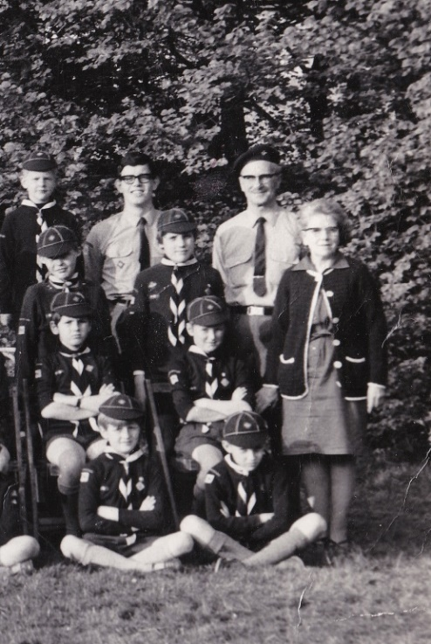
Figure 28: In December 2004 Eddy Lea, wearing full scout uniform (including shorts), gave his talk on “80 Years of Scouting”. [Eddy features in the back row of this photograph, on the extreme right].

2005-2006 [Organiser: Allan Barnes]
10 October Janet Hendey The work of the National Trust
14 November Jack Maclaren I.K. Brunel’s ‘Great Britain’
12 December George March Model Making and the RNLI
9 January Mel Rees An Amusing Interlude
13 February Richard Worthington The Art of the Goldsmith
2006-2007 [Organiser: Dick Nimmo]
11 September Eric Champion History of The Riverside Arts Centre
9 October Ewan Larcombe The Jubilee River Project
13 November Kay Webb Swan Lifeline
11 December Michael Rimmer Far North Queensland
8 January Terry Pattinson Experiences as a journalist
12 February Ian Dow Lights, Camera, Action! Ooops!
2007-2008 [Organisers: Dick Nimmo/Leo Pemberton]
18 April Tom Stubbs Ethiopia
9 May Christopher Claxton Our Amazing Heritage
11 June Gabby Hablin Personal Alarm Systems
10 September E Collins The Palace of Westminster
8 October Dr David Cutler Fuel for thought
12 November John Chapman We will not be ‘druv’
10 December David Harrison The Life of Sam Pepys
14 January Wycliffe Noble Famous People I’ve met
11 February Dr Peter Brandham Botany in the Horn of Africa
2008-2009 [Organiser: Leo Pemberton]
12 May Gavin Stanley African gold weights
9 June Keith Harman Dowsing
8 September George Rushbrook A Policeman’s Lot
12 October Mike Rimmer Turkestan
10 November David Steed Finchcocks Musical Museum
8 December Vida Edwards Knickers Through the Ages
5 February Frank Barnes Videos on 1990s 5-day holidays
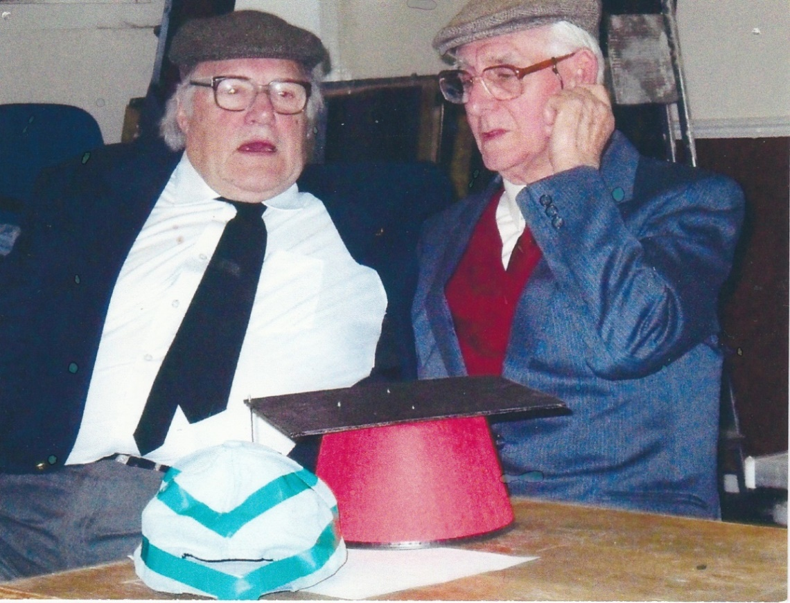
Figure 29: Two past Chairmen, Ray Knott and Mike Hesford, give
after lunch entertainment as Stan and Ollie in January 2011

2009-2010 [Organiser: Robert Gant]
10 April Dr Robert Gant Land use changes in the Green Belt
11 May Dr Chris French The “good life” in 19th century Surbiton
8 June Avis Marshall Bee keeping in suburbia
14 September Jane Langley TALK – we keep on talking
12 October Peter Heims The life of a private detective
9 November Dr Trevor Kennea Global climate change
14 December Brian Thorne I K Brunel
14 January Ray Knott &
Mike Hesford Camp Fire Yarns

8 February Les Woods The Sunbury Sports Association
2010-2011 [Organiser: Robert Gant]
12 April Emma O’Hara The work of the Princess Alice Hospice
10 May Dr Haydn James Music for massed voices
14 June Dr Colin Ryall The crow is a world traveller
13 September John Annabell Thames Water
11 October Prof Peter Beck No longer a pole apart – Antarctica today
8 November Richard Worthington A potted history of landscape and architecture
13 December Prof Bryan Woodriff Everyday life in Russia
10 January Insp Steve Cheeseman The Surrey Police Air Support Unit
4 February Gavin Stanley Living in Lusaka
2011-2012 [Organiser: Robert Gant]
11 April Neal Adolphus Japan: a personal view
9 May Kwasi Kwarteng MP Spelthorne through the ages
13 June Dr Anne Rowe The life and times of Iris Murdoch
12 September Paul Whittle Rock steady – the Gibraltar story
10 October Rebecca Laws The Thames Landscape Study
11 November Frank Barnes 65 years of Avionics
12 December Stephen Best Mr Musicman (performance)
9 January John Tye Dreamflight
13 February George March George at the airport for 40 years
2012-2013 [Organiser: Robert Gant]
16 April Alan Gallop Buffalo Bill
14 May Robert Skelton History of Black Rod and Parliament
11 June Jean Hayes The life of a lady bailiff
10 September Cliff Taylor The sporting history of Hurst Park
8 October Philip Littlejohn The Titanic
12 November Peter Bruckland Brooklands Museum
10 December Colin Gent World War II Royal Navy Destroyers
14 January Mike Davison Friends of Richmond Park
11 February Edwin Genet 88 years of ups and downs
2013-2014 [Organiser: Robert Gant]
8 April John Glenister The Surrey Air Ambulance
13 May Rev Stephen Sizer Israel, Palestine and the Middle East
10 June Alan Craig An A-Z of Indian experience
9 September Bob Ogley Doodlebugs and rockets: the V1/V2 campaign
14 October Rebecca Hunkin The history of Eton College
11 November Margaret Watson History of the harp
9 December Robert Leadbetter The Hampton and Sunbury Waterworks Railway
13 January Gill Govier Macmillan nursing
12 February Rev Harold Nicholson These boots were made for walking
2014-2015 [Organiser: Robert Gant]
14 April Terry Johnson The Great Train Robbery
12 May Michael Croneen/ Mike Hesford/Don Shimmield/ KenThomas Reminiscences of National Service: ‘Get some in’
9 June Norman Dingermans The South Downs National Park
8 September Paul Whittle Hill Stations of the Raj
12 October Richard Day The fire and restoration of Windsor Castle
10 November Dr Phillip Cribb Orchid hunting for Kew
8 December Richard Poad Grandma flew spitfires
12 January Andy Thomas Crop circles
9 February Leo Pemberton Up a gum tree
2015-2016 [Organiser: Robert Gant/John Lodge]
13 April Peter Durrant History and humour of Fleet Street
11 May Monica Chard Publishing in the local community
8 June Jane Delay Services provided by The Shooting Star Chase
14 September Jo Mabbutt The Livery Companies of London
12 October Tony Eaton Invasion 1940 – what if?
9 November David Hassard World class aircraft from Kingston upon Thames
14 December Fr Simon Douglas-Lane Travellers’ tales
11 January Tom Stubbs OBE The History of Ethiopia
8 February Les Messum Of Ships and Shoes and Submarines
2016-2017 [Organiser: John Lodge]
11 April Nigel Harding The Woking and Sam Beare Hospices
9 May Colin Gent Merlin engines
13 June Dr Robert Gant Inside out: reflections of a prison tutor
12 September John Lyon Secret classroom: a window on the Cold War
10 October Rupert Matthews The Battle of Hastings - 950th anniversary
14 November Mel Rees My family and other setbacks
12 December Margaret Watson Harp recital
9 January Dr John Peaty The Dambusters
13 February Dr Robert Gant Footprints in the sands of time
2017-2018 [Organiser: John Lodge]
10 April Hugh Laurie The work of Mary’s Meals
8 May Adrienne Dines The art of story-telling
12 June Barry Buttenshaw Prince Charles, Bombs and Barry
11 September Alan Gallop Children of the dark
9 October Colin Gent Singapore to Bangkok by car and train in 1962
13 November Tom Stubbs OBE The work of the War Graves Commission
11 December Dr Haydn James Music for massed voices
8 January Eric Champion The Riverside Arts Centre
12 February Geoffrey Peach The gardener’s life – a miscellany
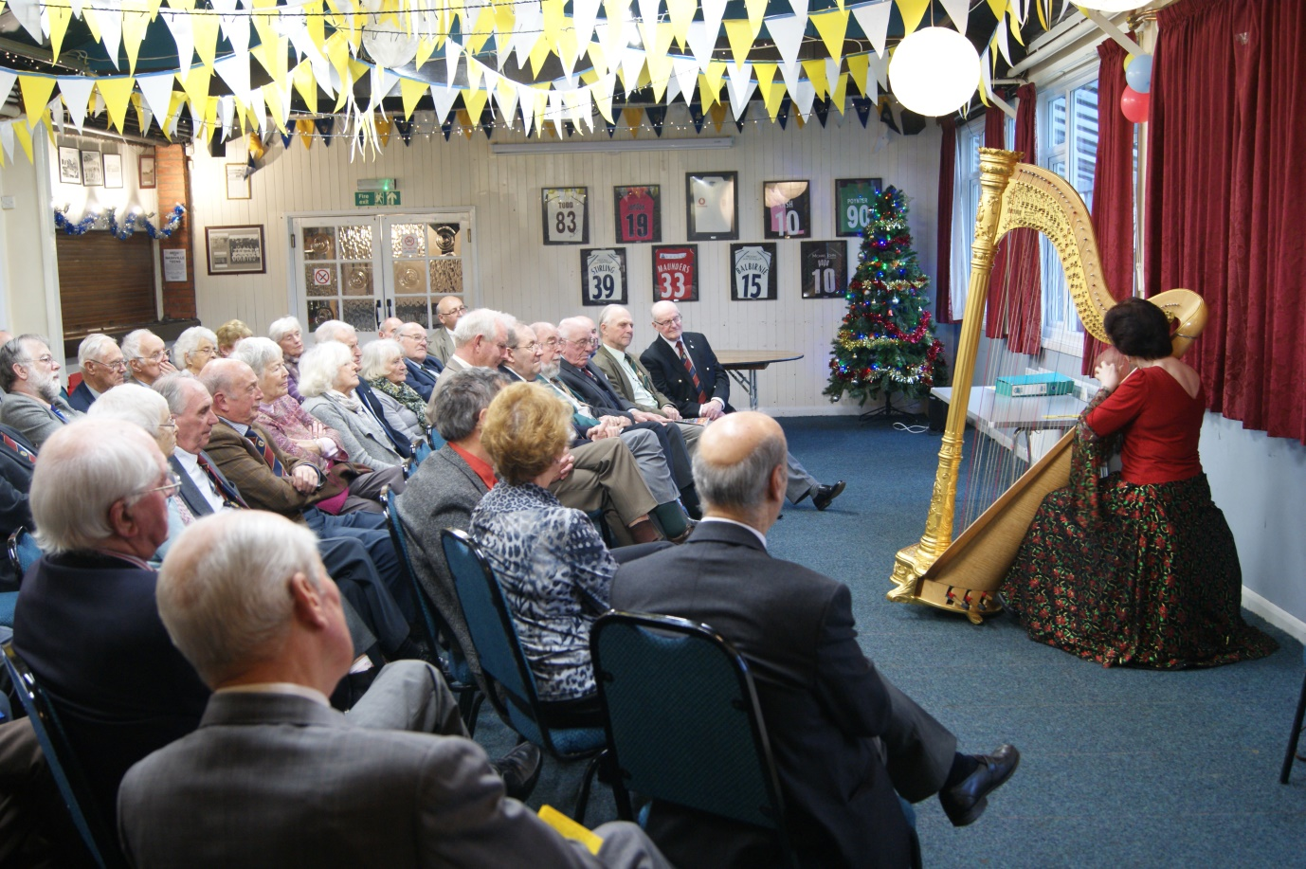
Figure 30: On her return visit in December 2017 Margaret Watson entertained members and guests with a recital and technical explanation on the harp
2018-19 [Organiser: John Lodge]
9 April John Peaty Wellington and Mapmakers in the Peninsula War
14 May Mike Attias A Life in Customs and Excise
11 June Susan Purcell Ups and Downs of Crossword Puzzles
10 September Dennis Brock WWII Experiences in the Army and as a P.O.W.
8 October Steve Poole Tall Ship Adventures for People of all Abilities
12 November Brian Parsons The Unknown Soldier
10 December Vic Quayle A Life of Grime
14 January Sheila Willis Poisonous plots
11 February Alan Gallop The Tolpuddle Martyrs
[The Chairman’s Address for 2018-19 was re-scheduled to 13 May, 2019]
Representative Events
12th January 2015: Andy Thomas - The Crop Circle Mystery
With a set of superb illustrations of crop circles and a relaxed but authoritative style of presentation, Andy presented the facts, history and theories behind the compelling mystery of crop circles. Based on detailed evidence, he addressed the central question: are crop circles a man-made art-form or are they the product of more mysterious, supernatural forces and a superior intelligence?
Framed thus for our consideration, he explored the spatial geometry of impressive examples from among the 10,000 photographed cases and tested forensic explanations based on plant physiology, geology, the mathematical sciences and human testimony to reach a conclusion. For us to reflect, he posed two chilling questions: firstly, should we believe what the popular press reports; and, secondly, what does this phenomenon mean for us and our civilisation?
Mike Attias proposed a vote of thanks. In this he drew members’ attention to the number of unanswered questions posed by the presentation, and the sense of personal unease that these might create for us in our daily lives.
(Robert Gant, Speaker Organiser)
Summary of a talk by Frank Barnes HLM on 14th November 2011
At intervals in the Speakers’ Programme, we have been privileged to have one of our members give an illustrated talk around their career and achievements. These presentations have been well-received. In November 2011 Frank Barnes, a distinguished avionics engineer and HLM, gave an address entitled “65 Years of Avionics”. This charted his 65-year career in the avionics industry.
We are fortunate that before his death in February 2016, Frank had given to Mike Hesford a copy of his prepared notes. Mike has now edited these and inserted an impressive set of illustrations. The full text is presented as Appendix E.

3.6 Ladies’ night (2001-19)
Characteristics
The Annual Ladies’ Night is one of the most attractive events in the Probus diary. The format has remained fairly constant over time and is illustrated by the specimen programme for 2009. Formal elements of welcome and address are complemented by fine-dining and dancing. The Chairman’s Charity is boosted by proceeds from a bumper raffle.
For several years Ladies’ Night was held at The Ashford Manor Golf Club. Numbers of guests often exceeded 100. However, as these numbers declined to around 65, in 2010 the event was re-located to The Sunbury Sports Association (SSA). In 2017 and 2018, following the removal of Probus Club activities to the Holiday Inn at Shepperton, Ladies’ Nights were held at that venue.
Listing of Events
Probus Year Date Venue Organiser
2001 23rd November Ashford Manor Golf Club Eddy Lea
2002 29th November Ashford Manor Golf Club Eddy Lea
2003 28th November Ashford Manor Golf Club Eddy Lea
2004 26th November Ashford Manor Golf Club Eddy Lea
2005 19th November Shepperton Moat House Eddy Lea
2006 10th November Ashford Manor Golf Club Derek Smith
2007 16th November Ashford Manor Golf Club Tony Stride
2008 20th November Ashford Manor Golf Club Don Shimmield
2009 20th November Ashford Manor Golf Club Don Shimmield
2010 20th November Sunbury Sports Association Don Shimmield

Representative Programme
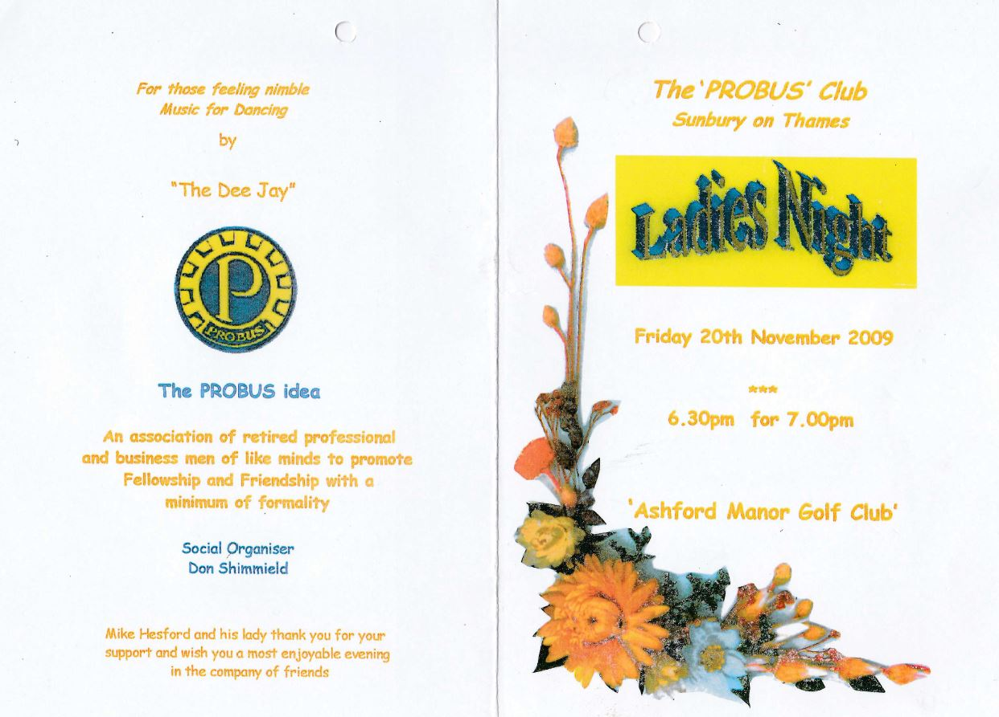
Figure 31: Ladies’ Night programme 2009

2011 19th November Sunbury Sports Association Don Shimmield
2012 19th October Sunbury Sports Association Don Shimmield
2013 8th November Sunbury Sports Association Don Shimmield
2014 16th January Sunbury Sports Association Don Shimmield
2015 15th January Sunbury Sports Association Don Shimmield
2016 20th January Sunbury Sports Association Don Shimmield
2017 10th November Shepperton Holiday Inn Don Shimmield
2018 16th November Shepperton Holiday Inn Don Shimmield
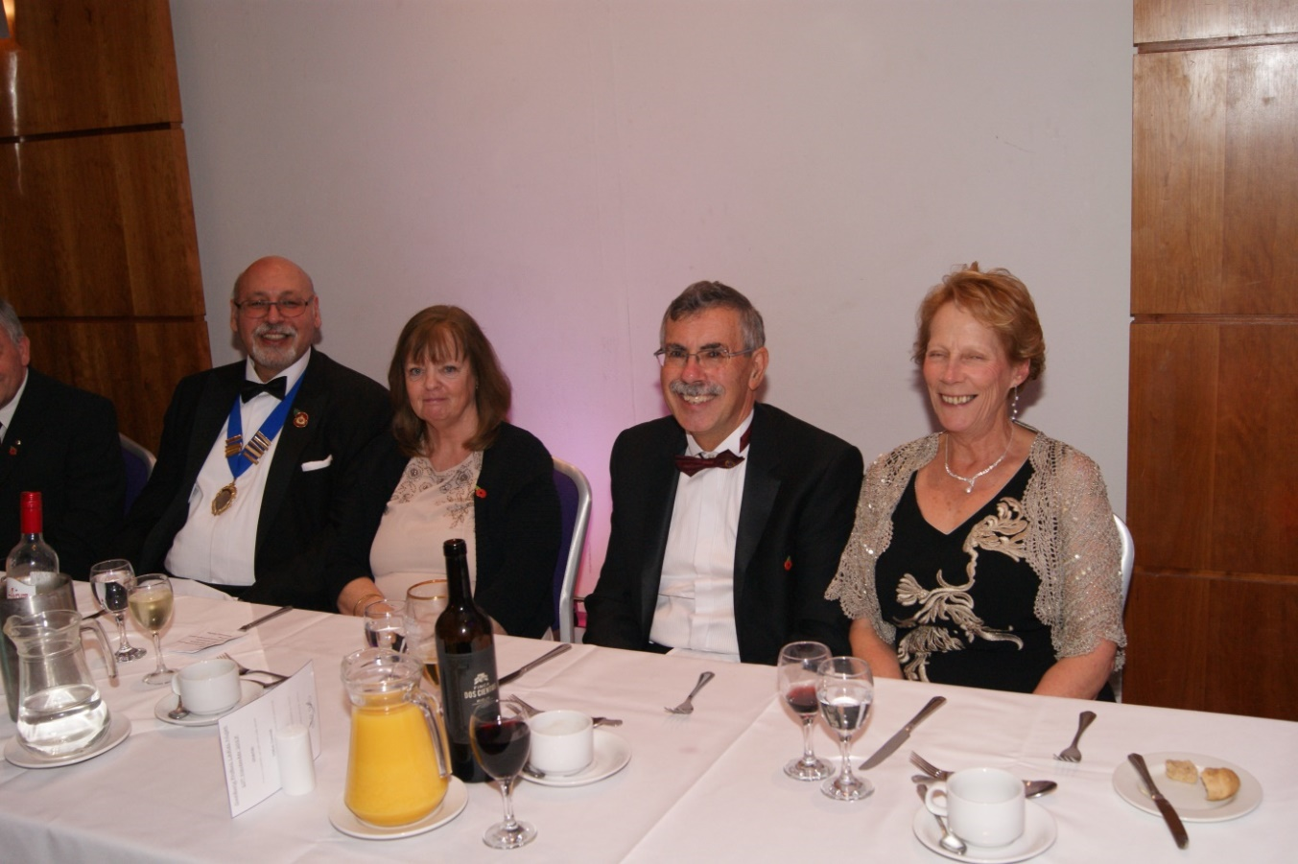
Figure 32: Chairman Mike Attias, and his lady Gerry, and Secretary Martin Moore, with
his lady Maggie, preside at Ladies’ Night 2017

3.7 Ray Gaunt (HLM): centenary birthday party
This report is based on an edited account of the tea party organised to honour Ray Gaunt on his 100th birthday. It recounts key features of his distinguished career in aeronautical engineering and continues with an amusing set of reminiscences on National Service life provided by four club members (See page 92 for a photograph of Ray during his working life).
The text derives from reports on the birthday celebration filed by Mike Hesford, Club Secretary, and Robert Gant, Speaker Organiser (See the report published in Sunbury Matters on page 34).
Introduction: the toast to Ray by Chairman Leo Pemberton
Ray Gaunt was born in Doncaster on 8th May, 1914. So far, Ray is the only member in the history of our club to have achieved his centennial year. The Club marked this landmark occasion with a celebratory tea party on 12th May 2014. Guests totalled 100 and included the widows of former members, wives of members, several of Ray’s close friends and Monica Chard, Editor of Sunbury Matters.
The Chairman, Leo Pemberton, presided and presented Ray with a bottle of champagne and signed card from Club members; a second bottle of champagne was presented by the Sunbury Sports Association. Jack and Sarah Phillips presented Ray with a massive 100th Birthday cake resplendent
with two large sparklers. The Chairman, Leo Pemberton, proposed a toast in sparkling Prosecco
to Ray, wishing him well for another hundred years! 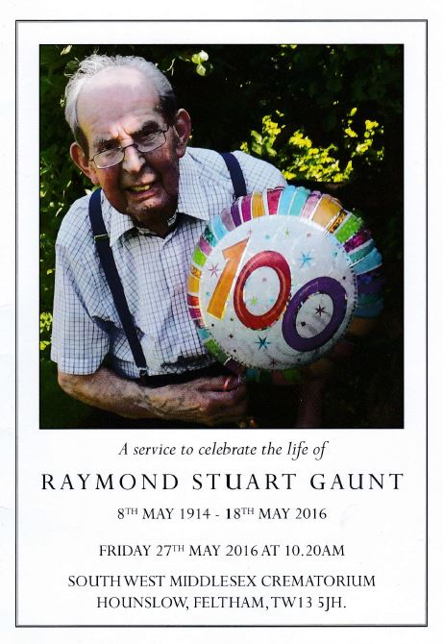
Figure 33: Ray Gaunt HLM RIP

The life and times of Ray Gaunt
Leo Pemberton then presented a résumé of Ray’s life, career, interests and membership of Probus since 1981.

Ray was born in Doncaster in 1914. The family moved to Bristol where Ray was educated. He commenced his working life as a trainee motor engineer. In 1940 he worked for BOAC at Colerne assembling Mohawk, Tomahawk and Cherokee fighter aircraft which had been transported in packing cases from the US to Avonmouth Docks.

Subsequently, Ray transferred to Nuneaton to work on Ensign transport aircraft, preparing them to carry supplies to El Alamein from Dakar; and thence to Lyneham to service Liberator bombers. In 1945 he transferred to Hurn to maintain Hermes, Yorks and Lancastrians (a modified Lancaster). His career progressed from fitter (engine and airframe) to charge hand and foreman.

In 1951 Ray moved to Heathrow. Five years later he was seconded to Bristol Aircraft Ltd (later to become Bristol Aerospace) where he received a commendation from the chief test pilot, A.J. Pegg.

Returning to Heathrow he became supervisor in the Britannia maintenance dock where he
developed some ingenious and cost-saving solutions to maintenance issues. In 1966 he became
works superintendent for ground equipment. In 1972 Ray was promoted to Maintenance Manager Support Services covering Motor transport, Central Area, Hangers and Catering and Freight Buildings. Ray retired in 1976 after 36 years with BOAC and a few weeks before the Corporation was merged with British European Airways to form British Airways.

Ray met his future wife, Peggy, in 1931 and they were married in 1940. They have a son living in America and a daughter living locally. Ray joined Probus in 1981 and was Club Treasurer for 3
years from 1986. He regularly played bowls and led our Probus club team for many years. He
was nominated Sunbury Sportsman of the Year in 2009. In 2013 was inducted as an Honorary
Life Member.

Following the death of Peggy, he maintains an active presence in Probus life, cares
for himself and continues to play outdoor- and carpet bowls.

Ray is a role model for us all!

‘Get some in’. Reflections on National Service

Robert Gant, the Speaker Organiser, then introduced the entertainment. He explained that for
several years the Probus Magazine had featured (nostalgic?) accounts of National Service. The Committee had decided that we should present our own set of reminiscences. Four Probus speakers, representing the three armed services, had ‘volunteered’ to share their experiences of National Service with an appreciative audience.

Ken Thomas, spoke about his service with the Royal Navy and whilst drawing attention to the harshness of wintertime basic training in Devon confirmed that it had been a character building experience that proved ‘highly educative’ in so many ways!

From the perspective of service with The Royal Engineers, Mike Hesford demonstrated how it was possible to negotiate a successful pathway through military bureaucracy and benefit from high quality skills training that supported his later career.

Michael Croneen continued this theme. Trained as an air traffic controller, he admitted to a minor infringement of RAF regulations which, perversely, led to his designation as a much sought after sign-painter (having used his talents to decorate the guard house), culminating in a self-managed period when he had been assigned, alone, to repaint a World War II Bomber for a Battle of Britain fly-past!

Robert then read from a script prepared by Don Shimmield (who was unfortunately absent) which outlined his varied RAF career as an aviation meteorologist. Members were delighted to learn Don’s definition of a meteorologist: a person who can look into a girl’s eyes and see weather (whether)!

Proceedings were brought to a close by Derek Smith who proposed a vote of thanks to our speakers. Derek confessed to service as a ‘redcap’, motivated primarily by financial gain, and shared his reminiscences of tedious service in the Egyptian desert guarding a large and isolated military stores base from local villains who sometimes infringed the perimeter minefields!

In summary: all speakers referred to the importance of National Service in their personal development, especially the way it enabled them to mix with men from other walks of life. It had also funded a wealth of anecdotes drawn from the early period of ‘square bashing’.

In that context, the final word must go to Mike Hesford who reported on his first early morning session on the parade ground at Malvern. Here, the drill sergeant had caught him gazing at the distant Malvern Hills and bellowed: “Them ‘ills is not for looking at, them are for running over” – and so it came to pass………!

