4.0 THE 50th ANNIVERSARY (JUBILEE) YEAR
This section provides a snapshot of our Probus Club around its 50th Anniversary. It presents the annual calendar of events to show the pattern of activity and includes an illustrated report on the Golden Jubilee Dinner held on 1st February at the Holiday Inn (Shepperton). A profile of membership in January 2019 follows. Finally, four senior members reflect on their personal experiences of club membership.
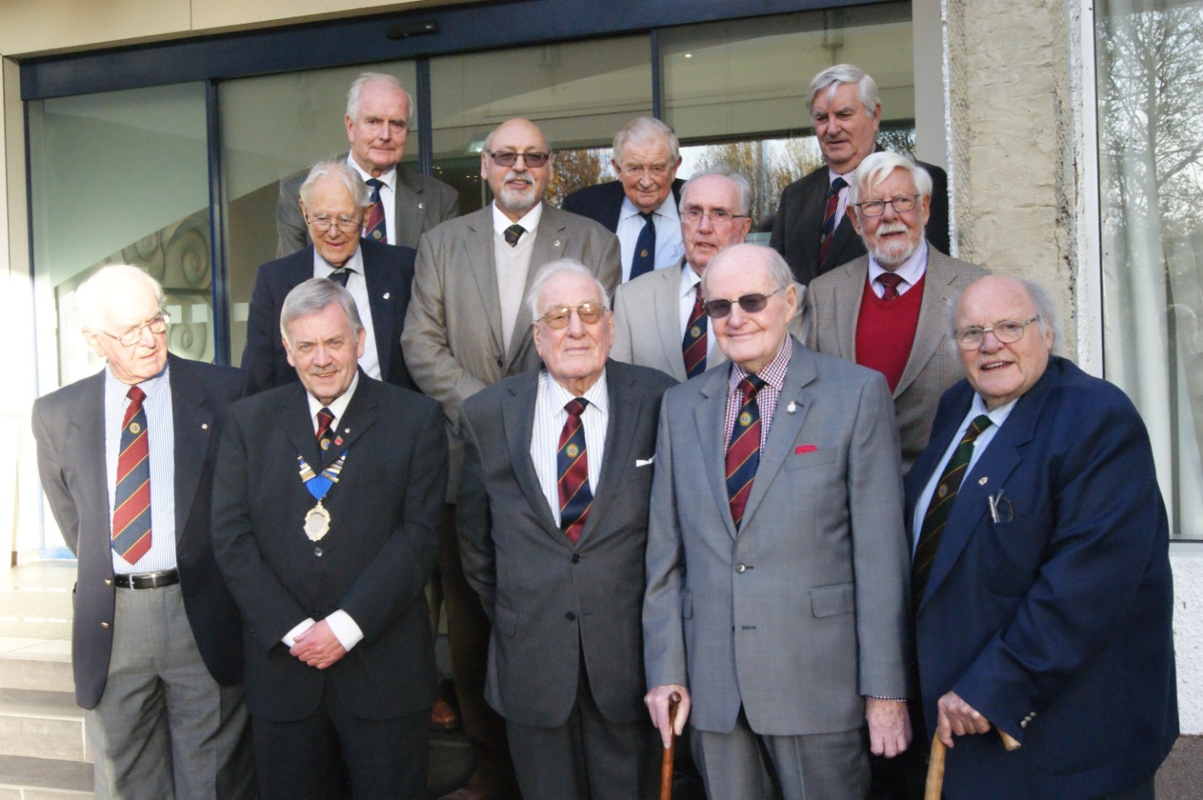
Figure 34: Past Club Chairmen with Chairman David Leitch (January 2019)
(Back row) Robert Gant Don Shimmield Gavin Stanley
(Middle row) Leo Pemberton Mike Attias Les Messum George March
(Front row) Norman Dixon David Leitch Edwin Genet Frank Brown Mike Hesford
To commemorate the 50th Anniversary of the Club, all members were presented with a bespoke membership badge (see the front cover of this document).
4.1 Calendar of Events
Sunbury Probus Club is much more than a luncheon club! It is a lively organisation that supports a full range of activities for members and guests. The annual diary presented in Table 6 lists events and formal meetings scheduled between the AGM on 12th March 2018 and AGM on 11th March 2019.
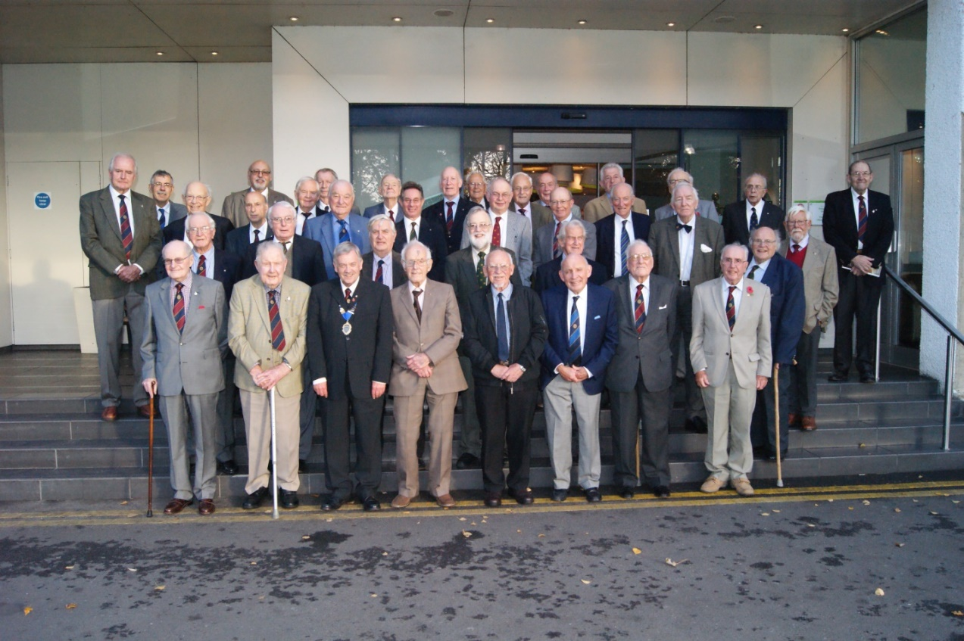
Figure 35: Club members attending lunch at the Holiday Inn, November 2018
Table 6 Diary of Probus Club Events 2018-9
March 2018
12 March AGM
22 March Pub lunch: Thames Court Inn, Shepperton
April 2018
3 April Committee Meeting
9 April Probus Luncheon (with speaker)
12 April Funeral of member Dr André D’Arbre
26 April Theatre Visit – Kinky Boots (Adelphi Theatre)
May 2018
2 May Pub lunch: Indian Zest Sunbury
8 May Committee Meeting
14 May Probus Luncheon (with speaker)
June 2018
5 June Committee Meeting
11 June Probus Luncheon (with speaker)
14 June Day Trip: Mottisfont and The Sir Harold Hillier Gardens
19 June Pub lunch: The Magpie Hotel, Sunbury
July 2018
3 July Committee Meeting
9 July Probus Luncheon (no speaker)
August 2018
7 August Committee Meeting
13 August Probus Luncheon (no speaker)
September 2018
4 September Committee Meeting
5 September Pub lunch: The Goat, Shepperton
10 September Probus Luncheon (with speaker)
24-28 September 5 Day Holiday - Lytham St Annes
October 2018
2 October Committee Meeting
4 October Theatre Visit - Wicked (Apollo Theatre)
8 October Probus Luncheon (with speaker)
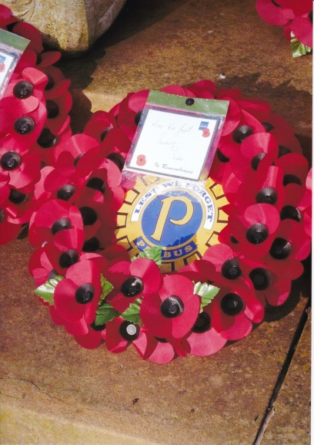
Figure 36: Remembrance Sunday at Sunbury War Memorial 2018
November 2018
6 November Committee Meeting
11 November Remembrance Sunday – Laying of a Wreath at Sunbury War Memorial
12 November Probus Luncheon (with speaker)
16 November Ladies’ Night - The Holiday Inn, Shepperton
December 2018
4 December Committee Meeting
10 December Probus Luncheon (with speaker)
January 2019
8 January Committee Meeting
14 January Probus Luncheon (with speaker)
February 2019
1 February Jubilee Dinner, Holiday Inn, Shepperton
5 February Committee Meeting
11 February Probus Luncheon (with speaker)
March 2019
5 March Committee Meeting
11 March Probus Luncheon (no speaker)
11 March AGM

4.2 The Golden Jubilee Dinner, 1st February 2019
Guests of honour
The Golden Jubilee Dinner was held at the Holiday Inn, Shepperton, on Friday, 1st February, 2019 (Figure 37). The Chairman, Mr David Leitch, and Vice-Chairman, Rev David Priddy, presided. The distinguished guests, in attendance, were: Mr Michael More-Molyneux, Lord Lieutenant of Surrey, Mr Richard Black, President of Rotary Club of Shepperton and Sunbury; Cllr Jean Pinkerton OBE, Mayor of Spelthorne; Mrs Linda Burton, Mayor’s Consort; Dr Kwasi Kwarteng MP, Spelthorne Parliamentary Constituency; Mr Tony Harman, President of Staines Probus Club; Mr Mike Hall deputising for Mr Neal Adolphus, Chairman of Shepperton Probus Club; and Mrs Monica Chard, Editor of Sunbury Matters.
The Chairman warmly welcomed the distinguished guests, members of Sunbury Probus Club and their personal guests. The 84 diners included 11 past Chairmen of the Club.
Craig Haslam officiated as the Toastmaster and Master of Ceremonies.

Formal proceedings
The order of formal proceedings is outlined as Figure 38. Highlights included the speech of welcome by Chairman, Mr David Leitch, in which he traced the origins of Sunbury Probus Club back to the foundation initiative by Sunbury Rotary Club; a response by Mr Richard Black which emphasised the importance of Probus to the Spelthorne community; and the cutting of the 50th Anniversary Cakes (presented as a ‘5’ and ‘0’) jointly by Dr Kwasi Kwarteng MP and Cllr Jean Pinkerton OBE.
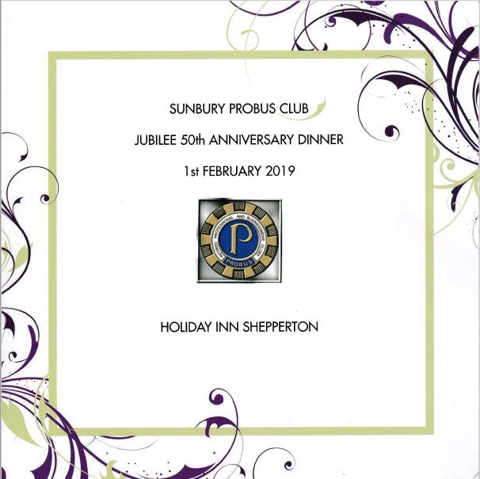
Figure 37: The Jubilee 50thAnniversary Dinner
Probus members were delighted to witness our Chairman, David Leitch, presenting a cheque for £10 to Mr Richard Black, President of Shepperton and Sunbury Rotary, as repayment for the initial sponsorship donation from Rotary in 1969 to meet expenses incurred in setting up our Club. It was noted (with relief) that the repayment was made without the addition of interest!
[Subsequently, at the Probus Luncheon meeting on 11th February, the Chairman read the correspondence he had received from the distinguished guests. They warmly thanked the Club for its hospitality, congratulated the committee on the professional standards set at the dinner and the choice of menu. All wished the Club well on the journey towards its centenary!]
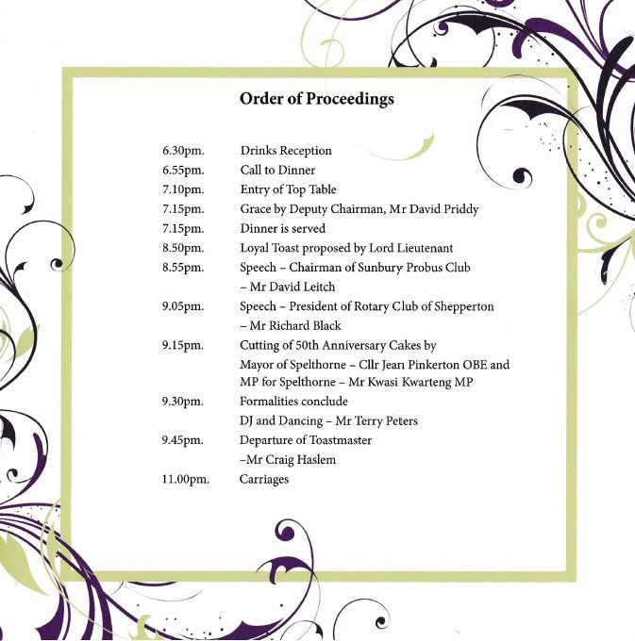
Figure 38: The Order of Proceedings
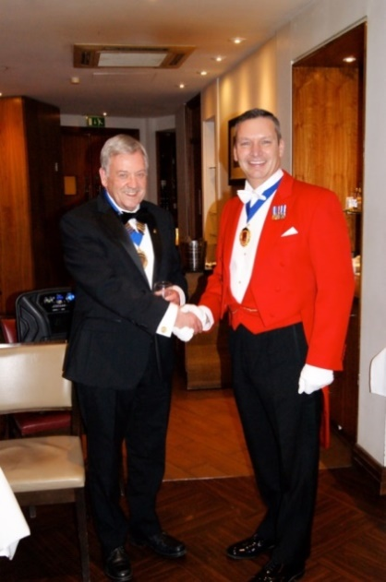
Figure 39: Chairman David Leitch and Craig Haslam, Toastmaster and Master of Ceremonies
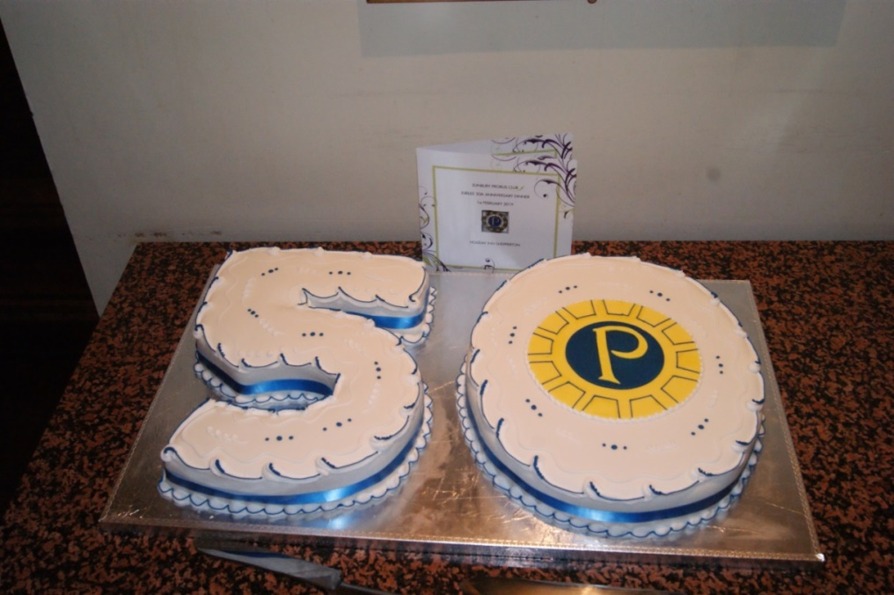
Figure 40: The Jubilee Cake

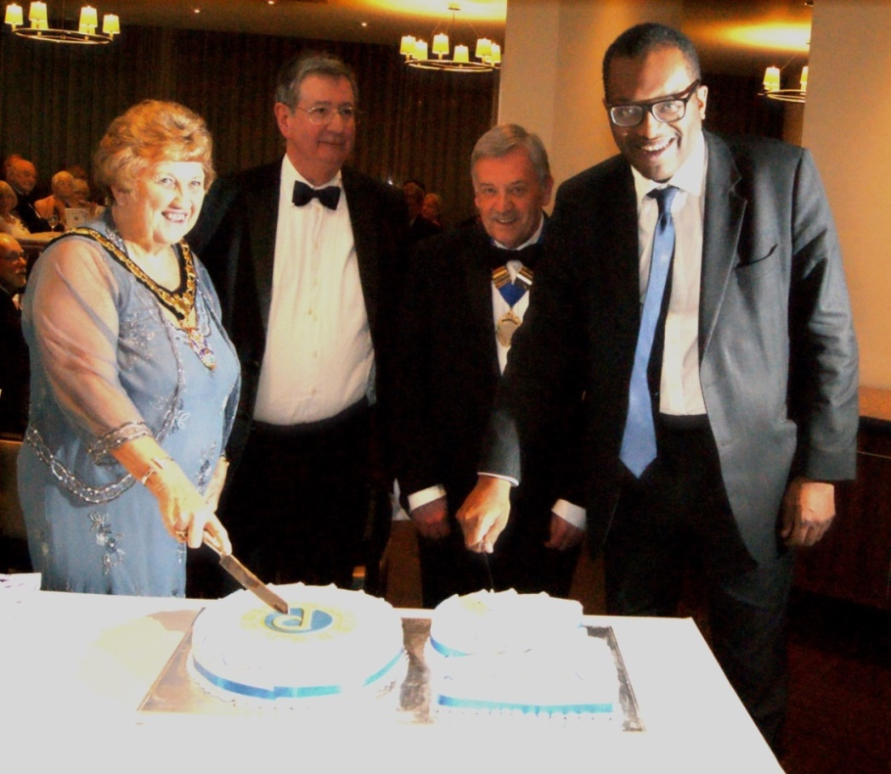
Figure 41: Cutting the Jubilee Cake (The Mayor of Spelthorne, Cllr
Jean Pinkerton OBE; Mr Richard Black, President of
Rotary Club of Shepperton and Sunbury; Mr David Leitch,
Chairman Sunbury Probus Club; Dr Kwasi Kwarteng MP)
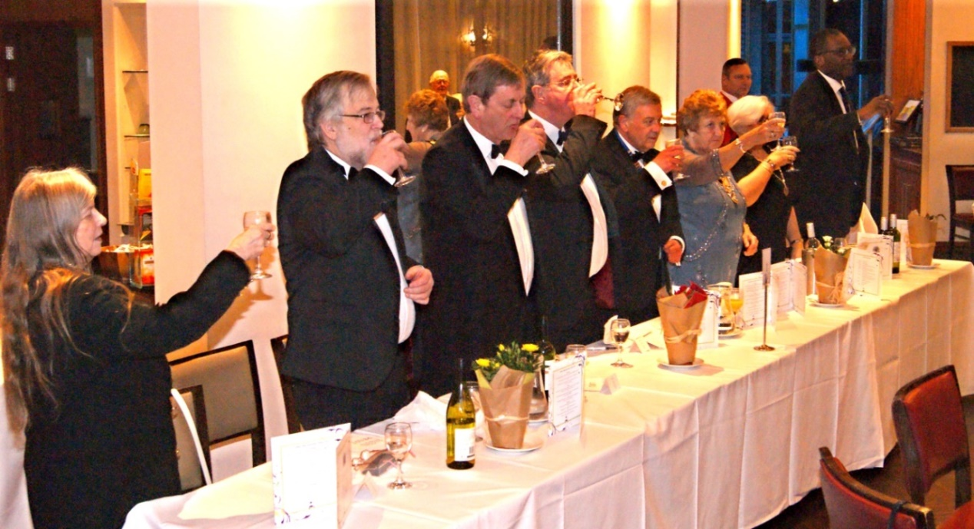
Figure 42: The toast to Probus (from left: Mrs Eileen Priddy; Rev David Priddy, Vice-Chairman;
Mr Michael More-Molyneux, Lord Lieutenant of Surrey; Mr Richard Black, President,
of Rotary Club of Shepperton and Sunbury; Mr David Leitch, Chairman; Cllr Jean Pinkerton OBE, Mayor of Spelthorne; Mrs Linda Burton, Mayor’s Consort; Dr Kwasi Kwarteng MP)

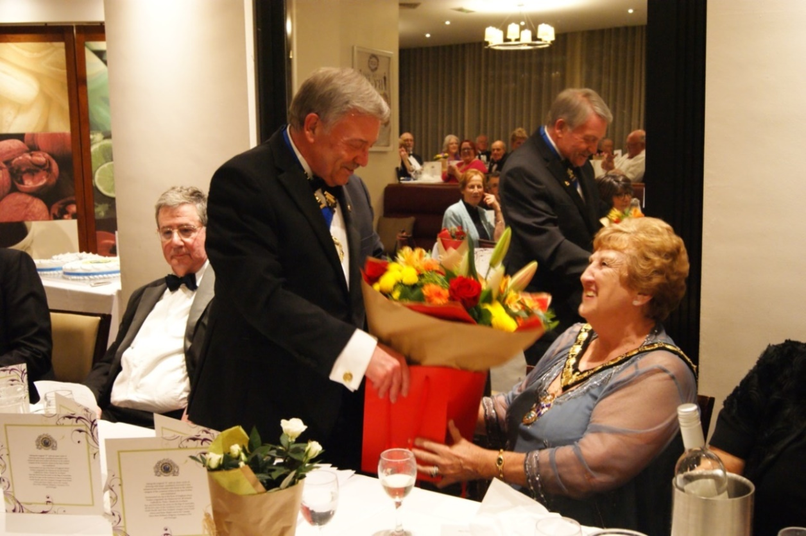
Figure 43: Chairman, David Leitch, presents a bouquet to Cllr Jean Pinkerton OBE,
Mayor of Spelthorne
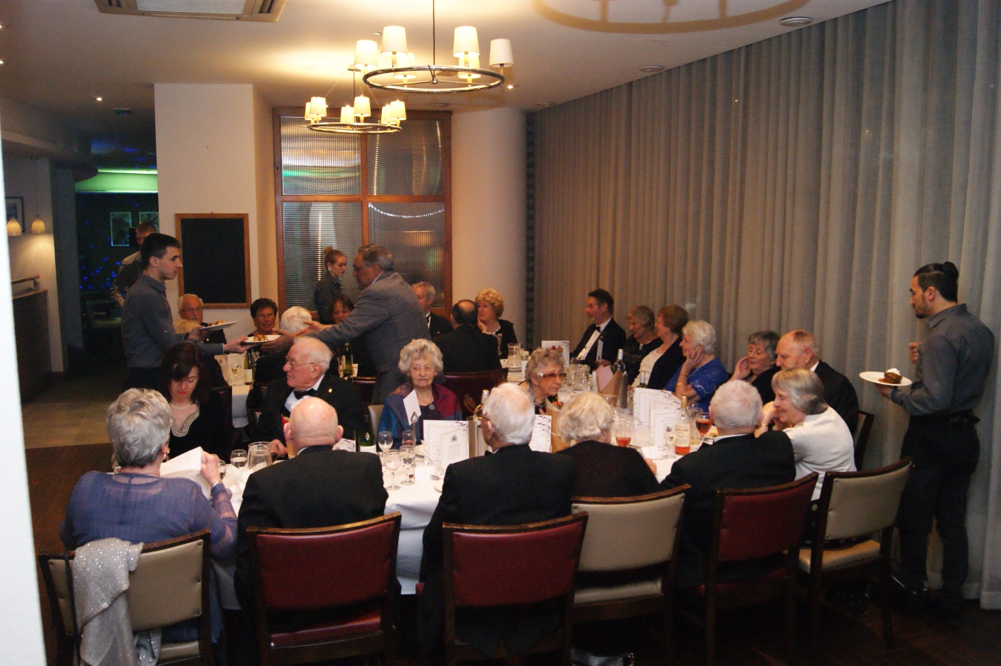
Figure 44: Guests at the Jubilee Dinner
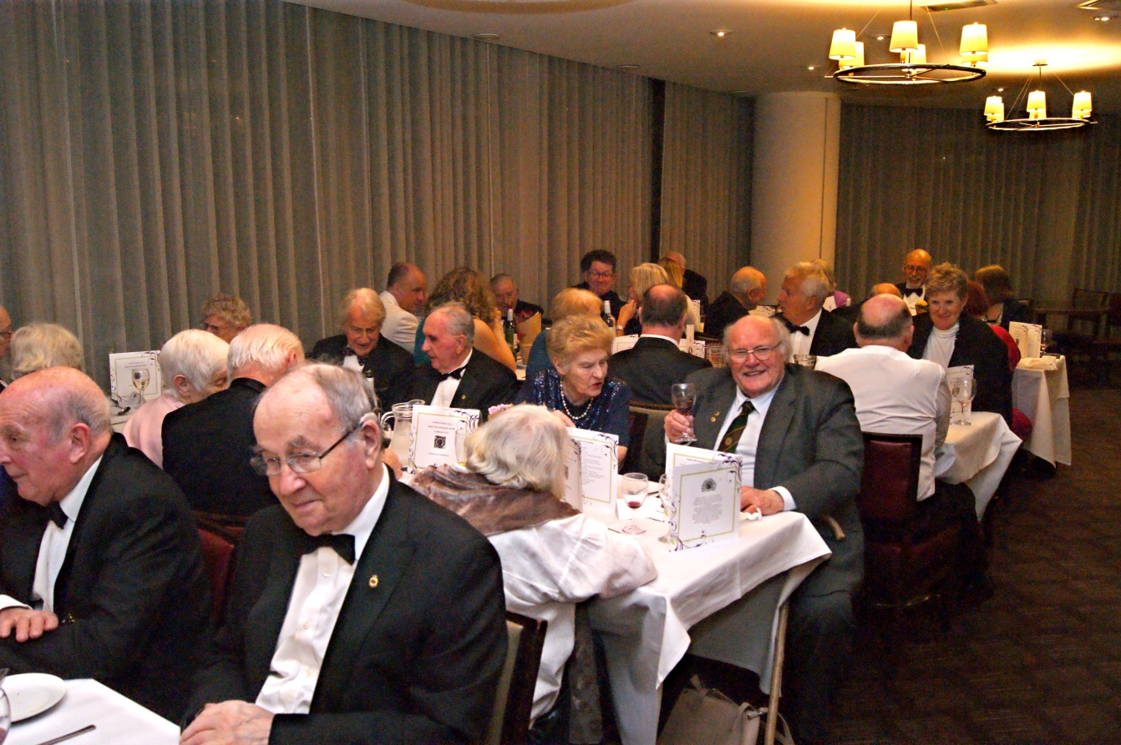
Figure 45: Guests at the Jubilee Dinner

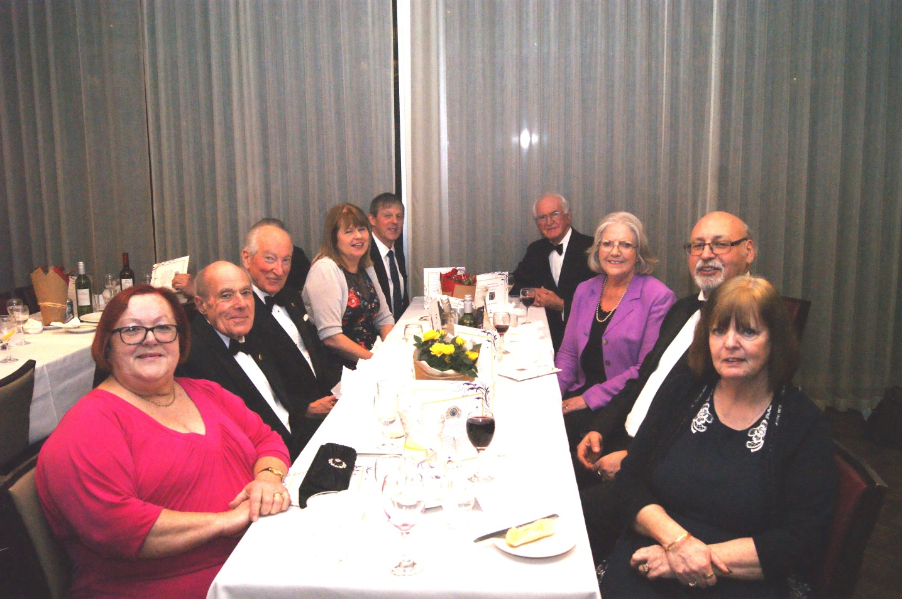
Figure 46: Guests at the Jubilee Dinner

4.3 Profile of club members 2019
Names and offices held since March 2001
At the 28th January 2019, Sunbury Probus Club had 56 registered members. Table 7 gives the names of members, dates of induction and responsibilities taken for administration and management of Club affairs in the period since March 2001.
Table 7 Club Membership on 28th January 2019
Surname Forename Induction Offices and responsibilities since March 2001
Adams Charles 14/04/1983 P/Pub lunches
Anderson Don 11/01/1999
Appleyard John 10/01/1994
Attias Michael 14/12/2009 P/Chairman P/Day trips Traders’ list
Barlow Brian 14/01/2008 P/Day trips P/Theatres
Brown Frank 12/10/1998 P/Chairman P/Secretary Printing
Cavalla John 11/02/2002 P/Treasurer P/Vice-Chairman
Champion Eric 12/11/2001 Speaker (2)
Chatterton David 10/06/2002 P/Bowls
Cope Ian 13/02/2017
Croneen Michael 13/08/2001
Cull Tony 08/05/2017
Diplacito Paul 10/02/2014
Dixon Norman 15/04/1996 HLM P/Chairman P/Treasurer P/Speakers History Group
Dowell John 14/12/2015 A/C Examiner Pub lunches (jt)
Dowthwaite Tom 11/09/2017
Duffy Terry 11/10/2010 P/Secretary
Faulkner Alan 11/07/2016
Gant Robert 11/06/2007 P/Chairman P/Almoner P/Speakers Speaker (2) History Group
Genet Edwin 11/09/2006 P/Chairman
Georgiou George 08/12/2014
Gibbons Richard 11/08/2008
Gray Patrick 12/01/2015
Greaves Richard 08/06/2015 Webmaster History Group
Hemsley Barry 08/12/2014
Hesford Mike 09/05/2005 HLM P/Chairman P/Secretary P/Theatres P/Day trips History Group SSA Rep.
Hopkins Gordon 12/11/2012 Photographer History Group
Ingall Stanley 10/01/2005 P/Day trips P/Photo board
Jones Roy 12/02/2018
Junker Peter 13/11/2017
Kellet Graham 08/08/2016
Kenney Keith 06/04/2009
L’Angellier Tony 10/08/2015 Pub lunches (jt)
Lawrence Terry 14/10/2011 Day trips
Leitch David 13/02/2012 Chairman P/Theatres History Group
Lodge John 11/10/2010 Speakers
March George 12/09/2005 P/Chairman Speaker (1) Regalia
Mayell Christopher 14/11/2016 Day trips (jt)
Messum Les 12/01/2009 P/Chairman P/Almoner P/Pub lunches
Mills Chris 13/02/2018
Mold John 09/11/1998 P/Day trips P/Holidays
Moore Martin 09/12/2013 Secretary
Pemberton Leo 15/01/2001 P/Chairman Almoner Speaker (1)
P/Speakers
Priddy David 08/08/2016 Vice-chairman
Roberts Gerald 12/01/2015
Ross Charles 09/05/2016
Scott Denis 10/01/2011 Theatres (jt)
Shimmield Don 19/07/1999 HLM P/Chairman P/Day trips
5-day holidays Ladies’ Night History Group
Stanley Gavin 09/05/2005 P/Chairman Treasurer Speaker (1)
Stockbridge Tony 07/12/1998
Timothy Michael 10/05/2004
Turner John 11/04/2009
Wakefield Michael 12/10/2015
Wilson Mark 13/06/2005 P/Day trips P/Audio
Wood Michael 13/06/2011 Assist. Treasurer
Worrell Alan 08/06/2015 Theatres (jt) Photo board

Notes:
- The symbol “P/” refers to past office holding /key responsibility
- Club members (other than Chairmen) who have given an after-lunch talk are acknowledged by “Speaker (x)” where ‘x’ signifies the number of presentations
- Pub lunches, Day trips and Theatre visits are jointly managed by two members
Date of induction
The pattern of members’ inductions is summarised as Figure 47. A total of 8 members had joined before 2000. Since 1st January, 2015, 18 members have been inducted.

Figure 47: Year of member’s induction
Age distribution January 2019
The age distribution of members profiled in Figure 48 is typical of many clubs across the UK. It identifies the significant proportion of members with birth dates prior to World War II. On 28th January 2019 a total of 8 Club members were aged over 90.
Catchment area of membership
In January 2019, 47 of the 56 members lived in Spelthorne. These were concentrated in the following wards: Sunbury East (26 members); to the west of Green Street in Halliford and Sunbury West (13); north of the A308 in Ashford, Ashford Common and Sunbury Common (6); and Shepperton Town (2). The balance included members from Walton-on-Thames, the London boroughs of Richmond and Kingston upon Thames, and north Surrey.

Figure 48: Year of member’s birth
Employment prior to retirement
Members of Sunbury Probus have been recruited from diverse professional, business and managerial backgrounds. Former employers include: multi-national BP, Shell, British Airways and IBM; listed companies and city financial institutions; reputable nationwide businesses; the professions; and departments in central and local government. Several members, in addition, have directed and managed their own companies.
A document filed in Club records lists the principal occupations of 74 members in April 2002. This self-reported information identifies 33 different job titles. The most common categories were: mechanical and electrical engineering (16); business and organisational management (12); commercial and branch banking (5); the civil service (5); company accountancy (4); overseas and commercial insurance (4); and further and higher education (3). These basic records highlight various branches of engineering at Heathrow Airport; moreover, they show the importance of commuting to employment in the public sector and financial services in central London and the metropolitan fringe. An equivalent census of 56 members in January 2019 produced a total of 36 job titles. The foremost categories were: aeronautical and electronic engineering (9); company and managing director (5); technical and research management (5); and education (4). Heathrow Airport remained a major local employer in the fields of engineering and associated roles in management.

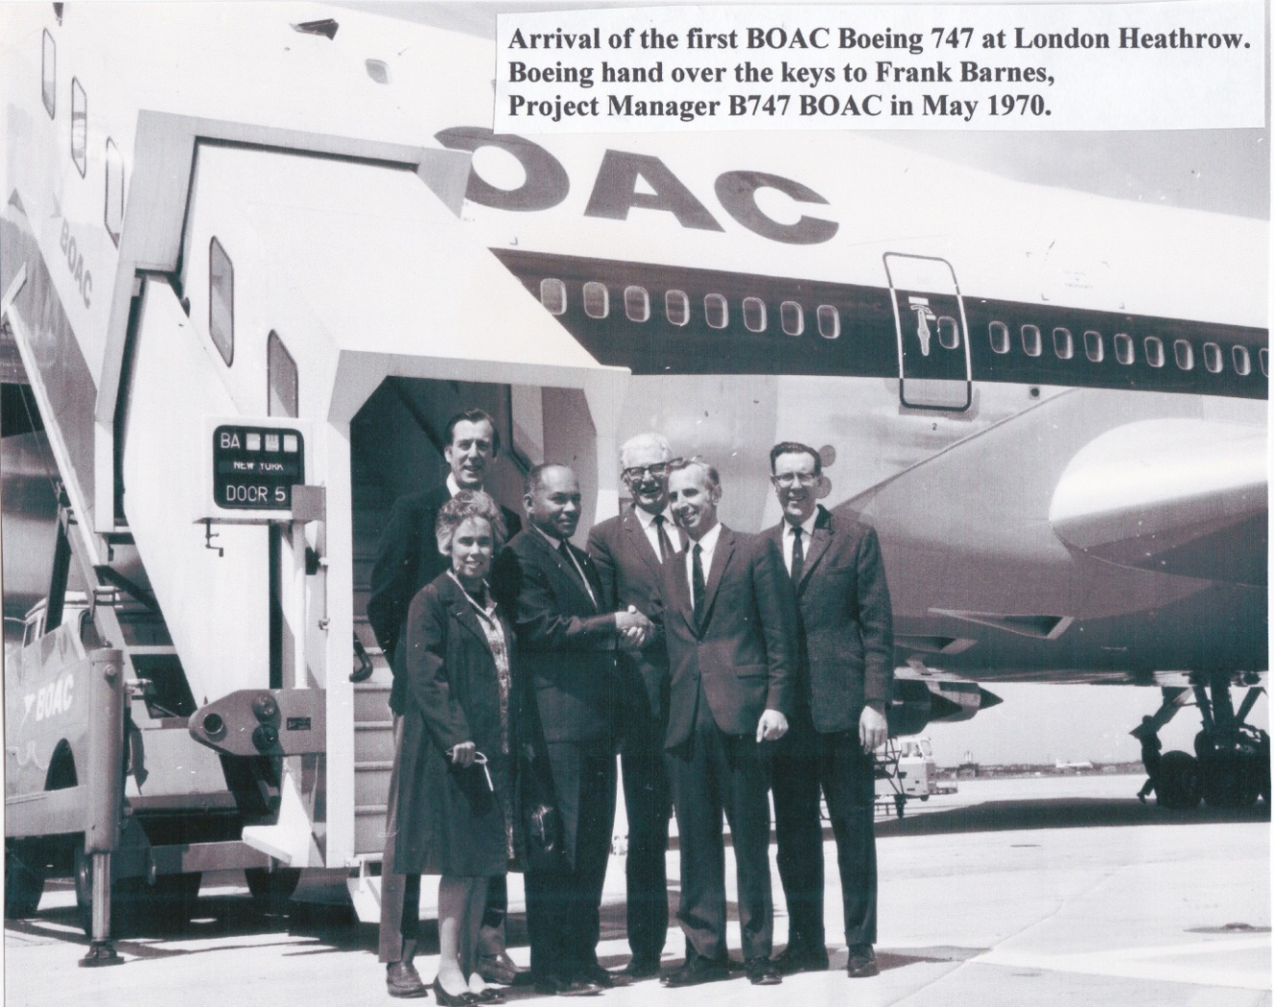
Figure 49: Frank Barnes HLM (second from the right) and Ray Gaunt HLM (on right)
in their senior positions at BOAC (see page 126 for detail)

Figure 50 re-casts former employment into the nine divisions of the Standard Industrial Classification. This exercise reveals two significant features. Firstly, employment in transport, storage and communications (Division 7) has declined from 26% in 2002 to 11% in 2018. This is explained by the reduced number of members (especially in branches of engineering) working at Heathrow Airport. Secondly, members employed in Community, Social and Personal Services (Division 9) have increased proportionately from 20% in 2002 to 32% in 2018. This reflects labour market trends and includes employment in local and central government, public administration, the ’third sector‘ and legal services. Meanwhile, relatively minor changes are registered across the remaining industrial divisions: manufacturing (Division 3), public utilities (Division 4) and construction (Division 5) show small positive changes. Significantly, the decrease registered for finance, insurance and business services (Division 8) conceals a numerical decline in former bank managers (from 5 to 0), several of whom had officiated as Club Treasurer and Accounts Reviewer!

Figure 50: Professional and business backgrounds of members
4.4 Personal reflections on Sunbury Probus Club
People often ask “What do members get from joining Sunbury Probus?” Reports from our three HLMs (Norman Dixon, Mike Hesford and Don Shimmield) and senior club member (Charles Adams) attest to the experience of good fellowship, a core value at the heart of the Probus movement. Let these distinguished members speak for themselves!
My Personal Reflections on Probus: Norman Dixon (HLM) (Joined Probus 15th April 1996)(Figure 17)
I first attended Sunbury Probus in 1993 at the invitation of Don Thornton, who later proposed me. I had to wait until 15th April 1996 before I was inducted as a member, however, because I had to go through the process of (a) being on a Supplementary list, and (b) being on a Potential Members List before they would let me in!! However, in those two years I enjoyed most of the benefits of being a Member without having to pay a membership subscription!! Little did I realise that I would end up not having to pay a membership fee for being a Honorary Life Member for which I feel very honoured. I would stress that I did pay all my dues between those events!
At first, Don Thornton was the only member I knew, but after a few lunches began to know several members because, like now, and despite many appeals from several Chairmen, we always sat in the same places each month. In March 1997 I became a Committee Member – in some trepidation – ‘to get it over with”. After a year arranging speakers (with a lot of help from other members) I was made Treasurer for two years, Vice-Chairman, Chairman (2001-2002) and then Past Chairman for a year. Despite my original reluctance, these six years on Committee proved to be my most enjoyable years of membership.
I remember thinking how active the club was – not much thought about sleepy retirement. In 1993, just before I joined, the Club had gone on their first 5-day holiday Trip to Torquay. This proved so popular that two holiday trips were planned every year – one in the UK and one on the Continent. This was in addition to all the other activities such as 1-day outings, theatre visits, pub lunches, and of course the monthly lunch, including a speaker. On top of all this was the annual Ladies’ Night and we had a sports section which played bowls in the summer and golf against other Probus clubs from time to time throughout the year.
We aimed to choose moderately-priced events because we were conscious that not all members had company pensions and some had to rely on their State Pension. Most outings were very well attended and sometimes we had to hold a ballot to decide who should be included. The unlucky ones were given priority next time.
The membership consisted of 60 Members plus up to five Life Members. In addition, there were 10 Potential Members and a further waiting list who were limited to some of the benefits. This was helpful in deciding the priorities as to who was able to attend the various functions, bearing in mind that wives and widows were sometimes included. When the number of Potential Members plus Waiting List reached 26, we decided to make some alterations. We made the 10 Potential Members into Full Members and gradually reduced the waiting list to nine. Needless to say, the Secretary kept a secret list of all enquiries.
Naturally, my main memories relate to my year as Chairman. I particularly remember two day-outings. The first was to Sandhurst for a rehearsal of the Passing Out Parade. The other was, I think, the highlight of the year. It was the visit to Wintershall in Surrey for a performance of “The Life of Christ”. The production was performed in the open air and yes --- it rained, and we, as well as the actors, got wet. Despite this everyone said what a magnificent performance it had been.
One other event that we booked for was “Friday night is Music night” but this was cancelled by the BBC because the theatre ceiling had fallen down!
I also remember well two 5-day holidays. The first to Bowness in the Lake district and was mostly memorable for the diversions we had to make because of the Foot and Mouth disease a few days before we travelled. The driver did such a good job negotiating narrow lanes which had not been on the original itinerary that I then requested that he be the driver for our other holiday to the Loire Valley in France. He made a brilliant start and arrived at Portsmouth one hour early so that we caught an early ferry across the Channel. This gain in time was unfortunately lost on the other side due to some sort of accident which resulted in nothing moving for an hour. Other coaches started whizzing past us to bypass the hold up and our driver decided to do the same – not realising that we could not get off the revised route for about 30 miles!! We then had another one hour hold up on a single track road and finally reached our hotel at 10 p.m. having started at 5.0 a.m. The hotel was magnificent, however, and had a hot meal ready for us on our arrival. Despite these mishaps, both holidays were very enjoyable.
Two other memories were (a) laying the Probus wreath on Remembrance Sunday at Sunbury War Memorial and (b) being very proud to represent the Club on the occasion of Her Majesty The Queen’s visit to the Sunbury Millennium Embroidery.
One big benefit of Probus has been the making of new friends. Having always worked away from Sunbury and getting home late, I did not know many people apart from our immediate neighbours. After joining Probus, however, I soon got to know people, and my wife and I soon had new friends particularly after going on some 1-day outings and especially after the 5-day holidays. Every time we got off a coach we found ourselves talking to other members. This has made a great difference to our lives.
In December 2002, Richard Worthington, Chairman in 2000-2001, handed me an article from the Winter Edition of the Probus Magazine which included a list produced by Mr Brian Hoy of Herne Bay Probus Club of 52 clubs formed in the first ten years. We were not on the list and only three clubs listed were formed before us. I wrote to Mr Hoy. Later, a second list showed us in 4th position. Over the years further lists have shown us in different positions but we remain one of the very first Clubs, as explained in Appendix A.
Naturally, there have been some changes. I seem to have joined at its heyday when numbers were high and persuading Members and their wives to attend the various activities was comparatively easy. Recently, our numbers have dwindled a little, but some Members might welcome this as there were worries that the Club was getting too big. The main factor is that the club is still flourishing. It may be more difficult to fill coaches on our trips and we now have to rely on widows joining us on outings. I believe this may be due to three factors (1) because we have already been to so many events, it is getting more difficult to think of new places to go;(2) our numbers have declined; and (3) the average age of members is now 80 whereas when I joined the Club, from the information available, I estimate it was between 70 and 75. However, we still carry out all the activities apart from bowls and golf. This is a tremendous achievement after 50 years. LONG MAY IT CONTINUE!!
[Norman Dixon]

My Personal Reflections on Probus: Mike Hesford (HLM) (Joined Probus 9th May 2005) (Figure 17)
I joined Probus on 9th May 2005 after a 3 year wait on the ‘pending list’. I had heard of the organisation from contacts with Rotary Club Members who are now with Probus, and while conducting the Father Christmas Tour round Sunbury driving the Scouts’ minibus towing Santa’s sleigh. At that time I was Group Scout Leader and was happy to assist when needed. Fred De Graff, the retiring District Commissioner, was the first to invite me to join; he later became Chairman. However, with my Scouting commitments and the long waiting list I decided to wait. In 2005 on retirement from the Scout group, I accepted an invitation from Michael Croneen, with Michael and Arnold Bradshaw as sponsors
My overriding impression of the Club is one of organisation by the members for the members and where over the years since 1969 retired men have grouped together to share lifetimes of experience. Indeed, several have given 40-minute after-lunch talks telling us of their personal experiences. Although talks have numbered several hundred in the past 50 years none had been recorded until Frank Barnes gave me his background notes for his lecture entitled “65 Years of Avionics” on 14th November 2011. My interpretation of those notes is included, below, as Appendix E.
I got to know several of the senior members of the Club really well during the difficult period when I assumed the Chairmanship, at very short notice, when Dick Nimmo fell seriously ill immediately prior to the AGM in 2009. As Vice-Chairman, I was instructed by the Committee to continue in Dick’s absence. Fortunately, the tremendous help and support provided by key members and past Chairmen enabled me to continue. In that context I am indebted to Gavin Stanley (Treasurer), Ken Pockett (Secretary), Frank Barnes, Arnold Bradshaw, Don Shimmield and Eddy Lea. I was duly elected Chairman in July 2009 on my 76th birthday.
My thoughts now turn to a select group of distinguished members who have contributed so much to the vitality and standing of our Club: Arnold Bradshaw, Ken Pockett, Eddy Lea and Ray Knott.
Arnold Bradshaw had always positioned himself at the doorway to the dining room, introducing you to as many members as he could muster. He became known as the face of Sunbury Probus with his broad beaming smile. Arnold ‘s early life was difficult, culminating in an attempt as an early teenager to walk from Ealing to the South Coast being picked up by police in Winchester. He joined the RAF for 6 years and then to the Pru where he eventually became London Office Manager. He married Gwen in Henley in 1950 moving via Thames Ditton to Sunbury in the process. He became Chairman and for years was our representative on the Sports and Social Club Committee. Arnold was a true member; he inspired the Committee to greater efforts and gave wise counsel when needed. Probus regretfully lost Arnold in April 2013.
Ken Pockett was Club Secretary for four years and was in post during my term as Chairman. He was extremely supportive helping out with quiet, considered advice and guidance particularly on Club matters. He ran day trips to Arundel in 2006 and London Docklands in 2007, which were well attended. Ken was a film maker, writing and editing films and video programmes over a period of 40 years. His interests were music and serving the public. As such he was the leading light in the publication of Spelthorne’s Newspaper for the Blind, working as a sound recording engineer. He was born in Heston in 1936 later moving with his family via Richmond to Sunbury where they lived for 50 years. Ken and Wyn married in 1964, had two sons and three grandchildren. He joined Probus in 2004 becoming a Committee member. Ken’s failing health prompted him to retire at the 2010 AGM; I followed in his footsteps as Secretary, there being no volunteers. Ken always used his wife’s email address wynpockett@talktalk.net and my wife thought, initially, that I was having an affair with Wyn when emails were received to arrange meetings! No one knows how Ken got his name, he was born Clement Arthur and he was of immense help to me in my dark hour of need. After a long illness, of which he never spoke, Ken died in November 2014, aged 78 years.
Eddie Lea was Chairman in 1987 and during that year organised day visits to see the Overlord Tapestry in Southsea and the Finchcocks Music Museum at Goudhurst, Kent. He became a Committee member in 1980, becoming Treasurer for six years from 1982; in 1983 he took on the organisation of the Ladies’ Night Dinners, a role he continued into the millennium. I first knew Eddie when my son joined 1st Sunbury Cubs in 1966. He and Peter Leadbeater jointly ran the Pack as Akaela and Baloo. He revelled in the fact that as a scout he had won the King’s Scout Award when the King was George V. Mine was George VI and Peter’s was Elizabeth II. Eddie was a prolific worker. His organisation was always immaculate and his timing amazing. I will always remember his last Ladies’ Night which was a resounding success. We assisted the Sunbury Rotary Club with their Santa Claus Christmas Collection and got to know several Rotarians who later became Probus members. Eddie continued in the Club for several years finally “going home” in the January of my year as Chairman in 2009, aged 94 years.
Ray Knott was Chairman in 2004. He had been a Committee member since 2000. In 2001 he organised short holidays to Bowness and the Loire Valley, followed in 2005 by visits to Jersey and Falmouth. He was a great help to me in 2005 when I joined the Club in showing me the ropes. Our best moment was enjoyed when, together, we gave an after dinner talk to the members on “Camp Fire Yarns” dressed up as Laurel and Hardy with whom we shared a passing resemblance. During rehearsals we realised how close our careers had taken us from boyhood in Staffordshire to Members of Sunbury Probus Club, through Scouting (Ray was also a King’s Scout) and the construction industry. Ray was a prolific walker and was a member of the Spelthorne Ramblers of which my wife is also a keen member. Born in Leek in 1927, and educated locally, Ray became an indentured apprentice electrical engineer; he qualified for exemption from National Service in 1947 and was directed into the government housing initiative for constructing 350,000 houses per annum for the foreseeable future. He progressed to teaching electrical engineering, first in Hemel Hempstead College and later at Kingston College. Although our paths crossed here, when I was engaged in the construction of a section of what is now Kingston University, we first met as members of Sunbury Probus. We sadly lost Ray in 2012, after a short illness, aged 85 years.
I pay tribute to the fine qualities of these four Probus members and their unstinting contribution both to the local community and Sunbury Probus Club. There are, of course, many others who have made significant contributions. These men, however, stand out in my memory.
[Mike Hesford]

My Personal Reflections on Probus: Don Shimmield (HLM) (Joined Probus 19th July 1999) (Figure 16)
Towards the end of the 1990's, the late Arthur Westcar - like myself, a previous BP employee - would often pop in for a cup of tea and a chat. Arthur would often arouse my curiosity by mentioning the Sunbury Probus Club and some of the activities that they were involved in, apart from their monthly lunches. It was obvious that visits to the theatre, pub lunches, day trips and 5-day holidays were all part of a dynamic set-up in which the Club was involved and which offered an immediate appeal. It was not long before I was accompanying Arthur as a guest to some of the lunches and other events. My application for membership was, however, held in a nasty queue, which did not seem to move for many months. In fact I was even told at one point that my presence at the monthly lunches should be restricted, as I was becoming a regular attendee. Fortunately there was a sudden easing of the bottleneck, and I was in.

My induction was memorable inasmuch as Arthur was otherwise engaged on the day and on arrival, looking a little lost in spite of my frequent visits, the late Arnold Bradshaw came over to me and introduced himself. Thus started a warm and lasting friendship not just with Arnold but with many other members. The Club had a certain vibrancy about it which made it very appealing and which it still has today.

It was not too long before, one day, I took a call from the then chairman, Norman Dixon, who wanted someone to take over the one-day trips. I must admit I was not that surprised and, by accepting, decided it would be a rather good way getting to know the members. My two-year tenure stretched to four and there was always a certain satisfaction derived from the arranging of a trip which members appreciated.

During my time in Probus there have always been incidents or happenings that have cast an indelible imprint on one's memory. Some are quite amusing (but not necessarily to the members involved) and some profound. There was the occasion of the 5-day trip to Troyes where we had expected to be staying at an attractive hotel in the French countryside which turned out to be on an industrial estate. Our group had been assigned a separate dining room from the other guests and the meals had been pre-ordered prior to leaving. Understandably, not many could remember what they had chosen. The waitresses couldn't speak English and were unable to enlighten us on what they were serving. Two intrepid members managed to find their way into the main area for the other hotel guests and were able to partake of an excellent cheese board for their dessert which they did on several occasions. But the event which proved, at the worst, uncomfortable for two couples happened late one evening. In arranging to meet up in the other couple’s room for a night-cap, the first couple managed to lock themselves out of their room. The idea of a night porter in this hotel was wishful thinking and so all four had to spend the night in a room for two. Needless to say the men were very gallant and slept on the floor!

There was also another memorable occasion, again relating to a French holiday, but this time it was in Normandy in 2013 and concerned the late John Cairns, a veteran of WWII. Visiting the museum at Arromanches, he was spotted by the authorities wearing his Gordon Highlanders forage cap and invited to sign the visitors’ book. Not only did he sign, but he was also presented with a medallion. Two days later, John was able to identify the grave of a particular fallen comrade and friend and also visit the Pegasus Bridge, which gave him some inner satisfaction that the trip had been worthwhile.

Having been involved in Ladies’ Nights for a few years now, the most notable change has been the fall in attendance. In the early 2000s it was not uncommon to have more than 100 members and guests attending. In those days the function was held at the Ashford Golf Club but, to cut costs, it was switched to the Sunbury Sports Association in 2010. Recently, again to receive value for money amongst other things, this event has been transferred to the Holiday Inn at Shepperton. Numbers attending these days are in the order of 50-60.

The one event which left a lasting effect involved a Ladies Night and the late Alf Filler's wife, Billie, in 2012. I had to visit her concerning her attendance just prior to my flying off to Singapore on holiday. When I told her where I was going she told me about her brother Stanley Warren and his experience as a POW of the Japanese. Stanley, a commercial designer before the war, had suffered badly since being captured in Singapore and, near to death, had been transferred to the Changi hospital. Making a partial recovery, he was asked if he would do some paintings for the prison chapel. Although he was working under extreme difficulties of sickness and lack of materials, he was able to produce five murals over a period of time which reflected events in the Christian bible. Apart from the spiritual uplift he received in carrying out the work, they also contributed much to the increase in morale of many of the POWs who sought solace in the chapel. The murals were later distempered over but came to light at a later date and the hunt was then on to find the painter. This was eventually achieved with the help of a national newspaper and Stanley was persuaded to make several journeys back to Singapore in order to restore them. They now form part of a Heritage Site in Singapore and special permission is required to view them. Replicas of the murals are open to the general public in the Changi Chapel and I was able to view these during my visit to Singapore and they left a truly memorable impression.

Finally, an amusing episode, at my expense, occurred on a day trip to West Sussex. The coach was approaching a new road bridge over the River Adur when I mentioned to the guide that during the war I used to fish off the old road bridge with a hand line and nice fat juicy lug worms. She promptly announced to one and all that if they were to turn their heads to the left they would see the old bridge from where Don once caught crabs!

[Don Shimmield]

My Personal Reflections on Probus: What Probus meant to me. Charles Adams (Senior Probus Member – inducted 14th April 1983) – Interviewed by Robert Gant, Club Almoner, 2017-18.
Charles felt unable to write this piece about his Probus membership due to recurrent ill-health and restricted mobility. Consequently, his recollections have been drawn from several home-based interviews conducted (over a few glasses of beer) by Robert Gant, the Club Almoner at that time.
Charles was the Senior Probus member in April 2018. At the time of interview, he had just completed a record 35 years of membership. Born in August 1921, he had joined the Royal Navy at the age of 18 and served as an aircraft technician for seven wartime years in the Fleet Air Arm. He saw active service on air craft carriers in the Atlantic, experienced the dangers and privations of life in Malta during the wartime siege, and finished his service in Australasia and the Far East until VJ day. In later life, at Heathrow, he managed a technical department dedicated to the maintenance of aircraft engines.
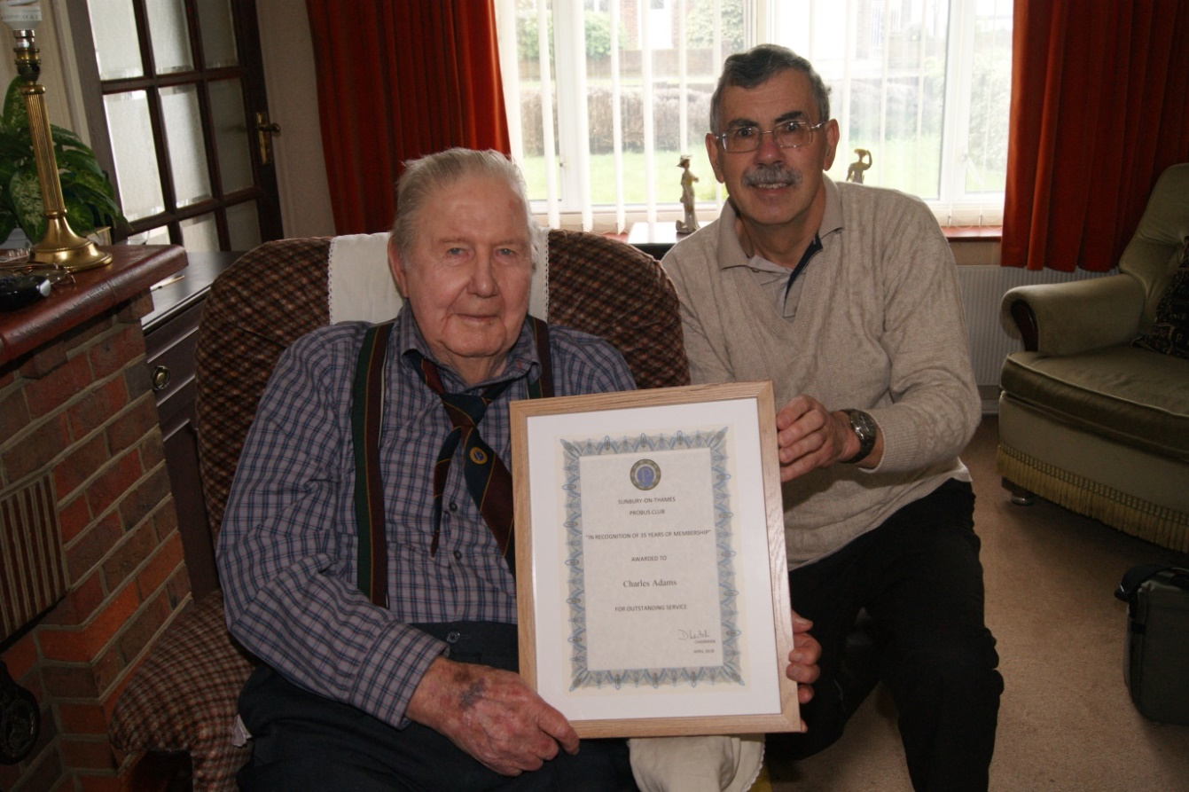
Figure 51: Charlie receives a scroll of honour in recognition of 35 years membership of Sunbury Probus Club from Martin Moore, Club Secretary, in August 2018
Bill Peat, a fellow member at Laleham Golf Club, had sponsored Charles for membership of Sunbury Probus Club. Charles recalls that, following an age on the waiting list, he was inducted in April 1983. He holds warm memories of the good fellowship experienced throughout his membership. To quote: “I only wish that I could get back to the lunches and enjoy the company of my friends; of course, most of the ones I was friendly with are now dead, and I don’t know most of the members today! But, I still want to get back. ” He added: “In the early years there were many men, like me, who had served in the war, and in particular the RN. I formed a bond with these, given our common background. There are few left now.”

During the Probus years 2002-2005 and for a spell in 2007-2008, Charles organised Probus pub lunches. He relished the task. He continued: “In those days there was not so much traffic. We were younger. With friends in the Summer evenings we had visited many pubs down in Surrey and chose the best and most reasonably priced for Probus lunches. We didn’t mind travelling, unlike today when many pub lunches take place closer to Sunbury. They were all well-attended. We had a great time. We made many new friends!”
Friendship and good fellowship again emerged in discussions on 5-day holidays. Charles and his wife Barbara (who interjected at points in the conversation) claimed that these events were quite amazing. They had taken part in the majority of these holidays and had made many good friends. Two holidays were isolated for special comment. The first was The Lake District holiday in May 2002 when considerable on-site changes in the programme became necessary to avoid the ravages of foot and mouth disease. “The burning heaps of sheep slaughtered in many places to reduce the spread of the disease were upsetting and still stick in my mind”, claimed Charles. ”But the organisation was amazing and full credit must go to Ray Knott, the organiser, for a brilliant job done in difficult circumstances.” The second truly memorable trip was to Liege in Belgium that included visits to the amazing Dutch bulb fields, and wartime cemeteries at Paschendale and Ypres that were particularly resonant to Barbara whose father had seen active wartime service in this theatre.
Charles had an overwhelmingly positive experience of his time in Probus. He valued the companion ship and opportunities to engage in the full range of social events. For some years, he played in the Probus golf team. At our final meeting, on being informed of the death of André D’Arbre, two months his senior, he asserted that: “It’s me now, I’m next on the list!” When informed that it didn’t quite work like that, he steadied himself and reflected that his genes were good, but that his father had only survived to the age of 93! What a sense of humour!
[Almoner’s note: Fortunately, in the months that followed these interviews, Charles felt sufficiently well to attend several Probus luncheons and Pub Lunches]

